Dual Microwave Radiometer Experiment
Final Campaign Report

Roger Marchand, University of Washington

July 2017

Summary
Passive microwave radiometers (MWRs) are the most commonly used and accurate instruments ARM has to retrieve cloud Liquid Water Path (LWP). The MWR measurements (microwave radiances or brightness temperatures) are often used to derive LWP using climatological constraints, but are frequently also combined with measurements from radar and other instruments for cloud microphysical retrievals. Nominally this latter approach improves the retrieval of LWP and other cloud microphysical quantities (such as effective radius or number concentration), but this also means that when MWR data are poor, other cloud microphysical quantities are also negatively affected.

Unfortunately, current MWR data is often contaminated by water on the MWR radome. This water makes a substantial contribution to the measured radiance and typically results in retrievals of cloud liquid water and column water vapor that are biased high. While it is obvious when the contamination by standing water is large (and retrieval biases are large), much of the time it is difficult to know with confidence that there is no contamination. At present there is no attempt to estimate or correct for this source of error, and identification of problems is largely left to users. Typically users are advised to simply throw out all data when the MWR “wet window” resistance-based sensor indicates water is present, but this sensor is adjusted by hand and is known be temperamental.

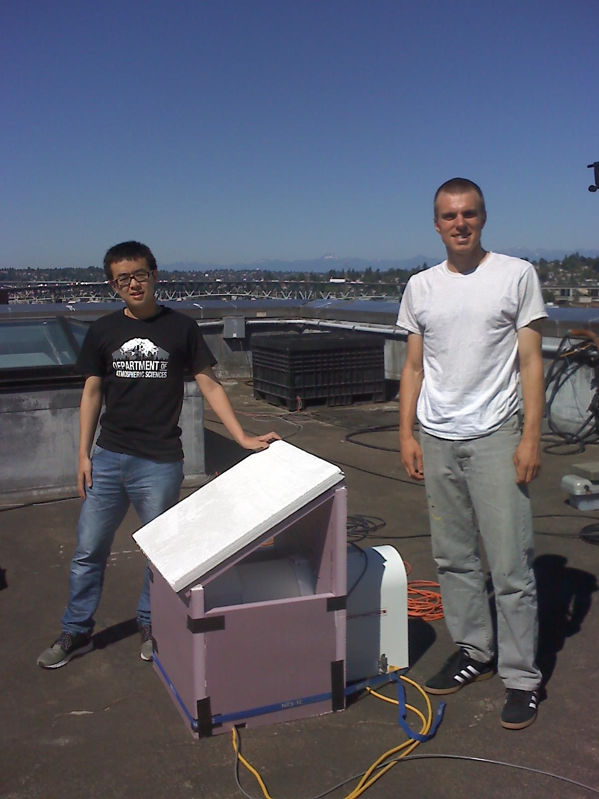
In order to address this problem, a pair of ARM microwave radiometers was deployed to the University of Washington (UW) in Seattle, Washington, USA. The radiometers were operated such that one radiometer was scanned under a COVER that (nominally) prevents this radiometer radome from gathering water and permits measurements away from zenith; while the other radiometer is operated normally – OPEN or uncovered - with the radome exposed to the sky.

The idea is that (1) the covered radiometer data can be used provide LWP (and water vapor) along the off-zenith slant path and (2) the two sets of measurements can be compared to identify when wet-radome contamination is occurring.

I wish to acknowledge the help of UW graduates students Wei Zhao and Casey Wall (shown here standing next to the covered radiometer). Much of the work shown here would not have been possible without their help.

Timeline:
Figure 1 - Wei Zhao (left) and Casey Wall (right) standing next to covered radiometer on roof of UW atmospheric science building.

The initial plan was to deploy the radiometers for a six-month period from Jan 2016 to June 2016. However, delays in getting the instruments, getting students in place to work on the project, and constructing a suitable cover delayed the start until May. In addition, one of the radiometers (MWR #18) failed in June and was replaced in July. As a result, the measurement period was extended until November of 2016. A list of precipitation events processed using a physical iterative retrieval and testing results are provided in the next section.

Results
It proved to be difficult to collect good data with both MWRs running simultaneously. The experiment design was to run both MWRs in a scanning or “TIP” mode. TIP mode is normally used for the purpose of generating tip-call calibration curves during clear sky conditions, and the MWR software does not routinely run in this mode when it is overcast. While the software allows the instrument to be kept in TIP mode continuously, there is a bug in the MWR software which causes the operating software to crash (with a variety of error messages) when “heavier” rains are falling and the instrument is operating in TIP. This software bug could not be isolated (by the instrument mentor, Maria Cadeddu) and remains uncorrected. The result was that one or the other radiometer frequently crashed, resulting in many fewer cases where both instruments were operating.

In October, the open radiometer was set to run in its normal “non-scanning” mode to increase the number of observed cases, at the expense of having no-off zenith measurements. No cases with unambiguously wet-radomes were identified prior to October, and it may well be that this is due entirely to the tendency of the MWRs to crash during heavier precipitating events.

Table #1 (below) summarizes the precipitation events captured by both MWRs. The MWR brightness temperature data were used to retrieve the vertical Precipitable Water Vapor (PWV) and vertical Liquid Water Path (LWP) using the physical-iterative retrieval approach published by Marchand et al. (2003). The retrieval is applied independently at each angle, and uses the Liege 87 absorption model, along with the nearest available sanding data (from the Washington Quillayute station). The raw MWR data, the physical-iterative retrieval results, and a variety of figures are being added to the ARM archive.

It is important to note that the retrieval does NOT include scattering effects, which are likely to be significant during precipitation. The point here is, not that the LWP values are accurate, but rather the intent is to determine the consistency of LWP values from the OPEN radiometer when looking at ZENITH with those from the COVERED radiometer when looking OFF-ZENITH. Differences here are nominally or potentially indicative of wet-radome contamination in the OPEN radiometer measurements.

Table #1 : Summary of Precipitation Cases Processed:

Prototype Cover: 5/20, 5/22, 5/23, 5/27
- Contamination free views ONLY at 19º elevation and ONLY looking east. There may still be a couple degrees K of contamination (see test case 5/18).
- 5/20 : Precipitation starting near 1 UTC and continuing on/off for several hours, with wet-wind flag on much of the time. Peak précis occurred just after 2 UTC. There is strong East/West asymmetry at this time, and no obvious water-on-radome contamination. Large LWP values > 4000 g/m² are observed and scattering is likely important.
- 5/22 : Drizzle after 1.75 UTC was too light to trigger wet-window sensor except briefly just after 3 UTC. Blowers seem to be working well, with no obvious wet-radome contamination.
- 5/23 : Brief, light drizzle event starting near 20.25 UTC with passing peak precip near 20.5 UTC. Only short period with wet window sensor was triggered. Again strong East/West asymmetry and no obvious water on radome.
- 5/27 : Several periods of drizzle between 8:45 and 14 UTC. Strong correspondence between MWR retrievals at 19 º and 23º elevation angles. No obvious wet-radome contamination.

Improved Cover (see figure 1) : 7/23
- Sidewalls a bit too high, data at 19º & 23º slightly contaminated (both east and west viewing) but data appears contamination free at 30º and 42º (see test case 7/25).
- 7/23 : Light drizzle between 14 and 15 UTC, Open/Zenith LWC consistent with Covered/Off-Zenith values (no clear sign of water-on-radome contamination). See Figure #3.

Final Cover (after 7/26) : 8/2, 8/7, 8/8, 10/2, 10/4, 10/5, 10/6, 10/7, 11/2, 11/5, 11/9, 11/12, 11/15, 11/16
- Sidewalls lowered and beveled (to reduce splashing onto radome). All off-zenith angles (east & west) now clear of contamination (see test case 7/26, Figure #2)
- 8/2 : Precipitation occurred near 13.5, 14.5, and 19.75 UTC. Wet window flag was briefly triggered for later two. Third event even shows larger LWP at Open/Zenith than Covered/Off-Zenith angles, suggesting possible wet-radome, but east/west asymmetry is large.
- 8/7 : Light drizzle Just after 19 UTC, Open/Zenith LWP consistent with Covered/Off-Zenith values (no clear sign of water-on-radome contamination). Noteworthy east/west asymmetry.
- 8/8 : Drizzle between 3.5 and 5 UTC. Wet window sensor triggered (on both MWRs). Open/Zenith LWP values are slightly larger than Covered/Off-zenith values, but not clearly due to wet-radome. Again there is noteworthy east/west asymmetry.
- 10/2 : Significant precipitation event, with peak LWP values > 5000 g/m² for Open/Zenith and Covered/off-Zenith. Strong east/west asymmetry, impossible to identify wet-radome contamination.
- 10/4 : Scattered precipitation between 19 and 24 UTC. Events just after 21.5 and 23 UTC show slightly larger LWP in Open/Zenith than Covered/Off-Zenith values, suggesting wet-radome contamination is possible, but difficult to tell with any confidence.
- 10/5 : Brief precipitation event just after 2 UTC produce Open/Zenith LWP > 5000 g/m² with much smaller values observed at all Covered/Off-Zenith angles. Despite east/west asymmetry, wet-radome contamination appears very likely.
- 10/6 : Brief precipitation event just after 8.2 UTC produced slightly larger Open/Zenith LWP around 500 to 600 g/m² with somewhat smaller values (< 400 g/m²) at Covered/Off-Zenith angles. Wet-radome contamination appears likely.
- 10/7 : Several hour period with precipitation with Open/Zenith LWP values between 1000 and 3000 g/m² . Several times with possible wet-radome contamination, but difficult to be certain.
- 11/2 : Hour long period with Open/Zenith LWP values greater than 1000 g/m² including a brief period with LWP near 4000 g/m² . This peak value is significantly larger than values obtained at Covered/Off-Zenith angles, and wet-radome contamination appears very likely.
- 11/5 : Brief rain event near 10.6 UTC, wet window flag triggered for a short time. Noteworthy east/west asymmetry, can not diagnose radome condition.
- 11/9 : Precipitation events near 17.75 and 18.5 UTC. The later features peak Open/Zenith LWP values near 1500 g/m², which is slightly larger than Covered/Off-Zenith values but there is noteworthy east/west asymmetry.
- 11/12 : Frequent pulses of precipitation (especially after 13 UTC). Several of the Open/Zenith LWP values peak above 1500 g/m², which are larger than Covered/Off-Zenith values. Wet-radome contamination appears very likely.
- 11/15 : Light precipitation is observed after 23.4 UTC, which is sufficient to eventually trigger both MWR wet window sensors. Open and Covered LWP values are consistent, suggesting no wet-radome contamination is present, and the blower is working well.
- 11/16 : Light precipitation is observed after 1.5 UTC, which is sufficient to eventually trigger both MWR wet window sensors. Peak LWP values for Open/Zenith (600 g/m² near 2.25 UTC and 800 g/m² near 3 UTC) maybe due to a small wet-radome contamination.
Test Cases :
In order to test the radiometer cover, we simply poured water on top of the covered MWR during a clear sky day, in order to simulate a heavy rainfall. The MWR was operated in a continuous “TIP” mode, where the device scans at 10 angles: zenith, followed by elevation angles ~19, 23, 30, and 42 to the left (westward, shown with dashed lines), zenith again, and the same angles to the right (eastward, solid lines). At each angle, the MWR measures the brightness temperature at ~23.8 and 31 GHz, which can be used to retrieve the path-integrated (or column) water vapor and condensed liquid water.
Figure 2, below, shows radiance measurements for the 7/26 test case (which characterizes the impact of water on the radome cover for most events studied, as listed in table #1). Here the black line is the covered radiometer and the open radiometer (blue line) is observing clear sky conditions. (The open radiometer was initially down and being rebooted when the test started). The water was poured on the cover at about 22.2 UTC, and as one expects, this produces a large radiance at zenith (that goes off scale). The key point here, is that away from zenith, the radiance values appear unaffected by the wet cover, showing no change at 22.2 UTC. Offsets between blue and black, as well as line pairs, in lower panels are likely due to errors in pointing or calibration.
Figure 2- Clear Sky Test of Cover in its final configuration (7/26).

Example #1 : A Light Precipitation Event (7/23)
Figure 3 shows an example of MWR LWP retrievals for a drizzling case from both the covered radiometer (in black) and uncovered radiometer (in blue). The purple x’s and green o’s are wet-window flags for the two MWRs, with values > 0 meaning water is present. The LWP values shown here are with respect to the vertical path, assuming a plane-parallel situation (with no horizontal variability). The dashed lines are the westward looking angles and the solid lines are eastward looking.
4

1
2
3
Figure 3 – LWP retrieval for lightly precipitation case (7/23/2016).
Notice that:
1) The zenith measurement from the covered radiometer (black line) top-panel shows a marked increase in LWP starting about 14 UTC. There is no blower on top of the cover, and it turns out that this makes the covered radiometer very sensitive to even the lightest of precipitation (or dew, which is a problem), such that it is usually possible to see the impact of precipitation well before the wet-window sensors are triggered, as is the case here.
2) Perhaps somewhat surprisingly, the peak values for the LWP retrieval for the uncovered MWR at all scan-angles ranges from about 500 to less than 1000 g/m², and compares well with peak values from the covered radiometer off-zenith. While not visually confirmed by students, nominally, or myself the off-zenith measurements have no water on the radome. If there is any wet-radome contamination, it is not distinct relative to the spatial & temporal variability. The agreement between the covered and open radiometers suggest that in fact, the blower is doing a good job (in this case) and the “bump in the uncovered LWP at 14:30 UTC” may well represent a real increase in liquid water path due to a liquid water from both cloud and precipitation sized particles – though we stress the retrieval does not include scattering effects which can be very important.
3) The various scan angles do not produce entirely similar patterns of LWP – that is there is a large degree of asymmetry when looking east vs. west. This is perhaps most dramatic near 19 UTC, where both radiometers observe a large increase in LWP to the east (solid lines) with almost no LWP to the west or at Zenith. The inhomogeneity is evident even during the passage of the surface precipitation near 14 UTC. This variability is notably larger than the instantaneous uncertainty in the LWP retrieval. This level variability frequently makes it impossible to know with confidence if a large zenith LWP is due to wet-radome contamination, or if, the cloud directly above the MWR just happened to have more water.
4) Curiously, all of the off-zenith measurements trend or slope downward from their peak values more slowly than the zenith measurements near 15 UTC. A possible explanation for this, is that a portion of the “rain shaft” is being observed at the off-zenith angles for a longer period. In effect the slanted beams are spatially smoothing the precipitation-and-cloud water. However, if that is the case, it is unclear why the smoothing appears roughly equal/simultaneous in the eastward and westward looking beams.
Example #2 : An example with wet-radome contamination
Figure 4 – LWP retrieval for case with very likely wet-radome contamination (11/2).
Notice the peak LWP value near 4000 g/m² in Figure 4 near 19.5 UTC. This peak is significantly larger than values derived from Covered/Off-Zenith scan angles. This case features relatively little temporal variability, making it very likely that that this peak is due to water on the radome.

Publications and References
Marchand, R., T. Ackerman, E. R. Westwater, S. A. Clough, K. Cady-Pereira, and J. C. Liljegren, 2003, An assessment of microwave absorption models and retrievals of cloud liquid water using clear-sky data, J. Geophys. Res., 108(D24), 4773, doi:10.1029/ 2003JD003843.
Wall, C., Marchand, R., Zhao, W., and Cadeddu, M. (2017), An Assessment of Rain “contamination” in ARM Two-channel Microwave Radiometer Measurements, ASR Spring meeting 2017

OPTIONAL: Lessons Learned
Key points
1) The basic idea of covering the radiometer to get good off-zenith measurements seems to work. While these measurements need to be coupled with a better understanding and inclusion of scattering effects, in order to retrieve an accurate LWP, it seems clear that getting slant-path LWP using this approach is possible.
2) While the covered data are potentially useful in identifying when the zenith measurements are contaminated by water on the radome, spatial/temporal variability makes this impractical much of the time.
3) ARM users are throwing out a lot of good MWR data, simply because the wet-window sensor has been triggered and there is no way to be confident about the data quality. The results here suggest that a better “water on radome” detector could (and should) be developed - and would likely substantially increase the utility of the MWR data.

4) The MWR software and computer system is old (running on Windows NT) making our ability to fix problems (in particular the bug which hurt this experiment), problematic. ARM should seriously consider upgrading its “fleet” of MWRs, or at least, upgrading the software and data collection systems. Certainly such an upgrade is a prerequisite to any further experiments along the lines of that undertaken here.
Finally, we note that results of this experiment were presented on ARM STM poster (Wall et al. 2017), and (I expect) these data will be used as part of future publications looking at scattering impacts on LWP retrievals.

