Northwest Temperature Extremes

Although the Northwest climate is generally quite temperate, certain locations experience extraordinary cold and heat, with records reminiscent of the Arctic and the Sahara. For Washington, the coldest temperatures occurred simultaneously on December 30, 1968 at Mazama and nearby Winthrop, reaching –48F (see Figure T.1 for locations). Both of these towns are at moderate elevation (roughly 2000 ft) in the Methow Valley, which extends northwestward into the eastern flank of the north Washington Cascades. These extreme temperatures contrasted with the remainder of eastern Washington, which plunged only into the –20s F. In Oregon, the cold record of –54F was set on February 9, 1933 at two valley locations in the eastern Oregon highlands: Seneca at 4700 ft in the Bear Valley and nearby Ukiah (3340 ft), about 70 miles to the north. All of these cold records occurred after the entrance of arctic air into the Northwest. Such arctic “blasts” generally are associated with a large ridge of high pressure over the West Coast that steers frigid air southward from northern Canada. Although clouds and snow often accompany the entrance of the cold air, within a day the skies generally clear, the winds lessen, and temperatures often plummet in response.
The highest temperatures of these two states occurred at two locations in close proximity: Ice Harbor Dam, Washington (118F on August 5, 1961) and Pendleton, Oregon (119 F on August 10, 1898). Both of these locations are at relatively low elevations (475 and 1074 ft, respectively) within the Columbia Basin. Such warm temperatures are also associated with high pressure and clearing skies, but in the summer such conditions promote sinking (and warming) air and cloud-free skies that facilitate strong solar heating.
What makes the above locations so extreme? Consider Mazama and Winthrop, Washington, within the wintertime “icebox” of Washington State. Both are found in the narrow Methow Valley at elevations ranging from 1760 ft (Winthrop) to 2170 ft (Mazama) and are surrounded by substantially higher terrain (Figure T.2). Cold air, which is heavier than warm air, tends to descend from the higher terrain and settle into the valley (Figure T.3), particularly during periods of high pressure when the sky is relatively clear (clear skies allow effective infrared radiational cooling by the ground to space). The fact that the Methow Valley is at several thousand feet often places it being above the fog and low clouds that frequently fill the Columbia Basin in winter. Such clouds act as a blanket that lessen radiational cooling to space—thus, the lower elevations
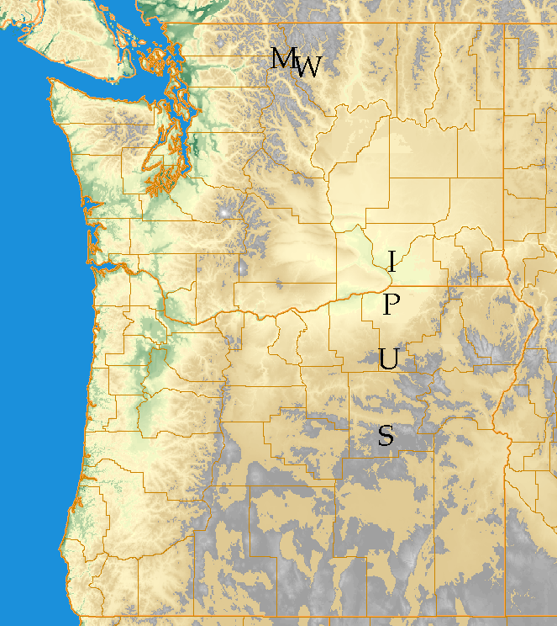
Figure T1: Extreme temperature locations of the Pacific Northwest. Cold temperature records have occurred at Mazama (M) and Winthrop (W), Washington and Ukiah (U) and Seneca (S), Oregon. High temperature records have occurred at Ice Harbor Dam, Washington (I) and Pendleton, Oregon (P)
of the Columbia Basin are usually warmer than Mazama and Winthrop. The elevation of the Methow valley also results in more frequent snow coverage during the winter than the lower Columbia Basin, with snow enhancing cooling in two ways. First, snow reflects much of the sun’s radiation away from the surface, promoting cooling during the day. The highly reflective nature of snow is obvious when skiing on a sunny day, with sunglasses being a necessity. Second, snow is an extraordinarily good emitter of infrared radiation and thus tends to be cool far more effectively than bare soil or vegetation. Finally, both Mazama and Winthrop are east of the Cascade crest, and thus are “protected” from the mild, marine influence that moderates temperatures over western Washington. For all of these reasons, the high mountain valleys east of the Cascades such as the Methow are often the coolest locations in the State.
The Oregon cold spots—Seneca and Ukiah—have much in common with the Methow since they are also located within high mountain valleys east of the Cascade crest (Figure T.4). As with the Methow Valley, radiative cooling to space over the surrounding snow-covered higher terrain cools air near the surface, which sinks into valleys and topographic bowls—in the case of Seneca, the bowl-shaped Bear Valley.
During the summer, the most extreme temperatures are found at the lower elevations of the Columbia Basin. Warm temperatures are favored east of the Cascades, since such locations are isolated from the cooling effects of the Pacific Ocean, which provides western Oregon and Washington with such temperate climes. But why are the lower elevations the warmest? During summertime days, surface radiational cooling to space is completely overwhelmed by the intense heating by the sun. Under such conditions, temperature decreases with height, with the warmest temperatures at the lowest levels. The lowest elevations are also warmed by compressional heating, since any air that descends into such low spots is compressed and thus warmed (just as a bicycle pump is warmed when air is compressed in it).
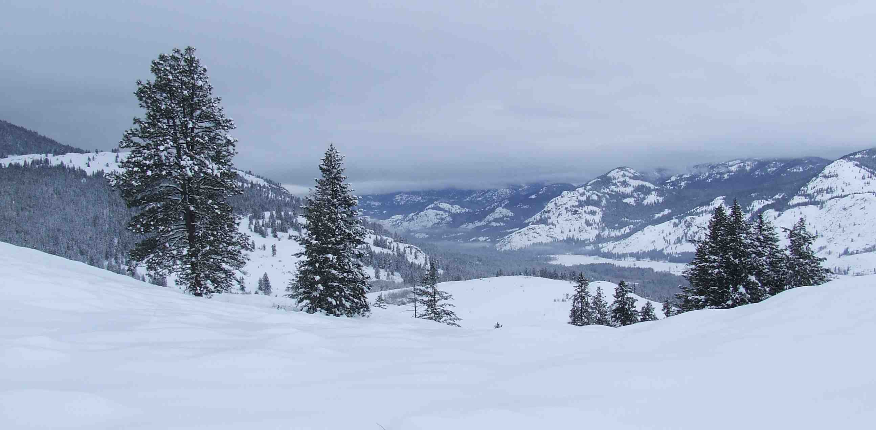
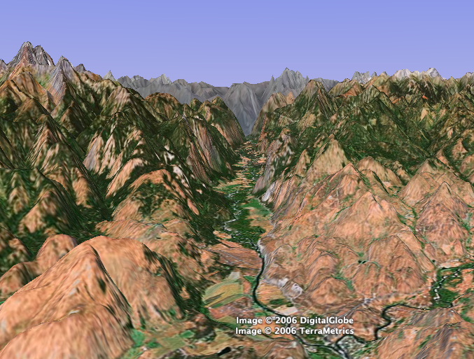
Figure T.2: The picture of the southern end of the Methow Valley on December 24, 2006 from Patterson Mountain (a). Three-dimensional image of the Methow Valley, viewed from its southern terminus and with the terrain exaggerated by a factor of three. Winthrop is at the valley entrance and Mazama is found at its northern end. Graphic produced using Google Pro.
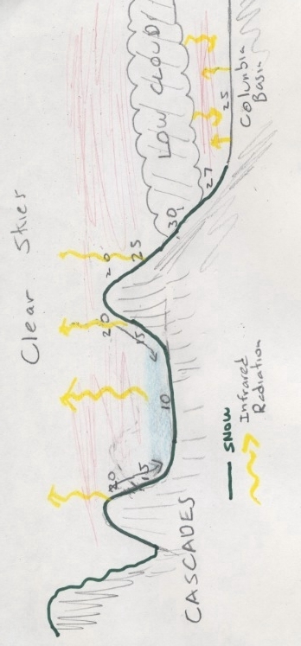
Figure T.3: Schematic of the origin of the cold temperatures in high mountain valleys such as the Methow. With higher, snow covered mountains around them, surface cooling under clear-sky conditions results in cold air sinking down the slopes and pooling in mountain valleys. In contrast, over the Columbia River Basin, a persistent covering of low clouds greatly reduces infrared cooling to space, as does the general lack of significant snow cover.

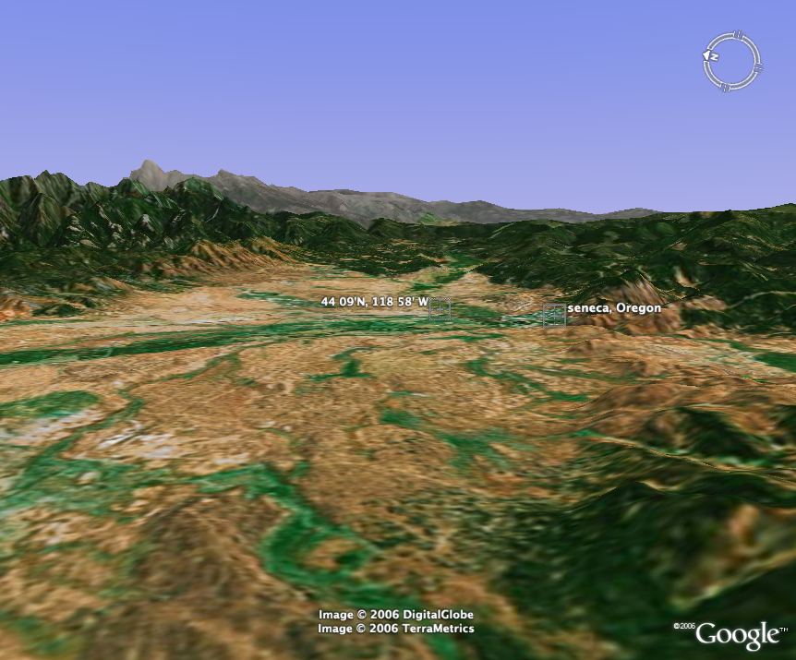
Figure T.4: Three-dimensional image of the Bear Valley, Oregon created by Google Pro. The view is facing the east and the terrain is exaggerated by a factor of three. Cool air often sinks into the valley, producing record cold at the cooperative observing location north of the town of Seneca (the observing site is found at the locations denoted by latitude and longitude: 44 09’N, 118 58’W).

