We thank both reviewers and the editor for insightful comments and suggestions that have helped to clarify some points in the manuscript and better put our results in the context of the existing literature. Please find the reviewer comments in red and our responses in black. We have repeated pertinent edited manuscript text in blue text to highlight how the Reviewer comments have been addressed in the edited manuscript.

Reviewer 1
Comments1. The response to volcanic eruptions is calculated over a period of up to 4 years following eruption (if I understood correctly).The response to volcanic eruptions, however, is known to have transient variations, both in the position of the ITCZ and in the intensity/width of the tropical rain belt, caused by the ENSO-like variations following eruptions, which are typically Niño-like in after the first year (i.e., leading to intensification and contraction) and Niña-like after the third year (i.e., leading to weakening and widening, Stevenson et al. 2016). I therefore don’t see justification for the general statement in lines 511-513, which is clearly sensitive to the methodology employed here. It could be that the authors intend to examine inter-annual variations next, which would include ENSO-like variations. I therefore ask that you either consider the transient response in the present analysis or clarify the limitations of the methodology used here and rephrase the statement on lines 511-513.

Thank you for the thoughtful comment. The Reviewer is correct that we calculate the precipitation response to volcanic forcing by averaging over a period of 4 years (provided an AOD of greater 0.02 is sustained for four years). This (up to) 4-year period is centered on the peak AOD. This methodology was intended to smooth out the transient evolution of the precipitation response to volcanoes while maintaining a signal that is robust over internal variability. Our intention was not to analyze the transient evolution of the hydrological response to volcanic forcing but agree with the Reviewer that the possibility that ENSO like response may contaminate the detection of a shift and we analyze this problem below.
The observational zonal and annual mean precipitation associated with a 2 standard deviation (σ) El Nino event – defined from the regression of a normalized deseasonalized Nino 3.4 index against the NOAA GPCP precipitation anomaly-- is shown in blue in Figure R1A. The optimal geometric mode characterization of this precipitation anomaly (defined from manipulating the climatological precipitation, shown in black) features a very small (0.08º Northward) shift and a substantial (C=0.93) contraction and weaker intensification (I = 1.03). We note that the Northward optimal shift seems at odds with the apparent southward shift of the Northern Hemisphere precipitation peak but that largest magnitude precipitation anomalies during El Nino are in the Southern Hemisphere tropics and those are consistent with a Northward shift of the Southern Hemisphere precipitation peak. The combination of these precipitation changes results in primarily an optimal contraction with a small shift. Therefore, if volcanic forcing does cause a transient El Nino, this would be primarily seen as a contraction of the precipitation and not a shift. We address this point explicitly with the following numerical exercise. We prescribe shifts ranging from 3º latitude southward to 3º northward and add a random realization – via 100 Monte Carlo simulations for each prescribed shift-- of ENSO associated precipitation (from Fig. R1A) with a magnitude that replicates the observational ENSO variability. The resultant optimal shift is plotted as a function of prescribed shift in Fig. R1B. While ENSO variability does have a modest impact on the detection of the shift, the standard deviation across Monte Carlo members is 0.1º latitude. Additionally, the shift mode explains the vast majority of the precipitation changes for any prescribed shift of great than 0.5º (not shown). For reference, the ensemble mean root mean squared precipitation change for the
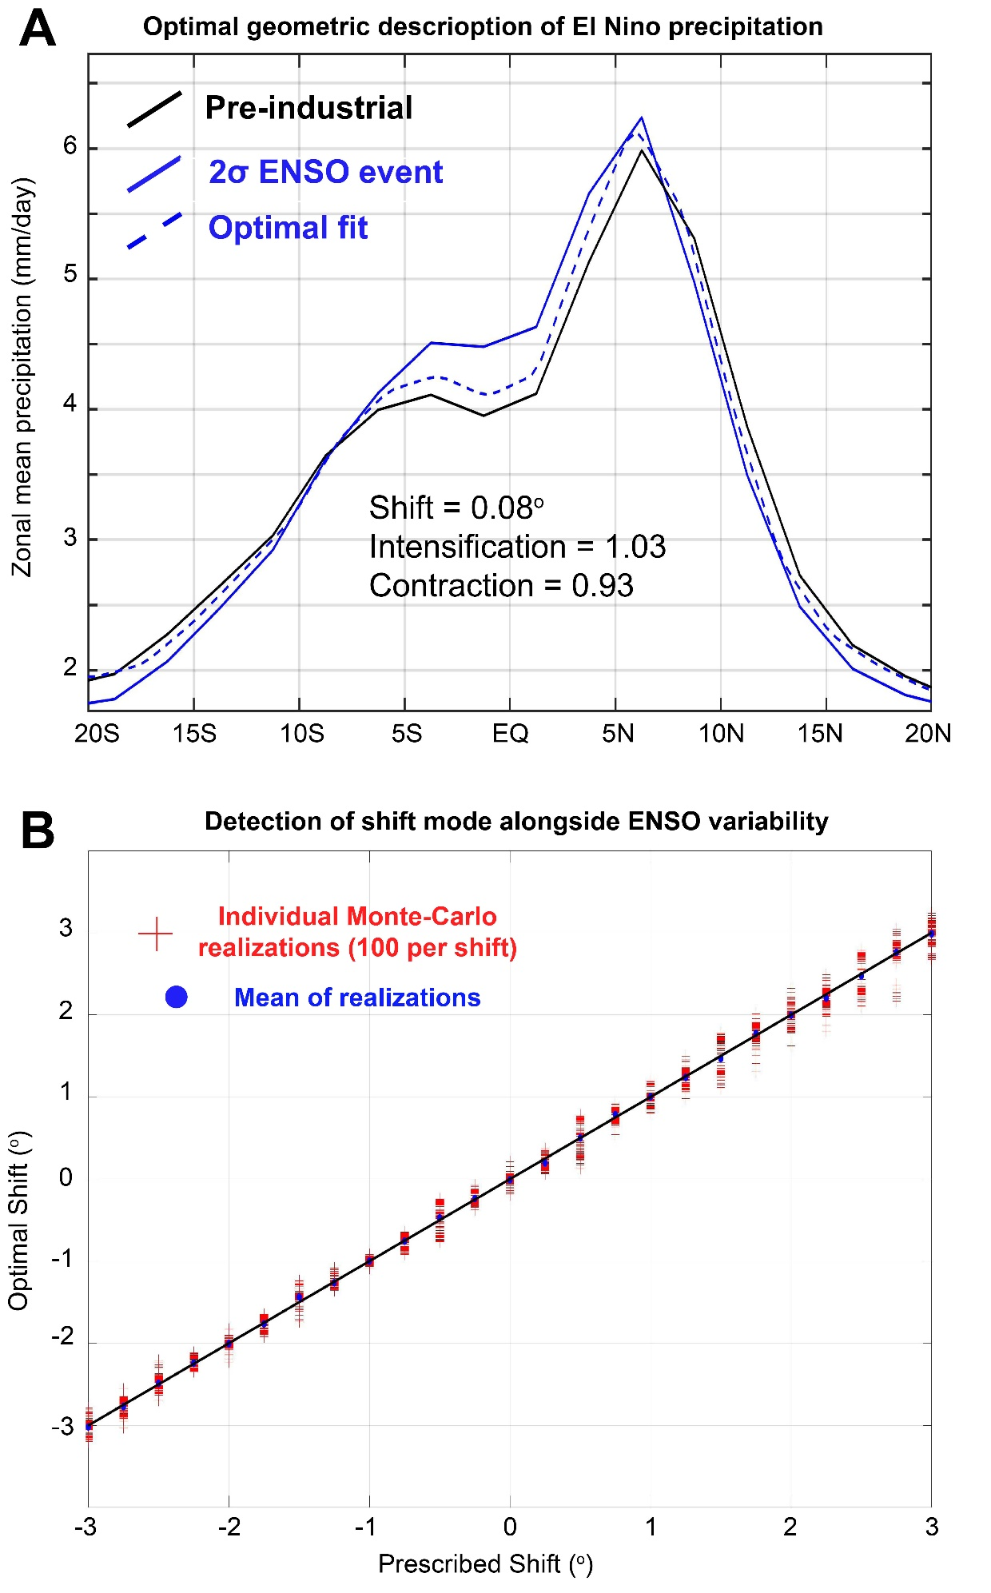
Figure R1. (A). The zonal and annual mean observed climatological precipitation (black) and that associated with a 2 standard deviation El Nino (solid blue line) as diagnosed from the regression of a Nino 3.4 index on the NOAA GPCP precipitation over the 1979-2018 time period. The optimal geometric mode fit to the El Nino precipitation is shown by the dashed blue line and the fit parameters are listed on the inset of the figure. (B) Prescribed versus analyzed optimal shift for a Monte-Carlo simulation with a prescribed shift and random realization of ENSO precipitation variability. The red crosses show the result of 100 Monte-Carlo realization for each prescribed shift.
volcanic eruption simulations is equivalent to that of 2º pure shift of the climatological precipitation. Thus, if the precipitation response to volcanic forcing was characterized by a shift, the shift should be detectable above the ENSO variability. These results suggests that ENSO variability does not contaminate the ability to detect a translation of climatological precipitation.

We have addressed the Reviewer’s comment in two places in the revised manuscript:

1) We have clarified our conclusion about the utility of the shifting mode for describing the tropical precipitation response to volcanic forcing (the original lines 511-513 that the Reviewer referenced) in revised Section 4.1.4.

“This result suggests that, while the tropical precipitation clearly redistributes precipitation away from the cooled hemisphere in response to extratropical volcanic forcing, the precipitation response to extratropical volcanic forcing is poorly characterized by a meridional translation of the climatological precipitation.
2) We have added citations and a discussion of the transient evolution of tropical precipitation to the discussion of the volcanic forcing simulations(Section 4.1.4)
Previous work has demonstrated that the precipitation response to volcanic forcing is ``El Nino like '' for eruptions in the NH (Stevenson et al., 2016) and it is possible that the methodology for defining the precipitation response to volcanic forcing used here includes a portion of the transient El Nino response. However, the tropical precipitation response to El Nino in observations is primarily characterized by a contraction of precipitation with a very modest shift (not shown) and, thus, it is unlikely that the transient ENSO response to volcanic forcing contaminates the diagnostics (or explanatory power) of the shift mode. Our general finding that the tropical precipitation is redistributed away from extratropical volcanoes and is reduced in response to tropical volcanoes agrees with the conclusions of Colose et al. (2016).

2. 717-721 It is not at all trivial. In some cases, it could simply be a ‘wet gets wetter’ response (Held and Soden 2006). Thus, the CI mode may have a strong thermodynamic basis, whereas ITCZ migrations are for the most part related to changes in the circulation/dynamics.
We address this comment in concert with our response to comment #3 below.
3. 460-563 One explanation for the CI mode that is worth exploring is that C and I are related to each other via the global conservation of precipitation minus evaporation (P-E). The sign of P-E follows the sign of the vertical wind and its subtropical roots mark the edge of the tropical region. It therefore could be that the relation between C and I, seen in the precipitation signal, result from the constraints on P-E.
Thank you for the suggestion to compare our results to the thermodynamic expectation of Held and Soden (2006). In the original manuscript, we did not explicitly compare the relationship between the contraction and intensification mode with the predictions for the thermodynamic scaling of precipitation minus evaporation. We include in the revised manuscript analysis, discussion and a figure addressing this point. We reproduce the pertinent text and figure of the revised manuscript here:
“We first evaluate the hypothesis that the tight relationship between C and I under climate change is a result of thermodynamic considerations. Following Held and Soden (2006), if atmospheric circulation and relative humidity are climate state invariant, then the change in precipitation minus evaporation, Δ(P-E) is given by:

∆ (P − E) = α∆T (P − E)

Where α is the linearized dependence of saturation vapor pressure on temperature in the Clausius Clapeyron equation and ΔT is the local temperature change. Hence, provided that the ΔT has a weaker spatial structure in the tropics then the climatological (P-E), thermodynamic constraints suggest that the spatial structure of (P-E) is climate state invariant but intensifies with warming and de-intensifies with cooling. Thus, thermodynamic constraints are equivalent to Δ(P-E) being explained entirely by a geometric mode akin to the intensification mode but acting on the climatological spatial distribution of (P-E) with no changes in the shape of (P-E).

The thermodynamic prediction for (P-E) under 4XCO₂ with scaling chosen to match the ensemble mean global integral of the absolute value of (P-E) is shown by the orange lines in Fig. 5. Under 4XCO₂, the change in E is nearly spatially homogeneous over the tropical domain (c.f. the solid red and dashed red line in Fig. 5A) and, thus, the changes in (P-E) mimic the spatial structure of ΔP. Importantly, the shape of Δ(P-E) differs significantly from the climatological (P-E) and, thus, the change in (P-E) predicted from thermodynamic constraints (orange line in Fig. 5B) is a poor match to that realized in model simulations (black lines in Fig. 5B). Specifically, the latitude of zero (P-E) robustly contracts toward the equator under 4XCO₂ and the bi-modal peaks in (P-E) also shift equatorward. Thermodynamic constraints explain only 25% of the ensemble mean Δ(P-E) under 4XCO₂ and 34% in the LGM simulations (not shown); similar percentages are found in individual models. This is roughly half of the fraction of the ΔP that is explained by a combined mode of contraction and intensification (53% for 4XCO₂ and 48% for the LGM) described in Section 4.3.

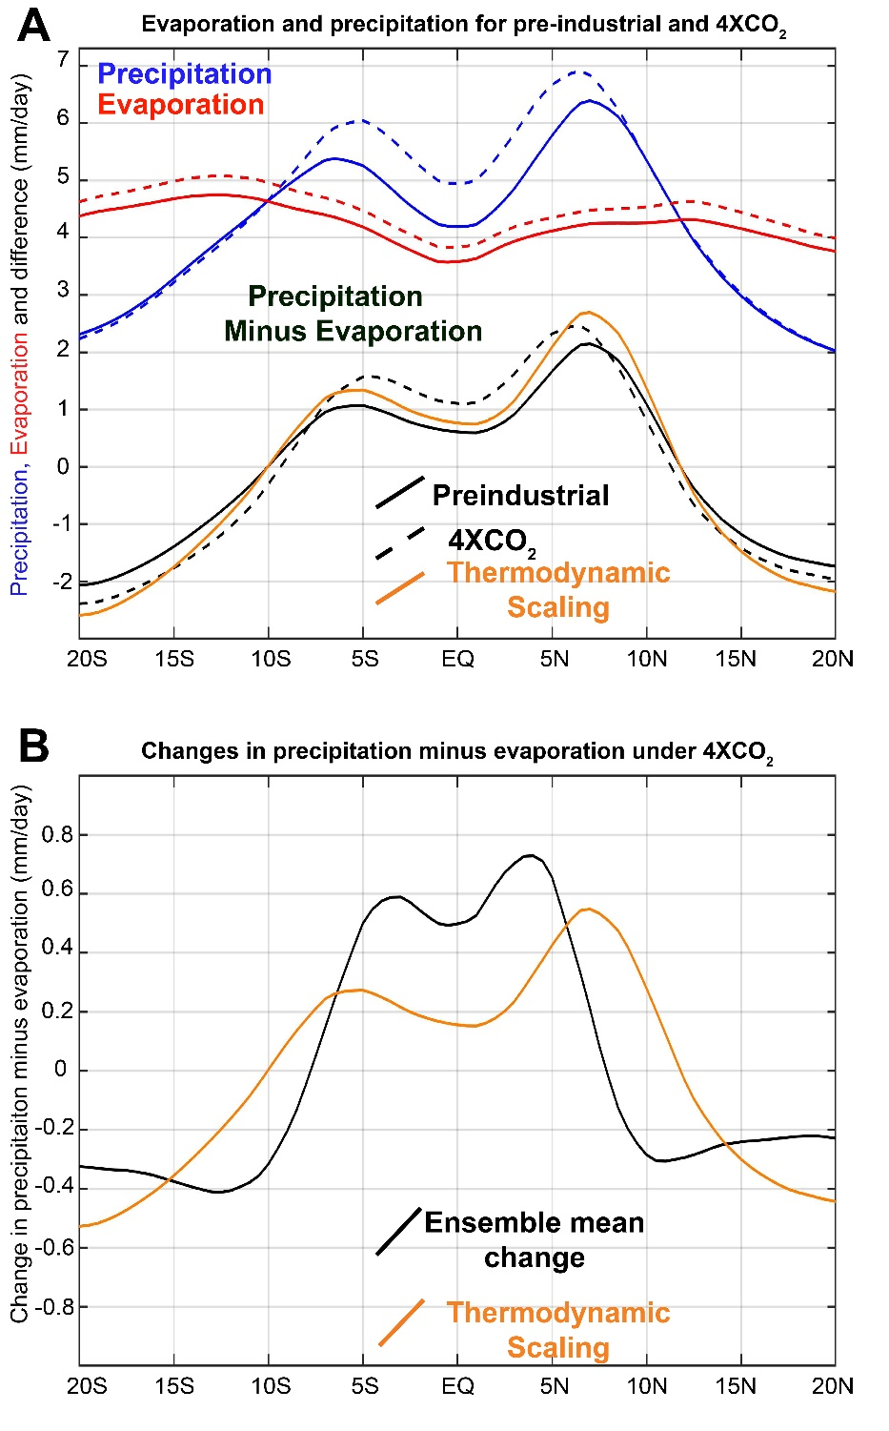
Revised Fig. 5: (A) Ensemble mean, zonal mean and annual mean precipitation (blue), evaporation (red) and precipitation minus evaporation (black) for the pre-industrial simulations (solid lines) and 4XCO₂ simulations (dashed lines). The thermodynamic scaling of Held and Soden (2006) which predicts precipitation minus evaporation will scale with water vapor content of the atmosphere is shown in the orange line. (B) The ensemble mean change precipitation minus evaporation (black) compared to the thermodynamic prediction.

We also modified the text on original lines 717-721 (referred to in Reviewer comment #2) to more explicitly address the greater utility of the intensification mode compared to the thermodynamic theory.

“Indeed, model simulations suggest that a decrease (increase) in precipitation proportional to the mean state precipitation throughout the tropics in response to global mean cooling (warming) is a good zeroth order hypothesis and has slightly more explanatory power for explaining the spatial structure of tropical hydrological changes than the thermodynamic constraints on (P-E) changes advanced by Held and Soden (2006) as discussed in Section 4.2.”

Comments by line52 The sensitivity of the authors to the inherently offensive nature of certain shades of pink is impressive.
Thank you.
84 Being a review, Schneider et al. (2014) is more suited for the citations in line 81. Also, the recent review by Kang (2020).
We have added a citation to Kang 2020 and removed the citations to the non-review papers except for the Chiang and Bitz (2005) citation which was the first demonstration of the ITCZ shift away from extratropical forcing in comprehensive models.
91power-weighted
Fixed.
97-108 This point is discussed and demonstrated in Adam (2021)
Citation added:
Adam (2021) recently demonstrated that the tropical precipitation changes in idealized model settings are better characterized by pulsing of the peaks rather than meridional translations for states that have bi-modal tropical precipitation peaks.
125 and elsewhere- - —> —
Fixed throughout.
132 analyses
Fixed.
242 )..
Fixed.
244 , and contractions
Fixed.

307, 308 and elsewhere C —> (as in Eq. 5). The same is true for S and I, which are inconsistently indented throughout the text.
Fixed throughout.
384 do you mean standard deviation of the ensemble mean (i.e., divide by the root of N) or standard deviation of the ensemble (which would make more sense)?
We meant standard deviation of the ensemble mean (divided by the square root of N) which we believe is the appropriate statistic for evaluation of the robustness of the ensemble mean changes.

465again, odd use of the serial comma.
Fixed.
534-536 I do not understand this explanation. Why would this reduce the sensitivity to tropical events? Also, Comment 1 above also applies to tropical events.
The energetic theory of (Schneider et al. 2014) states that the ITCZ location (assumed to be co-located with the energy flux equator) is a function of cross equatorial atmospheric energy transport (AHT_{EQ}) and the net energy input to the tropical atmosphere (NET_{TROP}) equivalent to the meridional gradient of the vertically integrated atmospheric heat transport):

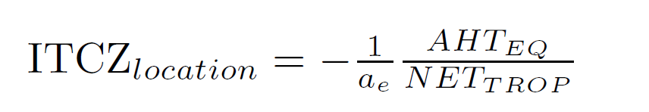

where a_{e} is the Earth’s radius (modified from Equation 2 of Schnieder et al., 2014). Thus, for a climate system with a climatological cross equatorial atmospheric energy transport, a change in the energy input to the tropical atmosphere would cause a change in the ITCZ location even in the absence of a change in cross equatorial atmospheric energy transport. A linearization of the above equation about the climatological values of AHT_{EQ} and NET_{TROP} and ITCZ _{location} (with bold to emphasize climatological values) gives:

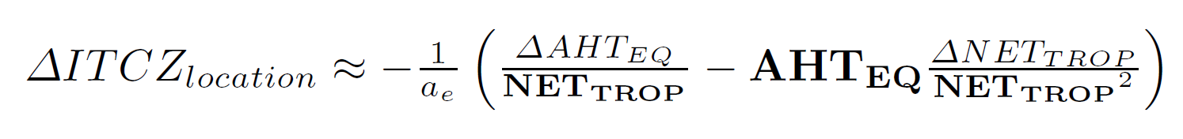
Substitution of the climatoligcal definition of the ITCZ_{location} from the first equation gives:

The sensitivity of ITCZ location to changes in tropical energy input is proportional to the mean state ITCZ location and the fractional perturbation in net energy to the atmospheric column. In physical terms, for a climate system with and ITCZ location on or near the equator (equivalent to zero AHT_{EQ}) changing the net energy input to the tropical atmosphere has minimal impact on ITCZ location since the ITCZ is nearly on the equator to begin with and there is little area in between the energy flux equator and the geographic equator.

656-660 cf. Adam (2021).
We thank the Reviewer for pointing us toward the work of Adam (2021) who points out that changes in precipitation centroid primarily reflect changes in the relative amplitude of peaks as opposed to shifts in the location of the peaks. We now cite Adam (2021) at the end of section 4 which has been revised to state:

Adam (2021) recently demonstrated that the tropical precipitation changes in idealized model settings are better characterized by pulsing of the peaks rather than meridional translations for states that have bi-modal tropical precipitation peaks.
and
Instead, the P_{CENT} changes primarily reflect opposing changes in the amplitude of the NH and SH tropical precipitation peaks (e.g. ΔP under freshwater hosing in Fig. 2B) as was recently demonstrated by Adam (2021).

We respectfully disagree with the Reviewer that the point made in the original lines 656-660 is consistent with the findings of Adam (2021). We are arguing in these lines that the precipitation centroid metric is more sensitive to changes in tropical precipitation as compared to the optimal shift. In contrast, Adam (2021) argues that: “In particular, the generally accepted idea of a damped (or “sticky”) ITCZ response in coupled models applies only to the precipitation centroid.”

In contrast, our work in the argues that the ITCZ location is even more “sticky” than the precipitation centroid metric. Regardless, both our work and Adam (2021) agree that the ITCZ shift paradigm is a poor characterization of tropical precipitation changes.

722Surely, there must be other works that qualify as ‘dynamics literature’ outside the immediate circle of the lead author.
Thank you for the suggested edit. Changed to:
A zonal mean ITCZ shift of 3º (as measured by changes in P_{CENT}) requires a sustained hemispheric asymmetry of atmospheric heating equivalent to a simultaneous doubling of CO₂ in one hemisphere and CO₂ halving in the opposing hemisphere (resulting in 1 PW of atmospheric energy transport across the equator) assuming no radiative feedbacks (which generally damp localized forcing, Donohoe and Voigt, 2015).
We only intended to cite the quantitative relationship between ITCZ location and cross equatorial energy transport and we agree that the phrase “dynamics literature” was misleading and perhaps arrogant.

Figures: inset fonts are too small. In particular Fig. 2c
The axis on Fig. 2c has been expanded to allow larger fonts on the inset.

Reviewer 2:
Overall, the motivation and the quantification procedure are written very clearly. I do think, however, a more physical-based discussion that connects the mathematic quantification in the manuscript and the current literature would improve the manuscript.
For example:
1. The differences between shifts in precipitation centroid and precipitation peak have been discussed in a few pieces of literature:
Adam 2021 suggests the ocean may damp the shifts in precipitation centroid but amplifies shifts of precipitation peak.
Thank you for pointing us toward this publication; it clearly demonstrates tropical precipitation changes are better characterized by changes in the amplitude of precipitation peaks as opposed to shifts for climate states with bi-modal tropical precipitation peaks. We have added citations to this publication in the introduction and discussion sections of the revised manuscript:
Adam (2021) recently demonstrated that the tropical precipitation changes in idealized model settings are better characterized by pulsing of the peaks rather than meridional translations for states that have bi-modal tropical precipitation peaks.
And.
Instead, the P_{CENT} changes primarily reflect opposing changes in the amplitude of the NH and SH tropical precipitation peaks (e.g. ΔP under freshwater hosing in Fig. 2B) as was recently demonstrated by Adam (2021).

Hwang and Chung 2021 show the seasonal dependency of the shifts in precipitation centroids could be explained by the cross-equatorial transport whereas the shifts in precipitation peak behave differently.
We address this comment below in our response to the next comment since we believe the Reviewer is referring to the definition of shifts in precipitation peak defined as the N=10 power weighted precipitation latitude in both cases.
The authors may consider discussing the references above. The optimal shift S may be more comparable to the shift in precipitation peak (N=10 in Equation 1 in Adam et al. 2016, J. Climate).
The change in N=10 power-weighted precipitation latitude (hereafter change in “ITCZ” ) is co-plotted against the optimal shift for the ensemble of simulations analyzed in this manuscript in Fig. R2 (below).
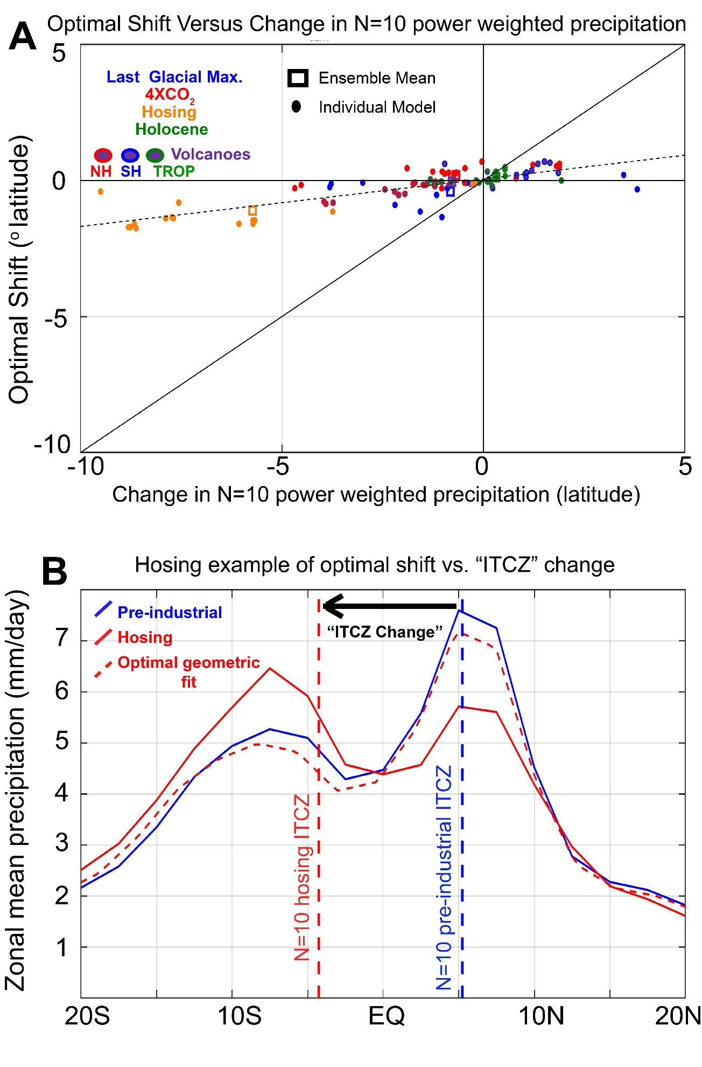
Figure R2. (A) Scatter plot of optimal shift in tropical precipitation (ordinate) versus change in N=10 precipitation power weighted latitude (abscissa) for the forced climate model simulations considered in the manuscript. (B) An example of the discrepancy between the optimal shift and power weighted latitude change from a freshwater hosing simulation. The pre-industrial precipitation is shown in blue and the precipitation after hosing is shown in red with the optimal geometric fit to the perturbed precipitation shown by the dashed red line. The precipitation power weighted (N=10) latitude is shown by the vertical blue and red lines respectively; the difference is defined as the “ITCZ change” and is shown by the black arrow.
The change in “ITCZ location” (N=10 power-weighted latitude) is significantly correlated with (R=0.79) with optimal shift. However, the change “ITCZ location” is substantially larger in magnitude by an average factor of approximately 6 (the regression coefficient of the linear best fit in Fig. R2A is 0.17). This discrepancy between the magnitude of S and the change in “ITCZ location” can be visualized in the example from the precipitation change from freshwater hosing simulation shown in Fig. R2B. In the pre-industrial simulation, the tropical precipitation is bi-modal with a larger magnitude peak in the NH and the ITCZ location is near the larger magnitude peak (dashed blue line). Under freshwater hosing, the amplitude of the NH tropical precipitation peak decreases and the amplitude of the SH precipitation peak increases. As a result, the “ITCZ location” is identified closer the SH peak (dashed red line). The latitudinal position of the two peaks has not changed appreciably – consistent with the finding of Adam (2021). As a result, the optimal shift that we diagnose is very small (-0.5º) since a meridional translation of the climatological precipitation cannot fit the change in precipitation. In contrast, the diagnosed change in “ITCZ location” is large ( -9.5º) and primarily reflects changes in the amplitude of the two peaks.
We have added the following text to the discussion to address the comparison between the optimal shift and the change in “ITCZ location”:
We note the magnitude of S is also smaller than the precipitation power-weighted latitude (Adam et al., 2016) -- by a factor of 6 for N=10, not shown-- a metric that responds (more sensitively for higher N) to the relative magnitude of the bi-modal tropical precipitation maxima.
Also, in the discussion sections we have revised the text to state:
Adam (2021) demonstrated that common metrics of ``ITCZ shifts'' respond to tropical precipitation changes that are best characterized by changes in the relative amplitude of bi-modal tropical precipitation peaks in the absence of changes in the location of the peaks. These precipitation changes warrant further study from a dynamics perspective and should be viewed as distinct from an ITCZ shift, in it's most literal sense.

We are unsure how to reconcile our results with the dynamical mechanisms highlighted by Hwang and Chung (2021) since their work focuses on the change in ITCZ location as diagnosed from the N=10 precipitation power weighted latitude which is poorly captured (in magnitude) by our methodology.
2. The hemispherically symmetric and asymmetric components have also been discussed. Adam et al. 2016 (GRL) compare the two components' contribution to the double ITCZ biases. They also provide physical explanations for factors influencing the individual components.
We are somewhat reluctant to make a comparison between our results and those of Adam et al. (2016) for the following reason: the equatorial precipitation index used in Adam et al. (2016) – defined as the magnitude of precipitation within 2º of the equator relative to that in the rest of the tropical domain – is sensitive to both the intensification and contraction mode. Therefore, we are reluctant to compare forced changes in C and the inter-model spread of mean state equatorial precipitation index without further analysis. We note that, that C and I defined to optimally explain the inter-model spread (relative to the inter-model mean) are only weakly (but significantly) correlated (R=0.5) but with a linear best fit slope that is significantly weaker (C= -0.3I, Fig. R3) compared to that found in this study from the forced simulations (C=-0.8I, manuscript Fig. 3B).
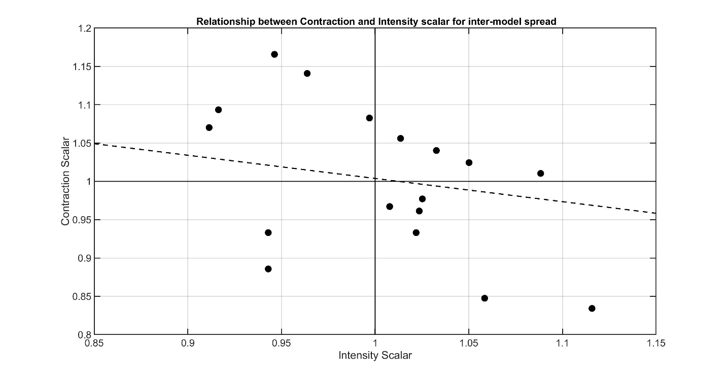
Figure R3. Relationship between contraction and intensification scalars for the optimal geometric description of the inter-model spread of the mean state tropical precipitation in CMIP5 pre-industrial models. The optimal parameters are defined relative to the CMIP5 ensemble mean precipitation.
We have added the following text to the discussion section to acknowledge the work of Adam et al. (2016):

Adam et al. (2016) found the models with more meridionally contracted mean state tropical precipitation had enhanced net energy input into the tropical atmosphere which is consistent with enhanced GMS leading to contraction of the tropical precipitation.

Sun et al. 2013 report the significant and distinct variations in the two components of tropical precipitation in the observational data. The key difference between these studies above and this manuscript is (probably) that the modes defined in this study are based on the climatological rainfall distribution, whereas the hemispherically symmetric and asymmetric components are based on rainfall anomalies. How do the authors interpret the differences?

Sun et al. (2013) analyze the hemispherically symmetric and antisymmetric modes of inter-annual (zonal mean) sea surface temperature and the tropical precipitation anomalies associated with the hemispherically asymmetric SST mode. We cannot compare our results on the CI mode to those of Sun et al. (2013) for two reasons: i. Sun et al. (2013) did not present the precipitation anomalies associated with the hemispherically symmetric SST mode (only the SST patterns) and; ii. Sun et al. (2103) analyze inter-annual variability (in observations) whereas we analyze (simulated) forced changes at climatological timescales. We demonstrate below that the dominant spatial pattern of observed inter-annual variability in tropical precipitation has substantially different geometric structure than that identified in the ensemble of forced changes. Specifically, the contraction and intensification scalars of observed (NOAA GPCP) tropical precipitation (with modes defined relative to climatological precipitation) do not follow the same relationship between C and I identified in the forced simulations (Fig. R4) but rather feature larger amplitude contractions/expansion scalars relative to the intensification scalar -- which are more consistent with the relationship between C and I expected from conservation of tropical domain averaged precipitation. For this reason, we prefer to not speculate on the connection between contractions and intensifications of tropical precipitation on inter-annual timescales and the response to long-term forcing without further analysis.
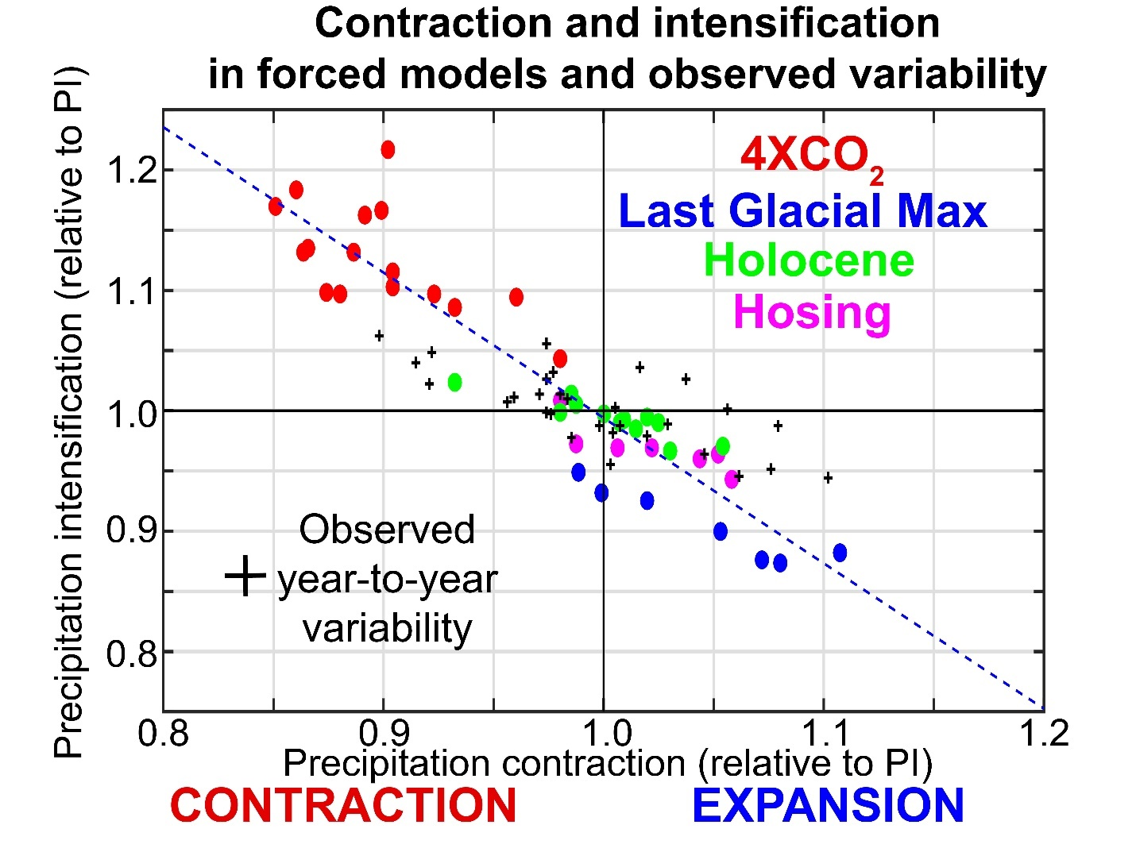
Figure R4. The optimal intensification scalar (abscissa) versus contraction scalar (ordinate) for forced climate mode simulations (colored by experiment type) and for the inter-annual variability in observations (black crosses), where each cross represents a 12 month average. In the forced simulations, the optimal parameters are defined relative to the precipitation in the preindustrial control simulations in the same model whereas the interannual parameters are defined relative to the climatological mean precipitation taken from the NOAA GPCP product.
3. Is there a theoretical reason to expect that the changes in precipitation should be based upon climatological precipitation?
We chose to define the modes of tropical precipitation relative to the model specific precipitation climatology because models with different climatologies will have different spatial patterns of precipitation anomalies for the same geometric change in precipitation. Our choice to define the modes relative to climatology in the specific model was motivated by geometric interpretation of the changes in precipitation rather than the underlying dynamics of the relationship between forced changes and tropical mean state bias (which we think are interesting and important but outside the scope of this more descriptive manuscript).
I can see the wet-get-wetter responses offer a physical explanation for the "intensification mode". How about the other two modes?
Please see our response to Reviewer 1’s comments 2 and 3 for a discussion of the how the “wet-get-wetter” theory relates to the CI mode. In summary, the “wet-get-wetter” response: i. has less explanatory power for forced changes in tropical precipitation than does the intensification mode and; ii. does not explain the contraction and expansion of tropical precipitation under global warming and cooling.
The connection between the shift mode and the energetic theory of the ITCZ is discussed in the manuscript (e.g. the second paragraph of the introduction and fifth paragraph of the discussion section). Possible mechanisms underlying the contraction mode (and why it might be related to the intensification mode) are reviewed in the 7th paragraph of the discussion section – beginning with the question “What mechanism accounts for the tight coupling between the contraction and intensification seen across the ensemble of forcing experiments?”
For the shift mode: The anomalous cross-equatorial cell predicted by the energetic framework (Kang et al. 2008) would lead to an increase/decrease in precipitation over the region of anomalous upward/downward motion. Wouldn't the changes in strength in the two peaks (as discussed in the text in this manuscript or the hemispherically asymmetric mode) be expected?
Our apologies but we do not understand the mechanism being referred to by the Reviewer. The theory of Kang. et al. postulates that the energy flux equator and ITCZ location shift in concert (by the same amount) in response to extratropical forcing (in a climate system with no seasonal cycle). This theory was motivated by idealized simulation with a single (unimodal) tropical precipitation peaks. We are unaware that this theory addresses the change in magnitude of the tropical precipitation peaks (which is evident in their Fig. 2A) or the expected changes in tropical precipitation in a climate with bi-modal tropical precipitation peaks. Our apologies if we have misunderstood the Reviewer’s comment here.

On the other hand, Schneider et al. 2014 derive a theory that links the position of ITCZ with the position of the energy flux equator.
This component of the Schneider et al. (2014) theory is consistent with Kang et al. (2008) who state in their conclusion: “the latitude of the energy flux equator where the atmospheric energy transport vanishes… provides insight into the position of the ITCZ.”

In a way, the shift in rainfall maximum is more tightly linked with the theory than the optimal shift S introduced by the author. More discussions linking the three indices with the physical mechanisms would be helpful for the readers. Is it possible that the small fraction explained by the shift mode is because it's too strong of a function of the climatological precipitation distribution? Would the shift in precipitation peak or the hemispherically asymmetric changes in rainfall be more appreciate indices that could be explained by the theories?
The intended purpose of our manuscript (as stated in the introduction) is to quantify how well a meridional shift (as well as contraction and intensification) characterizes the simulated changes in tropical precipitation. The shift is defined as a meridional translation of the climatological precipitation with no change in shape and we repeat this definition in several places throughout the manuscript to emphasize our definition of shift. Under this definition, the optimal shift S and the change in the location of the peak in precipitation are identical if the shift mode was acting alone. We apologize in several places to the reader if our interpretation of what is meant by a shift in the literature is overly simplistic and urge future studies – in both ITCZ dynamics and in paleoclimate studies -- to clarify the intended meaning of an “ITCZ shift”.
The manuscript is meant to be descriptive (in a quantitative sense) as opposed to mechanistic. We believe we have cited possible relevant mechanisms identified in the literature appropriately. A mechanistic understanding the dynamics of the CI mode is beyond the scope of the present work.
Other minor suggestions:
1. The three modes are explained very clearly and yet almost repeatedly in the manuscript. Consider shorten some of the descriptions.
We intended to be very clear how we are using the terms “shift”, “contract” and “intensify” to avoid any confusion over our terminology and that used elsewhere in the literature (see response to the Reviewer’s final comment above). We prefer to maintain clarity of our terminology at the expense of possible repetition.
2. Line 749 "uncer" should be "under"
Fixed.

