We thank Reviewer one for his/her thoughtful comments and keen editorial eye. The Reviewer’s suggestions have helped us craft a clearer manuscript, especially in regard to the choice of phase used to define the seasonal amplitude. Below, we list the Reviewer’s comments in red and our responses in black.
1. The definition of amplitude used here is somewhat odd.
Footnote 1 combined with the relatively uniformity of the
phase of the energy flux terms in Figs 6&7 have convinced
me I should not worry about this too much. However, I would
recommend at least the following:
(a) Confirm and note the qualitative result using the annual cycle
of temperature to fix phase.
The seasonal amplitude of atmospheric heating in phase with the annual harmonic of column average energy at the same latitude is shown below. The qualitative results found in manuscript using the insolation phase to define the seasonal amplitude are confirmed in the temperature phase metric of the seasonal cycle. This result is unsurprising, because the temperature lags the insolation by of order 30-40 days and thus the annual cycle of heating projects favorably onto that in temperature (column energy).
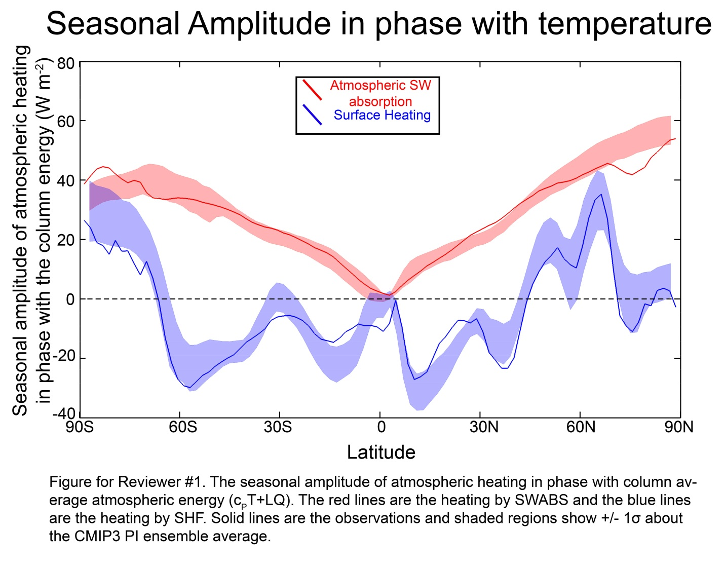
(b) reference Fig.6&7 early on, when "amplitude" definition first
comes up, so that the reader can at least convince themselves
that what you are doing is reasonable before they get into
results.
This suggestion has been incorporated into the revised manuscript.
(c) Add line to figures 6 & 7 (upper panels) to indicate the peak
of the reference sinusoid (presumably the summer solstice),
to make it easy to eyeball what fraction of the energy of
each of the annual terms is captured by this approach.
Done.
2. Line 191 ==>
Would be useful to compare this 21% to fraction absorbed at the surface.
Added to the text. 49% is absorbed at the surface and 30% is reflected back to space.
Also - how does this 21% SW absorption break down in terms of
component that is absorbed on the way up vs. component that is
absorbed on the way down?
We are unaware of a publication that addresses this issue. Using the isotropic shortwave model of Donohoe and Battisti (2011) we find that 92% of the shortwave absorption within the atmosphere is accomplished on the first downward pass through the atmosphere and the remaining 8% is accomplished in the subsequent passes (any path after the first reflection off the surface – an infinite number of reflections are accounted for) . A spatial map of the % of SWABS accomplished on the first downward pass is shown below. If anything, more radiation is accomplished on the initial downward path since this model assumes a fixed percentage of the radiation is absorbed on each pass and there is evidence that the water vapor shortwave absorption bands become saturated.
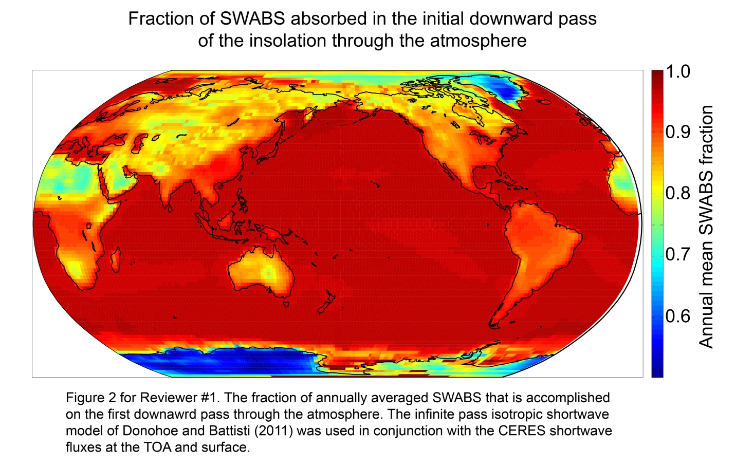
3. Lines 207-209 ==>
In this statement when you talk about
"energy that the ocean receives directly from the sun"
are you talking about just the absorbed component?
or the entire incident component?
We have changed “received” to “absorbed”.
It would be useful to quantify here by what fraction
seasonal energy storage amplitude exceeds the
seasonal exceeds the amplitude of either the
annual cycle of incident or absorbed seasonal
solar energy component.
The seasonal energy storage in the ocean exceeds the amount of shortwave radiation absorbed at the surface by as much as 30% (zonal average) in the Southern ocean . This statement has been added to the text. Nice suggestion-- thanks!
4. Figure 1 suggests that the SWABS term is all coming from above,
omitting the contribution of SW absorption that reflects off the
surface and is absorbed on its way back out.
See point 2 above. A discussion of this result has been added to the manuscript.
Typos and such
1. Typo line 13. "northern"
Fixed.
2. The column shortwave energy absorption term is sometimes written
with space "SW ABS" and sometimes not "SWABS"
This is a latex issue; no occurrences of SW ABS with a space are found in the source file.
3. Figure 2 - some graphics issue in the upper plot (white triangles
of missing ink)
This is a pdf rendering issue; the native files have no missing ink.
4. Typo line 194 (absorbptivity)
Fixed.
5. Line 204 ==>
suggest change "radiation at" to "absorption by"
Changed.
6. Figure 3 - Typo in both right hand side panel's y-axis labels
("total").
Fixed.
7. Figure 4 - Should refer to left panel before right panel.
Changed.
8. Line 235 - Typo - repeated word.
Fixed.
9. Line 380 - suggest changing "amplitude" to "magnitude"
Changed.
10. Figure 6 - typo in upper panel titles (cylcle)
Fixed.

