Atmospheric interaction with sea ice
The atmosphere can both force and respond to sea ice variability; internal variability of the atmosphere can initiate sea ice loss events and the atmospheric response to sea ice loss can either amplify or damp an initial ice loss events, thus impacting the persistence of sea ice anomalies. Here, we focus primarily on how the atmosphere responds to sea ice loss events but the proposed analysis does not preclude the possibility that the atmosphere can force (i.e. initiate) ice loss events. Specifically, we propose two diagnostic metrics of how the atmospheric processes feedback on sea ice loss events that can be calculated from observational fields and model output alike to facilitate an evaluation of model processes: 1. the impact of sea ice anomalies on the radiative heating of the climate system – the surface albedo feedback and 2. the change in lateral atmospheric energy fluxes between the Arctic and mid-latitudes resulting from enhanced upward turbulent energy fluxes in regions of ice melt – F_{WALL}. We expand on the calculation of each of these quantities below and present some initial observational results. We emphasize that the strategy of the proposed work is to compare the observational and coupled model atmospheric response to Arctic ice loss events to evaluate how model biases in the surface albedo feedback and the F_{WALL} response to ice loss might result in sea ice persistence biases in the models.
Ice retreat exposes the darker ocean surface to the sun resulting in enhanced absorbed solar radiation in the climate system. We quantify the ice albedo feedback as the change in planetary albedo (α_{P}) – the amount of solar radiation reflected at the top of atmosphere (TOA)-- that results from a unit change in surface albedo (α). In order for a surface albedo change to impact the energy budget of the climates system (i.e. change α_{P}), solar radiation must pass from the TOA to the surface – a process that can be impeded by solar reflection off clouds and solar absorption by atmospheric constituents—be reflected at the surface and then pass back upward through the atmosphere. In this respect, the impact of sea ice anomalies on the ASR that is quantified by the ratio of α_{P} to α is equal to the atmospheric transmissivity squared since clouds and atmospheric constituents can impede the surface albedo feedback on the both the downward and upward paths between the surfaced and TOA . This conceptual framework was formalized by Donohoe and Battisti (2011) and allows for the separation of the of impact of clouds and changes in α on the ASR in the climate system using satellite observations and standard climate model output alike. In the global average, the ratio of surface contribution to α_{P} to α (i.e. transmissivity squared) is 0.65 where as in the cloudy Arctic the value is of order 0.3. In the proposed work, we will compare the surface albedo feedback (α_{P}/α) in coupled model simulations and observations. Our working hypothesis is that model biases in the basic state atmospheric opacity over the Arctic result in too strong of a positive ice albedo feedback and, thus, result in increased persistence of sea-ice anomalies.
Figure XXX shows observational estimates of Arctic averaged anomalies in α, α_{P} and the direct impact of surface albedo anomalies on α_{P} (using the partitioning method above) over the CERES satellite record. All quantities are expressed in units of ASR (W m⁻²) by multiplying by negative insolation. On average, the anomaly in α_{P} that results from the α anomaly (purple line) is about 20% of the α anomaly (blue line) which is roughly consistent with the expectation based on the basic state atmospheric transmissivity. We also find that the planetary albedo (red line) associated with an ice loss event is substantially larger than the direct contribution of surface darkening which implies that a reduction of cloud reflection during ice loss events amplifies the radiative impact of ice loss. This conclusion is supported by analysis of the spatial pattern of radiative anomalies whereby the surface albedo feedback is limited to the ice edge region where ice has been lost (Figure XX D) whereas the ASR anomalies over the central Arctic (were there are limited ice concentration changes) are attribute to changes in clouds concurrent with the ice retreat (Figure XXE).
In the climatological average, the Arctic region has a radiative deficit of approximately 110 W m⁻² (Serreze et al. 2007) that is primarily balanced by the import of energy in the atmosphere (F_{Wall} = 100 W m⁻²) and secondarily by the ocean energy transport into the region (10 Wm⁻²). We anticipate that, as ice melts and energy is fluxed upward from the surface to the atmosphere, the atmosphere will remove some portion of this energy and this feedback will cool the atmosphere above the ice loss thereby damping the initial ice loss. We hypothesis that the amplitude of this damping mechanism may result in model biases in the persistence of sea ice anomalies. In the proposed work, we will compute the F_{WALL} anomalies accompanying Arctic sea ice losses from three sets of reanalysis (ERA, NCEP and MERRA) and compare these results to the same quantities in coupled model simulations. While our focus will be on the zonal mean F_{WALL}, a novel methodology developed by Donohoe and Battisti (2013) provides an analysis of the vertical at longitudinal structure of atmospheric energy fluxes that will provide further insight into the coupling between F_{Wall} and the ocean surface and the localization of the lateral energy fluxes and sea ice anomalies.
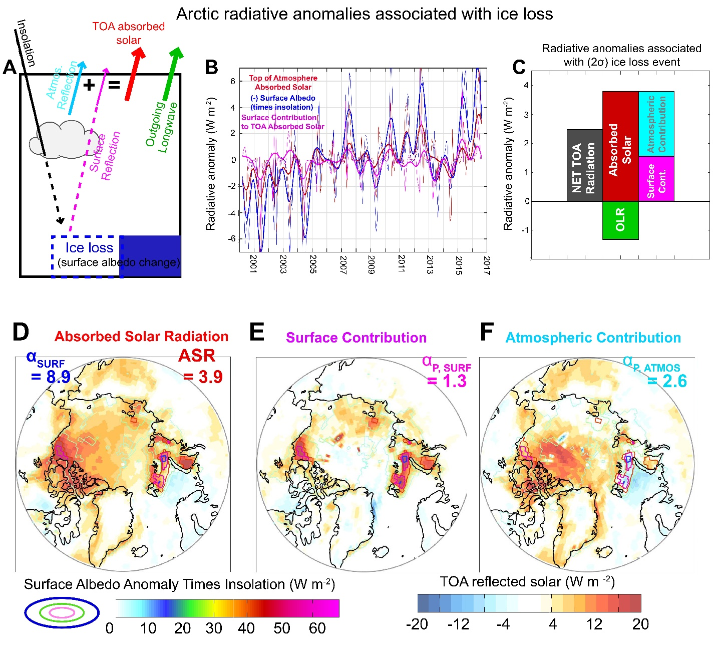
Figure 1: (A) Schematic for decomposing solar fluxes at the top of atmosphere into contributions from surface
albedo (purple line) and atmospheric reflection (cyan line). (B) Time series of anomaly in Arctic averaged (blue)
surface albedo, (red) TOA absorbed solar radiation (purple) surface contribution to TOA absorbed solar radiation from CERES. All data are expressed as Arctic averaged radiative anomalies into the TOA by multiplying the (negative of) surface/planetary albedo anomalies by insolation. Thin lines are monthly means and thick lines are low pass filtered with a 1 year cutoff period. (C) Arctic averaged radiative anomalies associated with “typical” (2σ) ice loss event. The (gray) net radiation at TOA is subdivided into (green) longwave and (red) shortwave contributions and the shortwave is further decomposed into (purple) surface and (cyan) atmospheric contributions to ASR. (D-F) Spatial maps of (D) absorbed solar radiation – ASR, (E) surface contribution to ASR (F) atmospheric contribution to ASR associated with an Arctic wide a anomaly. The contours show the spatial map of the surface albedo map with contour interval of 15W m⁻² and the domain average values (in W m⁻²) are given in the upper corners.

References

Donohoe, A., and D. Battisti (2011), Atmospheric and surface contributions to planetary albedo., J. Climate, 24(16), 4401–4417.

Donohoe, A., and D. Battisti (2013), The seasonal cycle of atmospheric heating and temperature, J. Climate, 26(14), 4962–4980.

Serreze, M., A. Barrett, A. Slater, M. Steele, J. Zhang, and K. Trenberth (2007), The large-scale
energy budget of the arctic, J. Geophys. Res., 112, doi:10.1029/2006JD008230.

