We want to thank both reviewers for their very thorough and insightful comments and suggestions for improvement of the revised manuscript. The depth of the reviewer’s knowledge of the subject area and the care both took in reading the chapter is very clear and we are grateful for their efforts. We have tried to incorporate all of the suggestions into the revised chapter and believe it is much improved as a result.
Our responses (in black) to the reviewer’s point by point comments are below:

Reviewer 1:
Since this is a book chapter, I suggest the authors to spell out the formula for the 3° per PW scaling upfront when they first discuss it (probably in Section 2). According to Schneider et al, it is simply
δy=(AHT_0)/(S_0-L_0-O_0),
where, subscript 0 indicates the latitude at which the Taylor expansion is conducted around, and the denominator can be also approximated to be d/dy(AHT_0), if the storage effect of the atmosphere can be neglected. S, L, and O are the net short wave, long wave fluxes, and the ocean heat uptake, respectively.
While we certainly appreciate the theoretical framework provided by the (influential) Schneider et al. review, we consciously wrote the chapter to emphasize the empirical evidence for the 3º PW⁻¹ relationship across timescales (and between models and observations) in the beginning of the manuscript and then pursue the theoretical underpinnings of the result later on (Section 3). We stand by this approach since, as emphasized throughout the manuscript, the linearization about the annual mean as done by Schneider et al. disagrees with the results presented by a factor of 3. Since Schneider et al. never make a quantitative prediction, we believe that starting with this theoretical framework to immediately demonstrate its quantitative shortcomings would begin the chapter with a negative result and requires introducing a complex explanation that may lose readers. Instead, we offer the result as an empirical take home message (how hard it is to move the ITCZ by more than a couple degrees) and then provide a discussion of the reasons why later on. We have expanded the discussion of reconciling the result presented with those of Schneider (more below) in the revised chapter.
In addition, I feel that section 3.2, although interesting, detracts the focus on the core issue---the location of the ITCZ. I would suggest the authors replace this section with more in-depth analysis of why the ratio of δITCZ/AHT0 is a factor of 3 less than would be expected from a linearization about the annual mean climatology. More specifically, they may linearize the problem with respect to the monthly climatology. I believe they will find that the ratio will fluctuate around 3° per PW as the season evolves, not 10° per PW derived from the linearization about the annual mean state. This is the only major suggestion. The remaining points are all minor.
Thank you for this insightful suggestion. We had not previously done that analysis and it is indeed helpful to the argument advanced in the chapter. We show (Figure R1) the annual mean and extreme seasons (JJA and DJF) meridional profiles of AHT below along with their linearization about the energy flux equator (dashed lines) and the slope implied by the 3ºPW⁻¹ (purple dashed lines) relationship discussed in the chapter. As suspected by the reviewer, the meridional slope at the extreme seasons imply an ITCZ sensitivity of 4.2 and 4.3ºPW⁻¹ (dashed red and blue lines) which are much less sensitive than the annual mean linearization (order 10º PW⁻¹ – dashed black line) but still more sensitive than the result seen in the chapter. We believe the remaining mismatch is a result of the separation of the energy flux equator and ITCZ. We have added the following text to the chapter to incorporate this result (in the introduction to section 3):
“If the meridional pattern of AHT (from NCEP reanalysis) is linearized about the location where the AHT is zero (the energy flux equator) during the extreme seasons (JJA and DJF), the implied ITCZ sensitivity is 4.2 and 4.3 º PW⁻¹ respectively (not shown), in closer agreement to the empirical result of 3 º PW⁻¹ demonstrated here but still a higher sensitivity due to the energy flux equator moving farther off the equator than the ITCZ during the extreme seasons.”

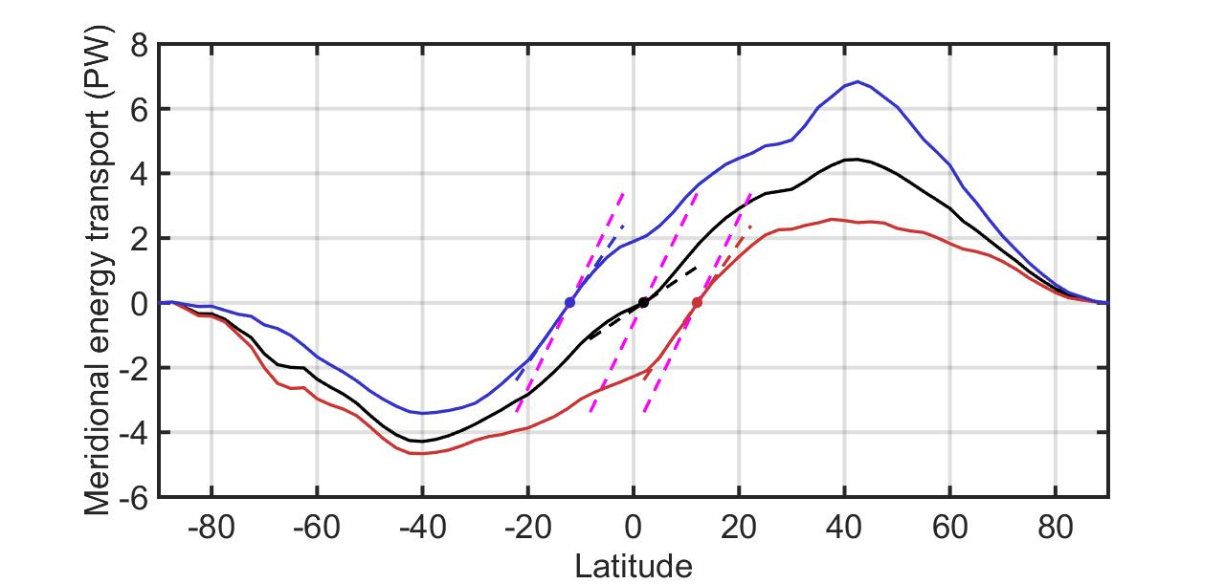
Figure R1. The meridional profile of atmospheric energy transport in the (black) annual mean, (blue) boreal winter (December-January-Febraury) and (red) boreal summer (June-July-August). The dashed lines show the linearization about the zero crossing (energy flux equator) for each curve and the purple lines show the slope implied by the 3º latitude per PW scaling assuming that the ITCZ translates alongside the pattern of the AHT around the energy flux equator. All calculations are performed from the NCEP reanalysis 6 hourly data (Kalnay et al. 1996) averaged from 1978-2014 to compose a monthly climatology.
We have elected to leave section 3.2 intact. While it does not directly relate to the ITCZ location, is does provide additional evidence of the amplitude of the seasonal cycle playing a critical role in modulating the spatial structure of tropical precipitation and puts forth an idea that has not been seen in the literature to date. We hope it will inspire future research directions.
Minor comments:
P2: Held (1980) should be Held and Hou (1980). In addition, the interpretation of Held and Hou is inaccurate here. The meridional extent of the Hadley circulation is limited, at the inviscid limit, by the requirements of both conservation of angular momentum and conservation of energy (i.e., the heating and cooling to the atmosphere should be equal to each other). Moreover, this is not exactly what is operating in the real world Hadley cell. Evidence from both theoretical modeling (Schneider and Walker, 2006, JAS; Lu, Vecchi, and Reichler, 2007, GRL) and analysis of comprehensive models suggest that the edge of the Hadley cell is set by the location where the angular momentum conserving wind first becomes baroclinic unstable. The update of the 2nd edition Encyclopedia of Atmospheric Sciences can be a nice reference for this issue (Lu J. and G. A. Vecchi, 2014, Hadley circulation, Encyclopedia of Atmospheric Sciences, 2nd Edition, Edited by Gerald North & John Pyle & Fuqing Zhang, 2998 pages, Elsevier). You may find the earlier version of it from http://wxmaps.org/jianlu/HADLEYCIRCULATION.jlu.vecchi.3.pdf
The citation to Held and Hou has been corrected, the text introducing that citation has been modified to more accurately reflect that work and citations to Lu and Vecchi 2014 and Walker and Schneider 2006 have been added to the discussion of baroclinic instability.
Page 5: It would nice to discuss the physical basis for the 14K contrast in the moist potential temperature. Are there any dynamical/thermodynamical constraints for this number?
We agree that understanding the origins/constraint of this value would be useful but are unware of any existing literature in the subject. We present the quantity as an empirical result in the chapter.
P8 and Figure 3A: “The observations fail to fall on” the line of the 3° per PW slope. I wonder what data sets are used for this blue square in Figure 3A? If, for instance, you use CMAP for the precipitation and NCEP for AHT, these two quantities are from different sources and thus may not be linked via the energetic constraint. I would be more desirable to use data from a same source.
Another very good suggestion. We have analyzed the NCEP precipitation product and a comparison to the PMAP data is provided below. Indeed, as the reviewer suspected, the NCEP precipitation data does put the annual mean ITCZ (as measured by the precipitation centroid) closer to the equator (1.5º) than that in the PMAP data set (2⁰). Note: the PMAP value of 1.6º cited in the text is the mean of monthly P_{CENT} which is slightly different than the P_{CENT} of annual precipitation due to the seasonal variation of precipitation averaged over the tropics – these differences are fairly subtle. While the NCEP data does better support the storyline of the chapter and the meridional distribution of precipitation is more in line with the bi-modal distribution seen in the models, we think the PMAP precipitation data set is more observationally constrained than the NCEP reanalysis. For this reason, we chose to show the PMAP data in the chapter. We offer further explanation of the failure of the annual mean to fall on the 3º PW⁻¹ line in our response to reviewer 2 below.
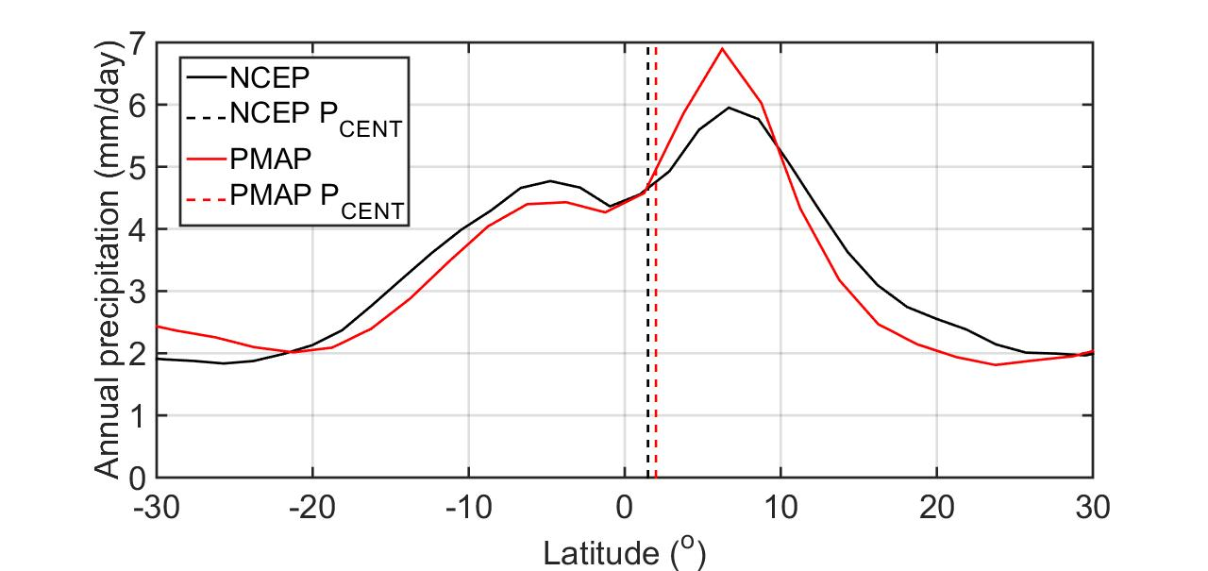
Figure R2. Annual zonal mean precipitation from (black) NCEP reanalysis and (red) NOAA PMAP. The dashed vertical lines show the location of the ITCZ as measured by the precipitation centroid of annual mean precipitation.

P9, line 8 from bottom: A 1° northward ITCZ shift is NOT associated with 0.34PM of AHTEQ from my reading of Figure 3C (more like 0.6PM). I agree it is the case in Figure 3D. There could be multiple reasons for this. First of all, the annual mean position of the ITCZ is not well defined. The estimate of its centroid is susceptible to error. Second, the mechanisms for the ITCZ variability at interannual time scales is mostly not externally forced, but the result of coupling with the ocean, which may lead to different ITCZ-AHT relationship.
The reviewer is correct that the regression between ITCZ shifts and AHT_{EQ} in figure 3C is smaller ( 1.8±0.8 º PW⁻¹) than those seen in the other panels. Technically the statement in the original chapter is not incorrect in that it refers to the regression coefficient between AHT_{EQ} and ITCZ position (0.34 PW per degree) which is not equal to the reciprocal of the regression coefficient between ITCZ and AHT_{EQ} cited above – since the correlation is less than unity. Since this is slightly misleading and all other results are presented in terms of ITCZ sensitivity to AHT_{EQ} we have revised the text to be more consistent with the presentation if other results:
“The regression coefficient between ITCZ location and AHT_{EQ} is 1.8±0.8 º PW⁻¹ “.

Middle of page 13: “translational” should be “translation”.
Fixed.
Section 3.1: Suggest you to directly estimate the ITCZ-AHT slope month by month. See the major comment for details.
Done and added to the introduction of Section 3.
Section 3.2: I don’t find this section integrated well with other parts of the chapter. But it is up to the authors to decide to keep it or not.
We have decided to keep the section in the chapter but do appreciate the reviewers point.
References may be provided to support the statement about the “southward ITCZ shift during the 1980s when sulfate aerosol emission from India peaked”.
Citation to Hwang et al. (2013) has been added.
line 2, P21: “leads”⇒ “leads to”.
Changed.
Line 2, page 22: There is no black line in Figure 6C.
Changed to 6B. Thanks.
Reviewer: 2
1) One weakness I found is the reasons why the reanalysis products do not follow the proposed relationship for the annual mean climatology (Figure 3A, second paragraph in p. 8). The presented argument is not quite clear and convincing to me. Please consider answering my questions below.
1. Questions and suggestions regarding my first main concern: p.8, second paragraph, the reasons why the observations do not agree with the models.
- I found the presented argument is not convincing, partly because some of the terms are not clearly defined. Particularly the term “the observations” is vague since the reanalysis products are not purely observations (e.g., Trenberth et al. 2010) and the authors of this manuscript and each of the cited papers (Marshall et al. 2013; Heaviside and Czaja 2013) used different reanalysis products. Such information is important for the reproducibility of the results.
We have clarified that the observational estimate is based on the average of reanalysis products and pointed to citations of where those calculations can be found (Marshall et al, 2013 and Fasullo and Trenberth 2008). We have replaced “observations” with “observational based estimates” and tried to convey the source of these data (i.e. satellites and reanalyses).
i) “the AHTEQ in the annual mean Hadley cell differs drastically between reanalysis products (Marshall et al. 2013) due to differences in reanalysis products at the top of the tropical boundary layer.”
As far as I understand, Marshall et al. 2013 concluded that the primary reason for the uncertainty in AHTEQ in the reanalysis products is the difference in the meridional velocity in the upper stratosphere between NCEP and ERA-Interim reanalyses, not "the differences in reanalysis products at the top of the tropical boundary layer". Please double-check where Marshal et al. 2013 discusses the tropical boundary layer.
The relevant lines of Marshall et al. are: “We also note that there is a zonal mean southward flow at 700 hPa over the equator in both sets of reanalysis. This flow occurs at the vertical minimum of MSE and leads to positive AHTEQ in the atmosphere’s MOC.” We have revised the text of the chapter to reflect that this mechanism leads to on offset less southward AHT_{EQ} in the annual mean compared to that which would be expected from the deep circulation alone.
ii) “there is a significant energy flux in the stratosphere in the observations that is poorly constrained by measurements.”
Is this statement also based on Marshall et al. 2013? Please clarify what observations/studies you are referring to.
We have clarified that these results are based on the results of Marshall et al. (2013) and are based on calculations from the reanalysis data.
iii) “stationary waves make a significant contribution to the annual mean AHTEQ in the observations (Heaviside and Czaja 2013) and not in the models.”
Please provide evidence to support for saying "not in the models".
We have revised the text to state that it is unclear if the same stationary eddy energy transport at the equator is present in climate models.
Also, my understanding of the main conclusion from the cited paper (Heaviside and Czaja 2013) is about the importance of Somali jet during JJA in the AHTEQ. If this is significant to the annual mean, then I expect it to appear in JJA season as well, but such deviations specific to certain months are not obvious in the observations (reanalysis) in Figure 3b. I may have missed other information in Heaviside and Czaja 2013, but even so it is still important to provide more specific and consistent summary of the cited papers, given that the disagreement of the reanalysis products to the proposed relationship weakens the authors’ main points.
The seasonal variations in stationary eddy energy transport across the equator were found to be small by Donohoe et al. (2012); the main contribution to the seasonal cycle in AHT_{EQ} is variations in the Hadley cell strength with the stationary eddies contributing an offset to the interecept of the seasonal relationship. We have added a discussion and citation to this work in the revised chapter.
- Another reason for the apparent disagreement of the reanalysis products may be the use of prescribed SST (therefore infinite source of heat and moisture) in most of the reanalysis products.
This is an interesting point although we calculate the AHT from the dynamic fields (velocities, specific humidity and temperature) only. While the infinite sources of heat and moisture may well bias the dynamics, we do not use the surface energy fluxes (or TOA radiation) from the reanalysis products in the calculations presented.
- I think one way to strengthen the discussion on the uncertainty in the reanalysis products is simply to calculate the annual AHTEQ using one or two additional products, especially those quite different from the NCEP reanalysis used in this manuscript (and Marshall et al. 2013), such as MERRA, JRA-25, or CFSR. Including a couple of them may significantly increase the uncertainty range in the figure, or even follow the proposed relationship, which will support the authors' argument. Looking at CFSR is interesting with this respect because a coupled atmosphere-ocean model is used instead of prescribed SST.
According to the communication in the previous review round, such analysis has been already done by Adam et al. 2015, but its reference is not given in the list. Also some of their conclusions should be mentioned.
Such an analysis would indeed be interesting but is beyond the scope of the present (mainly review) chapter. The Adam et al. paper focuses on the interannual variability in the ERA and NCEP reanalyses and is, unfortunately, not accepted for publication at this time. We prefer not to cite work which has not been peer reviewed.
2) Another aspect that can be improved is the organization of the materials. I am from a general community of climate dynamics, and reading this manuscript I felt it is a little difficult to keep track of the materials presented in some of the sections; what is presented in which section. This manuscript covers a wide range of model experiments and analyses across different time scales, which are all useful but can be overwhelming for some readers.
For example, some observations and conclusions are already presented in Introduction with rather thorough reasoning (e.g., “the annual mean ITCZ position represents the small residual of seasonal ITCZ migrations off the equator…”, p.4, with Figure 1 and cited papers there) and the results in the later sections are used to further support those statements (sections 2.1-2.2, and 3 for the above example).
Another example is the title for section 3.1, which implies similar materials as those in sections 2.1-2.2, although they are different.
An easy fix seems to keeping the discussion in Introduction just about the general description of the ITCZ (e.g., meridional profiles of the annual, JJA, and DJF means, definition of ITCZ, importance of the ITCZ location) and the hypothesis/questions that will be shown in the later sections, then distribute other more in-depth discussions and analysis framework (most of p.4 and the first half of p.5) into section 2. I also noted that the section introduction for section 2 is already long enough to be a subsection (e.g., “2.1, Analysis framework”).
A brief summary section might be also helpful. In the current form, this chapter ends with rather weak or negative impression from the uncertainty in the future ITCZ locations in the CMIP5 ensemble (section 4). A paragraph that reminds the readers of the materials in each section and the last two paragraphs in section 4 could be combined and converted into a brief summary section.
We have modified the organization of the manuscript as suggested by the reviewer. Specifically, the quantitative analysis of the seasonal cycle has been moved from the introduction to section 2 and we discuss the main findings of the chapter in more general terms in the revised introduction. We have also reordered section 2 by giving the methodology its own subsection and placing the (lengthened) seasonal analysis ahead of the annual mean subsection. We have modified the title of section 3.1 to distinguish it from section 2.3 (previously section 2.1).
Specific comments
2. Related questions about Figure 3
What is the standard deviation in the "observation" in panel (a)? Is it the interannual variability in the NCEP data?
The standard deviation is the spread between the different sets of reanalysis (for AHT_{EQ}) and the interannual variability for precipitation centroid. We have added an explanation to the text and figure caption.
Similarly, panels B and C are based on different references, but did they use the same observation (NCEP reanalysis)?
Yes. Added to the figure caption.
Other minor comments
3. Abstract, the sentence “Future changes in the ITCZ position must conform the 3° latitude shift per PW of hemispherically asymmetric atmospheric heating.”
This sentence (the use of “must”) is quite strong, making the proposed relationship as an already established fact. I suggest to soften the expression, or change it as to cast a hypothesis for the future ITCZ change based on the proposed relationship.
Agreed. Revised from “must” to “will likely”.
4.p.5, the last sentence
“We then extend these results to the changes in tropical precipitation expected under global warming (Section 4).”
The phrase “the changes in tropical precipitation” is rather ambiguous and not used much in section 4 (it appears in section 3). I recommend to use “the changes in ITCZ position” to be consistent and more specific.
Edited to “ITCZ shifts expected under global warming”.
5.p.6, L3 in the third paragraph.
"In the introduction to this section, we derive the relationship between AHTEQ and the hemispheric energy budget for …”
I don’t think you need “In the introduction to this section,” since the relationship (equation 2) is derived just a half page above, in the same section (the latter part of the sentence needs to be revised accordingly).
Revised to “here”.
6. p.6, the last sentence of the second paragraph:
"…thus, the ITCZLOC appears to be a relatively stable feature of the climate system with changes greater than a couple degrees of latitude rather unlikely even under rather extreme climate forcing such as those associated with glacial cycles."
I feel this sentence needs some editing, for instance,
"…thus, the ITCZLOC appears to be a relatively stable feature of the climate system, and its changes greater than a couple degrees of latitude will be unlikely even under rather extreme climate forcing such as those associated with glacial cycles."
Revised.
7. p.14: section 2.4.3 should be 2.4.1
Changed. Now section 2.5.1.
8. p.14: Maybe section 2.5 more appropriate to be 2.4.2? This section still talks about the ITCZ shift due to external forcing, which is the theme of 2.4.
Changed. Now Section 2.5.2.
9.p.19 Feldl et al.,2013 should be Feldl et al., 2014. (second line of the last paragraph)
Fixed.
10.p.21:Please mention for the readers that the Hemispheric contrast represents NH minus SH in discussing Figure 6.
Added.
11. p.22, lines 2-3: "(black line in Figure 6C – note the shaded black line intersects the x axis in most regions)"
I cannot find these lines in Figure 6C. Do you mean the dashed black lines representing x=0 and y=0?
The text should have pointed to Figure 6B. Fixed.
12.ReferenceHeld, I., 1980: Nonlinear axially symmetric circulations in a nearly inviscid atmosphere. J. Atmos. Sci., 37, 515–533.
should have another co-author as
Held, I. and A. Y. Hou, 1980: Nonlinear axially symmetric circulations in a nearly inviscid atmosphere. J. Atmos. Sci., 37, 515–533.
Fixed.

