We thank the reviewer for thoughtful comments that have helped to improve the clarity of the revised manuscript. We respond to the reviewer’s comments (in red) below:
1. Title and Section 4: The title doesn’t seem to represent the work presented in this paper. As the authors acknowledged that the small changes in ITCZ location in a warmer climate (4XCO2) is due to taking averages of two split answers from CMIP5 models. It shows uncertainty, not a signal. So, the conclusion in the last paragraph on page 22 is not valid.
We have changed the title of the chapter to more clearly reflect the uncertainity associated with future ITCZ shifts: “The location of tropical precipitation and the hemispheric contrast of energy input to the atmosphere; why future tropical precipitation shifts are uncertain.“
We stand by the conclusions as stated in the final paragraph of the chapter. Though the direction of future ITCZ shifts is uncertain, the ITCZ does not shift by more than 1º latitude in any model simulation (in response to an instantaneous CO₂ quadrupling even) and we believe the relationship between the ITCZ shift and hemispheric energy budget provides a suitable framework for understanding the magnitude of future changes. The language of the conclusion paragraph allows for the possibility that large magnitude feedback processes (at the hemispheric scale) that are not included in the suite of climate models may exist in Nature.
2. Role of monsoon: Authors defined ITCZ as the peak location of zonal mean rainfall. So, the seasonal variation of ITCZ will be highly correlated with monsoon rainfall. As shown in Fig. 1, the seasonal change in the location of oceanic ITCZ is very small. Instead, the seasonal variation of ITCZ is dictated by south Asian monsoon in summer and Austral monsoon in boreal winter. Due to the nature of monsoon, ITCZ_LOC change is small even if ATH_EQ can vary a lot depend on the data used (different reanalysis or models) (See the first paragraph on page 11). I recommend the authors to address on the potential role of monsoon in the relation between AHT_EQ and ITCZ_LOC.
If we define the ITCZ location using only the precipitation over the ocean domain (see below figure), we get a nearly identical slope between ITCZ location and AHT_{EQ}. Surprisingly, the ocean domain seems to be responsible for the non-zero intercept but does not change the slope. We are not sure what physical process causes the non-zero intercept. We have included a statement of this result in the revised manuscript (last sentence of the first paragraph of Section 2.2):” We note that a nearly identical (-2.9º PW⁻¹) seasonal relationship between the ITCZ location and AHT_{EQ} is found if the ITCZ location is defined as the centroid of precipitation over the ocean domain only, suggesting that the seasonal migration of the ITCZ tracking more than seasonally alternating monsoons of Asia and Australia.”
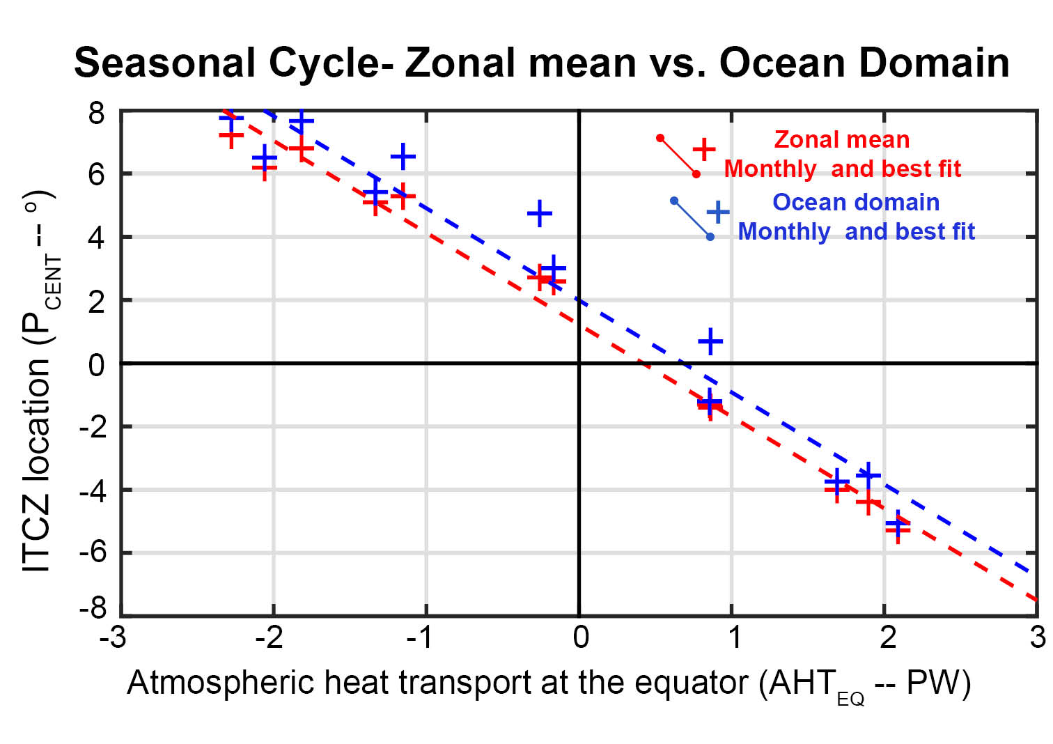
Figure R1. Climatological seasonal cycle of observed ITCZ location (P_{CENT} from NOAA CMAP) and AHT_{EQ} from NCEP reanalysis. The red is ITCZ location defined from the zonal mean precipitation over both land and ocean and the blue is the zonal mean over the ocean domain only. Crosses are monthly means and the dashed line is the linear best fit.
3. Authors clearly showed the ITCZ_LOC lead the change in AHT_EQ, not the other way around. Throughout the manuscript, however, the authors argue that AHT_EQ leads ITCZ_LOC. Also, the relation between AHT_EQ and hemispheric contrast in atmospheric heating (<RAD>, etc) is not shown in this manuscript.
The ITCZ shift and AHT_{EQ} anomaly are concurrent in the interannaul variability as demonstrated in the plot of lead/lag correlations below. This is true of both the raw monthly variability and the low frequency variability. We do agree with the Reviewer that the cause and effect of the relationship between ITCZ location and AHT_{EQ} is unclear. Our intention is to point out that an ITCZ shift of 3 degree is accompanied by 1 PW of AHT_{EQ} which can result from a host of processes including radiative feedbacks from the ITCZ shift itself, extratropical feedbacks, external forcing, changes in ocean circulation. We explicitly address the radiative impact of the ITCZ shift on the hemispheric contrast in atmospheric heating in the second paragraph of Section 2.3 although the indirect impacts of the ITCZ shift are undocumented in the current literature (to our knowledge).
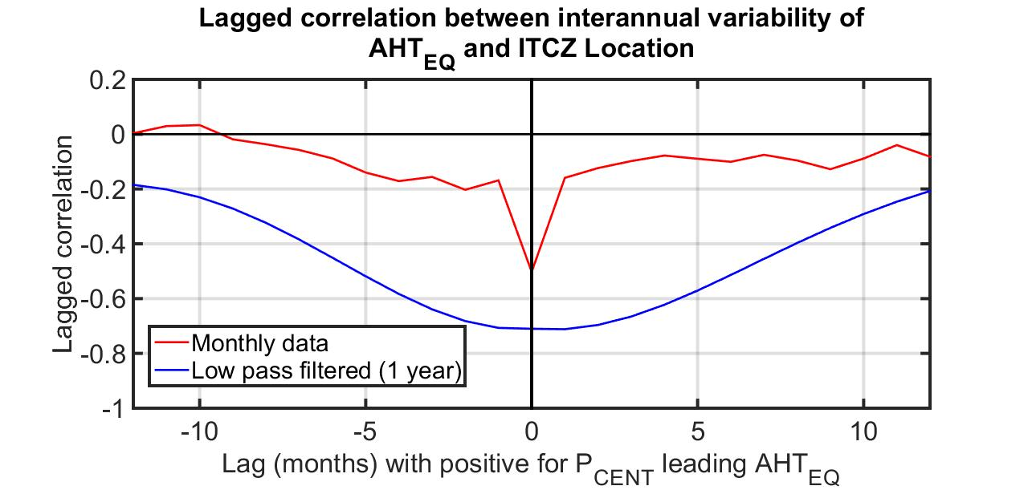
Figure R2. Lagged correlation between observed interannual variability of ITCZ location (P_{CENT} from NOAA PMAP) and AHT_{EQ} (from NCEP reanalysis). The red is the monthly mean data and the blue is for low pass filtered data using a double pass Butterworth filter with a cutoff period of 1 year. Data runs from 1979 to 2014.

4. Uncertainty (Lines 18-19 on page 8): Will the relation shown in Fig. 3C hold if different reanalysis data is used? What is the range of the ratio (ITCZ_LOC/ATH_EQ) if ATH_EQ is taken from different reanalysis?
An extensive analysis of the interannual variability in other sets of reanalysis was recently performed by Adam et al. (2015). We have pointed the reader to this analysis.
5. Lines 10-11 on page 11: “same physics”, could you elaborate what physical mechanism is referred here?
Changed to: ” physical processes relating the mutual dependence of ITCZ location and AHT_{EQ} to the Hadley cell are robust in models and Nature alike.”
6. Lines 17-18 on page 11: “quantitative prediction of ITCZ location”, according to this study, AHT_EQ has to be known to predict ITCZ_LOC. But, AHT_EQ is highly correlated with ITCZ_LOC (lines 6-7 form the bottom of the page 4, and many other places), so it seems not easy to predict ITCZ_LOC based on the relation between forcing and energy budget.
We agree with the reviewer that the ITCZ shift is both caused by and effected by the hemispheric energy budget. A predictive model of the ITCZ would require the separation of Hemispheric contrast of atmospheric heating into components that are independent of the ITCZ shift and those that result from the ITCZ shift. Similar to global mean radiative feedbacks, if the a northward ITCZ shift results in more heating of the Northern Hemisphere, this would act as a positive feedback to the ITCZ shift and demand a larger ITCZ shift to balance a given external forcing. The impact of the ITCZ shift on the hemispheric energy budget (in PW) relative to the external process that initiated the shift can be used to define a feedback gain. We have included this point in the revised manuscript and pointed the reader to the relevant literature in the revision:” Some portion of the hemispheric asymmetry in energy input to the atmosphere may be a consequence of the ITCZ shift itself, either due to radiative changes associated with shifting convection or changes in surface fluxes associated with ocean circulation anomalies initiated by changing trade winds. These effects can be incorporated into a predictive model for ITCZ shifts – in response to an energy input external to the ITCZ shift—by introducing a feedback gain associated with the energetic changes due to the ITCZ shift as discussed in Donohoe et al. (2014a).
7. There are two Donohoe et al (2013) and Donohoe et al (2014), and it should be cited as, for example, 2013a (2014a) or 2013b (2014b).
Fixed.
8. The 3rd line on the second paragraph on page 11: Which “shaded red box”?
Shaded regions representing one standard deviation of the model spread in each experiment have been added to figure 3D.
9. Section 2.4.2 on page 12: It is not clear how this section supports the robustness of the ratio (ITCZ_LOC/ATH_EQ). It seems suggest the importance of the role of extra tropics.
This section was intended to give an idea of the magnitude AHT_{EQ} changes associated with a very large hemispherically asymmetric forcing and the processes that determine that magnitude. We have an introduction sentence in the previous paragraph to transition into that discussion: “Furthermore, the ITCZ shift is fairly small (<1º) in all simulations because the shift is constrained to the approximately 3º PW⁻¹ relationship and the change in the hemispheric contrast of energy input to the atmosphere does not exceed 0.3 PW even for the highly hemispherically asymmetric forcing associated with the Laurentide ice sheet in the LGM”

10. Line 12 from the bottom of page 13: “SST” should be “SST contrast”
Fixed
11. Lines 3-4 on page 16: It seems contradict to lines 9-10 on page 17. Also, it is not consistent with the equation (2). It I understand correctly, the discussion on this page is the meridional derivative of the equation (2), and not sure how this helps supporting the robustness of the ratio. This part (about annual mean) can be shortened or removed.
The text is presenting the straw man argument of meridionally translating the annual mean climatology without taking into account the seasonal intensification of the winter Hadley cell. We believe the text clearly conveys the contrast between the straw man argument and the result emphasized throughout the text: “Why is the ITCZ three times less sensitive to the hemispheric contrast in forcing and feedbacks than the conceptual model based on the meridional translation of the annual mean climatology above suggest?”
12. Page 16: How the location of “the zero stream function (lines 20-21)” differs from the location that “the meridional gradient of the stream function is greatest (line 24)”?
The meridional gradient of the streamfunction determines the vertical velocity and is not the same entity as the streamfunction zero. This is especially true when there is a large amplitude asymmetry between the winter and summer Hadley cells (see the left panels of Fig. 1B-C).

