We thank the reviewer for thoughtful comments that have helped to improve the clarity of the revised manuscript. We respond to the reviewer’s comments (in red) below:
1. The authors refer to “the region of tropical convective precipitation” as “ITCZ”, which is not consistent with the conventional definition of ITCZ (inter-tropical convergence zone). It would be better to conform to the convention, especially in the title, abstract and the beginning of the article. Then they can describe the equivalency of maximum tropical convective precipitation and the ITCZ positions.
We struggled (and argued) about the proper terminology to use in the manuscript; the literature is ambiguous about whether the ITCZ refers to the region of precipitation over the ocean (sometime specifically the Pacific) or also includes convective precipitation in the monsoonal regions. We tried to address the definition of the ITCZ directly in the chapter and have expanded on the equivalency of low level divergence and convection in the revised manuscript: “We note that the region of convective precipitation that we use to define the ITCZ here is inseparable from the low level convergence since convection (upward motion in the atmosphere) demands low level convergence for an incompressible fluid (Boussinesq continuity equation) subject to the boundary condition of no vertical flow through the surface.” We agree with the reviewer that this potentially leaves the terminology in the abstract at odds with conventions in the literature but we believe that maintaining the terminology used and expanded on in the chapter in the abstract is worth the tradeoff. The terminology used in the title, abstract and body of text is self-consistent.
2. The authors pointed out that the 3° latitude ITCZ shift per PW of asymmetric hemisphere atmospheric heating holds well on the observed seasonal cycle and for the inter-model spread of annual mean climatology, but the linearization of observed annual mean ITCZ position and energy transport across the equator would yield 3 times higher sensitivity of ITCZ position shift per PW of heat transport. On Page 16, the second paragraph, the authors argued “that the large seasonal migrations of the Hadley cell and ITCZ render the annual mean a less meaningful physical state that is seldom realized in the real (or modeled) climate system. As a result, a linearization about the annual mean state provides unrealistic ITCZ sensitivity to external forcing due to the exclusion of a seasonal cycle.” I found this argument superficial, as annual mean climatology in the models does not suffer this problem of “a less meaningful physical state.” I was wondering how closely the models’ seasonal cycle of ITCZ shift follows the universal relationship (a modeling counterpart of Figure 3B) and why the models’ annual mean position follows the same universal relationship (Figure 3A). The authors offer some possible explanations on Page 16 (item 1 & 2). It would be useful to examine if these explanations apply to the models’ annual mean climatology.
We have included the seasonal cycle of ITCZ location and AHT_{EQ} in coupled climate models in the revised Figure 3B. The seasonal relationship between ITCZ location and AHT_{EQ} is consistent with the order 3º PW⁻¹ despite some inter-model spread and the observations suggesting larger ITCZ migrations per unit unit of AHT_{EQ} than most of the models. We agree that it would be interesting to test the hypothesis that the seasonal relationship in a given model determines its annual mean sensitivity to external forcing. Such an analysis would require a more rigorous exploration of the response to various external forcing patterns in each model that are beyond the scope of the present manuscript. 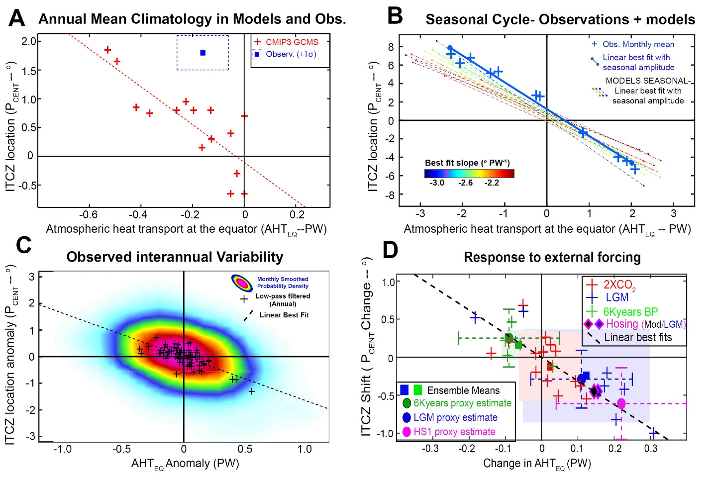
Revised Figure 3.
3. In Figure 3c, it would be better to show a scatter plot like the other 3 panels for the observed inter-annual anomalies and compute the slopes.
We have revised panel C of figure 3 to a scatter plot with the same scaling as the other panels. Thank you for the suggestion.
4. In Figure 3c and section 2.3, the authors used annual mean anomalies because they thought that annual mean anomalies “have a more robust connection to the Hadley cell anomalies.” (Page 9). Given the observed annual mean ITCZ position and hemispheric heat transport does not yield a consistent relationship as the seasonal cycle and the interannual anomalies are dominated by ENSO which has a strong seasonality, why not use interannual anomalies for each season, such as December-January-February when ENSO signals usually reach peaks?
Thanks for the suggestion. We have broken down the correlations by season below. Interestingly, the Boreal winter shows the best correlations and the correlations is not significant in the summer. ENSO has zero correlation with the ITCZ location when all seasons are considered.
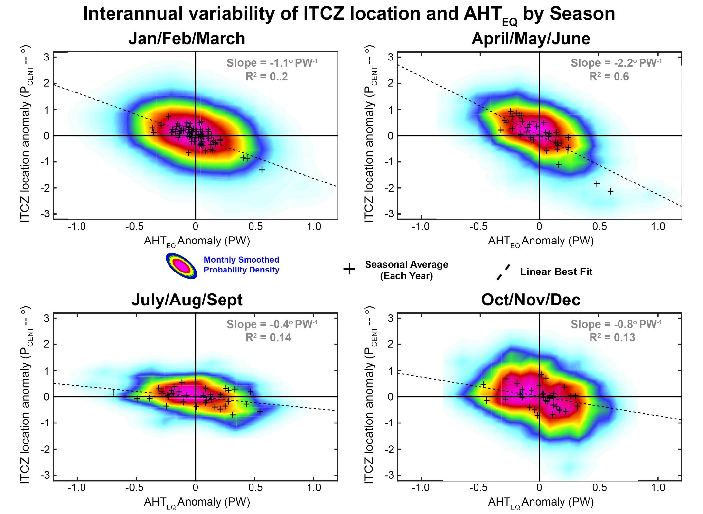
Figure R1. The interannual variability of ITCZ position (P_{CENT} from PMAP) and AHT_{EQ} (NCEP reanalysis) broken down by season. The colors are the smoothed probability density of the monthly data and the crosses are the seasonal averages for each year. The dashed black line is the linear best fit. The best fit slope and variance explained is shown in the upper right of each panel.
Similar (more thorough) analysis was recently performed by Adam et al. and we have pointed the reader toward this manuscript in the revised chapter: “We note that the correlation between El Nino—the prominent mode of East-West sea surface temperature variability in the Tropical Pacific—and both the ITCZ location and AHT_{EQ} is not significant although recent literature suggests that the correlation is significant in the Boreal winter (Adam et al. 2015).”

5. Section 2.4.1 (2xCO2 simulations) and Section 4 (future ITCZ shifts under global warming) appear to be overlapped. Section 4 is more detailed and clearly laid out. I would suggest remove Section 2.4.1 and just mention part of the CMIP3 results in Section 4. Section 2.4 can then focus on paleo-climate model simulations and proxy records.
Section 2.4.1 has been removed and absorbed into Section 4.

