We thank the reviewer for insightful comments and suggested editorial improvements. The suggestions have helped us clarify our methodology and terminology used and place the present work in the context of the existing literature. Below, we list the reviewer’s comments in red and our responses in black.

1. Theories based upon slab ocean model results do not necessarily represent ITCZ shifts correctly. For example, Hwang and Frierson (2013, ref # 13) suggested that Southern Hemisphere cloud biases could shift the ITCZ toward the Southern Hemisphere, but Kay et al. (2016) found a contradictory result using a fully coupled model. Kay et al. (2016) conclude that the ocean’s role in cross-equatorial heat transport should not be neglected in considering theories for ITCZ shifts. At a minimum, the authors need to justify why they feel confident in neglecting the role of ocean heat transport in their theory. I would assume that seasonal variations in the ocean’s cross-equatorial heat transport are relatively small, but it would be good to provide some evidence to support that assumption. In terms of the global warming scenario, neglecting the ocean seems like a bigger assumption, as the ocean’s cross-equatorial heat transport is likely to be altered in some fashion as the
climate warms.
We agree that ocean dynamics play an important role in damping the annual mean ITCZ response to hemispherically asymmetric forcing as the recent developed theory of Green and Marshall (2017, Coupling of Trade Winds with Ocean Circulation Damps ITCZ Shift) highlights. However, we note that all the CMIP5 simulations we analyze are coupled and the theoretical framework developed includes the atmospheric response to ocean heat transport changes (even though the ocean heat transport does not appear explicitly). Stated otherwise, the AHT_{EQ} is the equal to the hemispheric contrast of atmospheric energy input which itself is equal to the difference of TOA radiation and surface energy fluxes. The surface energy fluxes include the combined impact of ocean heat transport and ocean heat storage. At annual timescales (in an equilibrium climate) the storage term disappears and ocean heat transport across the equator is 0.6 PW (in the observations—Frierson et al. 2013, Marshall et al., 2013). On seasonal timescales, the hemispheric contrast of surface energy fluxes is of order 18 PW – see below plot for observational estimates based on the methodology of Donohoe and Battisti, 2013, The seasonal cycle of atmospheric heating and temperature, J. Climate).
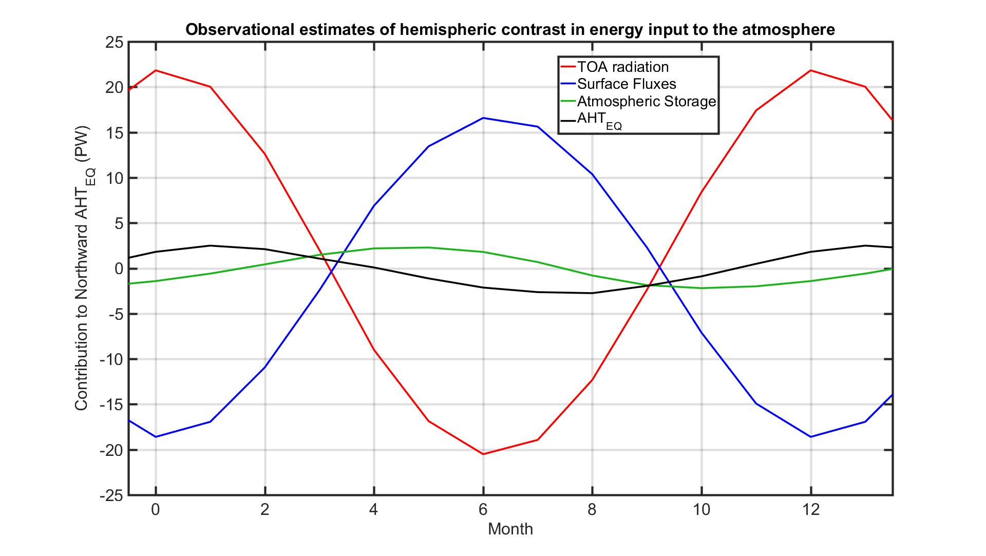
The 18 PW seasonal cycle of hemispheric contrast is a combination of seasonal energy storage in the ocean and seasonally varying ocean heat transport across the equator and is primarily associated with the solar heating of the surface. We do not know of any literature that has tried to decompose this seasonal contribution into the heat transport versus storage and our (untested) intuition is that the ocean heat storage accounts for the vast majority of this term. AD’s work has advocated that the seasonal cycle of atmospheric heating (and thus AHT_{EQ}) is dominated by the direct solar absorption by the atmosphere and damped via thermodynamic coupling to the ocean surface (citation above) and thus, the ocean dynamics are less important than thermodynamic coupling to the mixed layer. Stated otherwise, the near seasonal balance of TOA radiation and surface energy fluxes in the above figure is just a statement that the vast majority of season variations in insolation pass through the atmosphere and heat the surface and that the atmosphere is only effected by the portion of this insolation that is absorbed in the column -- SWABS (see Fig. 4 of Donohoe et al., 2013, The relationship between ITCZ location and atmospheric heat transport across the equator: from the seasonal cycle to the Last Glacial Maximum.) This viewpoint also seems consistent with the 0.1PW ensemble mean change in ||AHT_{EQ} || under 4XCO₂ being driven radiatively by SWABS changes due to water vapor absorption and surface albedo changes (diagnosis note shown here) and independent of ocean heat transport changes.
In summary, the surface ocean in each hemisphere is heated and cooled seasonally by of order 20 PW by the sun. Cross equatorial ocean heat transport changes would have to comparable in magnitude to impact ||AHT_{EQ}||. Even if ocean heat transport changes were this order of magnitude, or diagnosis of AHT_{EQ} accounts for changes in surface heat fluxes and, thus, does not exclude the impact of ocean heat transport changes.

2. How sensitive are the results in Fig. 2c to the removal of a couple of models? It looks like the entire correlation may hinge on the behavior of 3–4 models.
Below, we show the regression coefficients between WA_{ITCZ} and ||AHTEQ||that results from 1000-member Monte-Carlo resampling with replacement of samples half the size of the available ensemble. We find that the regression coefficient exceeds the threshold for significance at the 95% confidence interval (one sided T-stat with 8 DOF of 1.86 – shown by the vertical black line) in 946 of the 1000 simulations. This statement says that, even if we only had half the model simulations available, it is highly likely that there is a significant correlation between WA_{ITCZ} and ||AHTEQ||that does not rely on the inclusion of a couple of the extreme models.
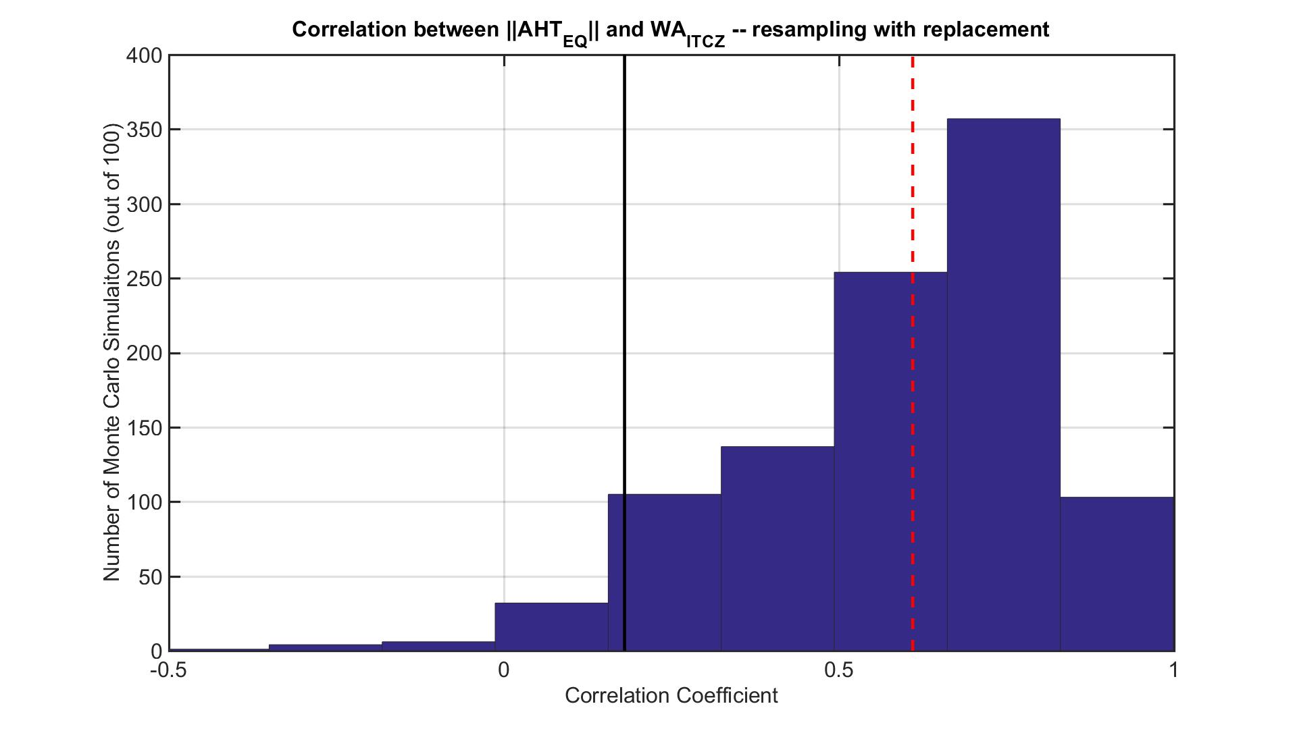
Additionally, we note that none of simulated values of ||AHT_{EQ}|| or WA_{ITCZ} are outliers in the statistical sense; maximum Z scores for all models are 2.1, well below the standard threshold value of 3.5 for identifying outliers (Boris Iglewicz and David Hoaglin (1993), "Volume 16: How to Detect and Handle Outliers"). In physical terms, we believe it is important to identify the mechanism that causes the modeled distribution of WA_{ITCZ} to differ so drastically between climate models.
3. As presented, Figure 3a is difficult to interpret. I might have missed this, but I don’t think the methodology used to calculate this figure is clearly described anywhere in the main text or in the supplemental information. In particular, this statement on p. 11 does not provide sufficient information: “projection of the line onto the abscissa is equal to || AHTEQ ||, and the slope is the regression coefficient between the ITCZ location and AHTEQ.” Why not simply show a scatter plot of the AHTEQ and ITCZ location in both boreal winter and summer and draw a line between them? Applying this regression fitting procedure seems like an unnecessary step.
Unfortunately, space limitations did not allow a thorough explanation of the methodology in the main text. We described the method in the supplemental information, repeated below:

“The seasonal amplitude of AHTEQ (||AHTEQ||) is defined as the amplitude of the annual
harmonic in AHTEQ. The seasonal cycle of ITCZ location and AHTEQ are very strongly anticorrelated (R = -0.99) in the observations and on in coupled model simulations (R = -0.91). For this reason, the product of the seasonal relationship between ITCZ location and AHTEQ – defined as the linear regression over the climatological seasonal cycle– and the seasonal amplitude of AHTEQ accurately determines the SRITCZ (R2 = 0.96).”

This methodology was adopted from Donohoe et al. (2013 – Figure 6 and discussion therein). We agree that presenting a scatter of extreme seasons is a more intuitive result. However, the timing of the extremes in ITCZ location differs between different climate models making a consistent definition of Boreal and Austral summers difficult. We have elected to maintain the methodology of using the annual harmonic here because it takes into account all of the monthly data, does not suffer from timing issues and for consistency with the existing literature on ITCZ and seasonal heating of the atmosphere (Donohoe et al. 2013, Donohoe and Battisti 2013). Given the very strong correlation between ITCZ and AHT_{EQ} over the seasonal cycle, nearly identical results are found if we simply used regressions between the extreme seasons as suggested by the reviewer.

4. One shortcoming of this manuscript is that it does not attempt to contextualize the results within the context of earlier studies on the contraction of the ITCZ with global warming, such as Lau and Kim (2015; ref #14), Byrne and Schneider (2016; refs #5 and 6), and Su et al. (2017). How does the authors’ proposed mechanism compare and contrast to those discussed in these previous studies?
Thank you for he suggestion. Lau and Kim (2015) and Su et al. (2017) both document the contraction of tropical precipitation under global warming in climate models, but do not offer a proposed mechanism. We regret missing a citation to Su et al. (2017) and have added that citation to the revised manuscript. Refs. 5,6, and 32 also identify changes in GMS as essential to future contraction of convective regions by way of the so called ”upped-ante” mechanism. These arguments largely rely on annual mean considerations of regions of ascent and subsidence. Our perspective relies critically on the seasonal migration of the zonal mean convective region and in this sense is complementary yet unique from the existing literature. We have expanded our discussion of the existing literature in the discussion section (repeated below).
“The robust meridional contraction of tropical precipitation under global warming 15, 16 results
from enhanced GMS of the tropics. Other studies 5, 6, 32 have identified changes in GMS as critical to future narrowing of convective zones from annual mean energetic considerations. We offer a complimentary view point that changes in the seasonal range of the ITCZ are an essential ingredient of future tropical precipitation changes.”
5. I find some of the terminology in the paper to be misleading and inconsistent with what is typically used in the literature.
a. As the authors note on p. 4, the double ITCZ bias refers to the fact that most models possess equivalent annual-mean peaks in tropical precipitation in each hemisphere, whereas the NH maximum is more pronounced in observations. Additionally, the double ITCZ often refers specifically to regional signatures over the eastern tropical Pacific (e.g., Oueslati and Bellon 2015). In this paper, the authors instead use the term to characterize the seasonal variations of the ITCZ (and thus the annual-mean width of the ITCZ). I personally find their usage of the “double ITCZ” term misleading, particularly in the abstract where readers will assume that it has its conventional meaning. Why not just say that most models exaggerate the width of the ITCZ (or tropical precipitation maximum)? That seems like a more accurate characterization of the problem examined. If the authors wish to retain the usage of the double ITCZ terminology, I think they need to show some evidence from the eastern tropical Pacific (not just the zonal mean) supporting their claims.
We have removed the term “double itcz” from the abstract, the relevant lines of which now read:
“Climate models are biased toward overly expansive tropical precipitation resulting from an exaggerated hemispheric contrast of atmospheric heating during solstice seasons.”
We retain the use of “double itcz” in the main text, where we feel we have clearly defined what our use of the term and acknowledged our definition contrast with that used in some of the literature:
“The above results indicate that the climate model bias toward a more meridionally expansive
and bi-modal tropical precipitation distribution is a consequence of biases toward larger SRITCZ
and we equate this bias with the terminology ”double ITCZ”. Our definition differs from that
in recent literature14 that equates the double ITCZ bias with the contrast in tropical precipitation between the two hemispheres. We argue that there are two independent modes of tropical precipitation biases: (1) the hemispheric contrast in annual mean tropical precipitation that results from the annual mean ITCZ location and (2) the width or degree of bimodality in the tropical precipitation that is governed by the SRITCZ and is the focus of the current work.”

This use of double ITCZ is motivated by the idealized aquaplanet simulation where the annual mean tropical precipitation varies from a singly peak at deep mixed layer depth (low seasonality) to a clear double peak with a shallower mixed layer depth (enhanced seasonality) despite maintaining hemisphere symmetry. In this sense, our metric defines the “double itcz” as how bi-modal (doubly peaked) the distribution is independent of how hemispherically asymmetric the distribution is. One could envision a scenario whereby the single precipitation peak is moved into the Northern Hemisphere (for example, by adding ocean heat transport while maintaining a deep mixed layer) but remains singly peaked. Some metrics used in the literature (Hwang and Frierson, 2013) would define the resultant singly peaked distribution as a “double itcz” and we remain steadfast that this is a poor description of that bias. We advocate that there are two separate biases (width and hemispheric asymmetry) with orthogonal impacts on tropical precipitation and mechanisms of operation.
In regard to focusing on the Eastern Tropical Pacific: our manuscript focuses on zonal mean precipitation and circulation only. We believe introducing zonally localized analysis would detract from the emphasis of the manuscript.
b. The usage of the term “tropical width” in the text and figure headings is also problematic. Most papers in the literature that use this term are referring to the width of the Hadley circulation and the poleward expansion of the subtropical arid regions noted on p. 2 (e.g., Davis and Rosenlof 2012). At a minimum, the tropics extend out to the Tropics of Cancer and Capricorn, and in this paper, only features equatorward of 10 degrees latitude are considered. Again, I think the term “ITCZ width” or “width of the deep tropics” would be more appropriate.
We have replaced “tropical width” with “tropical precipitation width” throughout (including figure titles and axes).
Minor comments/typos:
p. 2, 7th line: Both anthropogenic forcing and natural variability have likely contributed to the recent poleward expansion of the Hadley circulation (Waugh et al. 2015). It’s not accurate to say that either one or the other has played a role. Both have played a role, but their relative importance is in question.
p. 3, 7th line: Suggest removing “we argue that.” This conclusion is not something new to this paper. It is clearly shown in figures in references 10 and 11.
p. 3, last paragraph: Here, austral and boreal winters are defined using the JJA and DJF seasons, respectively. In Fig. 4 and in the supplemental information, JA and JF are used instead. Please use consistent seasonal definitions throughout.
p. 3, last line: “all but two of the models” – It looks like all but three of the models based on Fig. 1b. See blue point near (15, 13.3).
p. 5, last paragraph: “transmitted to the surface” – Do you mean transmitted from the surface?
p. 7, last paragraph: “R2 = 0.99” – If two quantities have the same seasonal evolution, they will be highly correlated, so this value is misleading. How correlated are anomalies in AHTEQ and the ITCZ location (after the seasonal cycle is removed)?
p. 11, last paragraph: What is the correlation between the inter-model spread of SRITCZ and ||AHTEQ|| in the 4xCO2 simulations?
p. 12, first sentence: Correlation does not imply causality. Suggest changing to “inter-model differences in WAITCZ are significantly correlated (R = 0.60) with …”
p. 12, last paragraph: The ensemble average shows an increase in ||AHTEQ|| with 4xCO2, but what about individual models? It would be helpful to state the number/percentage of models with an increase to show the degree of agreement across models.
p. 14, 7th line: How can you tell that the zonal mean mass transport in the Hadley cell is weaker? From Fig. 4, the core of the cell appears to be slightly weaker in the enhanced CO2 climate, but the cell also extends higher in the vertical. Do you have calculations to support this statement?
p. 14, 11th line: “shifts equatorward” – The paper starts with describing the poleward shift in the poleward edge of the Hadley cell, yet here it states the Hadley cell shifts equatorward. I think this needs to be clarified. It appears that the core of the Hadley cell overturning might shift equatorward, but its poleward bound still shifts poleward.
References: Proper nouns and acronyms are not capitalized throughout.
Fig. 1a: You might consider adding observations to this figure panel.
We originally had observations in 1a but felt it cluttered the plot. We have provided a version with observations here.
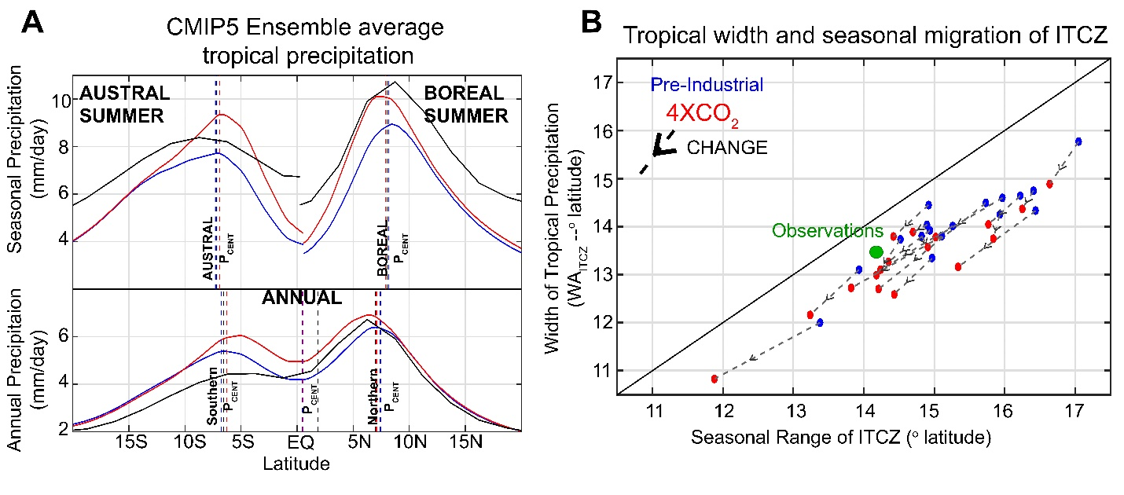
All scatter plot figures (Fig. 1b, Fig. 2c, Fig. 3a): You might consider adding the correlation coefficients stated in the text onto the figures directly, so that readers do not have to search through the text to find these values.
Fig. 2: Why is the observational value different between panels b (2.1 PW) and c (2.4 PW)?
Figs. 2b and 2c, titles: “Amplitude of the seasonal cycle”, “seasonal amplitude of atmospheric heating” – is this referring to ||AHTEQ||? If so, please just use this abbreviation, as it is defined in the figure caption. The other phrases are not consistent and are confusing.
Fig. 2c: Needs color bar.
Fig. 2, caption: “magnitude of the seasonal cycle of atmospheric heating” – Do you mean the hemispheric contrast in atmospheric heating?
Fig. 4 caption: Description of solid and dashed lines does not match the figure legend.
Supplemental Information:
p. 4, first paragraph: and decreases in the region of subsidence
p. 4: Why are the observed and modeled heat transport calculated differently? It seems like the same methodological procedure should be applied to both. The differences in methodologies used between observations and models needs to be justified.
p. 5, second paragraph: in the observations and in coupled model simulations
Fig. S3: CMIP5 historical simulations end in 2005. Were these extended with an RCP scenario until 2016?

