We thank the reviewer for insightful comments and suggested improvements. It is clear that the reviewer read the manuscript very deeply and the comments have helped to craft a more quantitative and precise revised manuscript. Below, we list the reviewer’s comments in red and our responses in black.

1) I don’t think the general readership of Nature Geoscience will be familiar with the
use of the precipitation centroid. The authors should motivate this method of
quantifying the ITCZ. I think the reader would wonder, why not use the latitude of
maximum precipitation to define the ITCZ, why not use the width of the region
where P-E > 0 in the tropics to define the ITCZ width? Both examples are more
easily connected to sensible weather.

Thank you for the suggesting the additional motivation of the P_{CENT} metric. Using the location of the precipitation maximum as an ITCZ metric is problematic for two reasons: (1) In a bi-modal precipitation distribution – such as the annual mean precipitation in most climate models—the peaks in each hemisphere have near equal magnitudes and small precipitation changes can, therefore, have large impact on the location of the maximum and (2) because the maximum can only occur at the location of a discrete grid cell (even after interpolation to a finer grid), the location of the maximum precipitation is a coarse and discrete metric that is dependent on the models grid spacing (that differs between models). We have added the sentence “ P_{CENT} is preferred over defining the ITCZ as the location of peak precipitation because P_{CENT} accommodates bi-modal precipitation distributions where picking a single peak is problematic and is insensitive to model grids spacing” to the revised manuscript.

We agree that the metric of P-E is useful from a climate standpoint. However, the width of the region of P-E >0 is a very different physical quantity – ranging between 20º and 25º latitude in CMIP5 PI models—from the width of tropical precipitation – ranging between 12º and 16º latitude in CMIP5 PI models. As discussed in the introduction of the manuscript, the focus here is on the location of intense precipitation and not the edge of the arid zones. The former is associated with the location of the ascending branch of the Hadley cell whereas the latter is associated with the location of the descending branch and it is unclear if (unlikely that) the energetic arguments presented in the manuscript apply to the descending branch of the circulation.

2) I don’t think the general readership of Nature Geoscience will be familiar with the
energy budget as in (2). (Note this is an approximate energy budget so there
should not be an equal sign see Donohoe et al. 2013 equation 9.) The authors
need to provide more background, e.g. how is the right-hand side related to a
vertically-integrated energy flux divergence, what assumptions are being made?,
how do the units work out?
Another issue is that (2) assumes the Hadley cell (mean-meridional circulation)
dominates the atmospheric MSE flux at the equator but Table 1 in Marshall et al.
(2013, Clim. Dyn.) showed in reanalysis data that stationary eddies dominate the
equatorial MSE flux. Can you please confirm that equation (2) holds in the
reanalysis and the models, e.g. that the Hadley cell transport dominates the
cross-equatorial atmospheric MSE flux?

We have expanded the discussion of the Eq.s 2-3 in the revised manuscript including a more precise definition of the gross moist stability used in the current work and the assumptions being made. Additionally, we have included a derivation of equation 3 in the supporting material and some caveats to its application that we further elaborate on in response to the reviewer’s point below.

Eq. 2 assumes that AHT_{EQ} is dominated by the Hadley cell. Given the definition of the GMS used (the mass flux weighted MSE contrast between the upper and lower branches of the time mean overturning circulation), Eq. 2 would be exact if there were no eddy contribution to AHT_{EQ}. The reviewer is correct to point out that eddies do contribute appreciably to the annual mean AHT_{EQ} (Marshall et. al 2013 and Heaviside and Czaja, 2013, Deconstructing the Hadley cell heat transport). However, the annual mean AHT_{EQ} is the small residual (of order 0.2 PW) of nearly symmetric seasonal migrations of the Hadley cell off the equator resulting in solstitial season AHT_{EQ} of order 2 PW. This seasonal cycle in AHT_{EQ} is the focus of the current manuscript and it is indeed dominated by the Hadley circulation – in both NCEP and ERA reanalysis-- as we show in the new figure S4. The partitioning of AHT into meridional overturning circulation (MOC), stationary and transient eddies requires 6 hourly 3d climate model output which is beyond the scope of the present work so we cannot currently confirm whether the AHT_{EQ} in models and its changes due to climate forcing are also dominated by MOC. We are working on a methodology to partition AHT in climate models from monthly mean data only (Donohoe, Armour, Roe and Battisti, The partitioning of poleward transport and changes under climate forcing in coupled climate models, in preparation).

3) It is not clear how the authors get from (2) to (3). Why are you only extracting the
amplitude of the AHTeq annual harmonic? What about the amplitude of the
GMSeq annual harmonic? The authors need to be more transparent about their
assumptions, something similar to the derivation in Donohoe et al. (2013) where
equation (10) is derived from (9) would be appropriate.

We have added a discussion about the assumptions made in Eq. 3 including the role of seasonal variations in GMS_{EQ} to the revised manuscript and supporting material. In short, Eq.3 as written assumes that ||GMS|| / mean(GMS) << ||AHT_{EQ}|| / mean(AHT_{EQ}), where || double brackets|| are the seasonal amplitude (equivalent to the standard deviation times a factor of sqrt(2) if the entire signal is an annual harmonic) and the mean is the annual mean. ||AHT_{EQ}|| / mean(AHT_{EQ}) is of order 20 in CMIP5 models whereas ||GMS|| / mean(GMS) is of order 0.2. Therefore, seasonal variations in GMS_{EQ} play a small role in SR_{ITCZ}. This result is supported by the near linearity of AHT_{EQ} and Ψ_{EQ} in the observations (see Fig. 5A of Donohoe et al. 2013)

An additional complication of relating ITCZ shifts to AHT_{EQ} changes (as in Eq. 3) is that the AHT_{EQ} is easily relatable to the mass overturning streamfunction (via GMS) but the ITCZ shift is significantly smaller than the Hadley cell shift seasonally as the ITCZ is located within the winter Hadley cell (see Donohoe et al. 2013 and Donohoe and Voigt 2017 -- Shifts in the region of tropical precipitation under global warming). Stated otherwise, the energy flux equator (where the streamfunction is zero) is not equivalent to the ITCZ location (defined by P_{C ENT} or otherwise). We attempt to circumvent this by effectively linearizing about the solstitial seasons circulation and assuming that the basic structure of the solstitial mass overturning streamfunction (dΨ\dθ) is unchanged. Under these assumptions, the ITCZ shift during the extreme seasons is constrained by the required AHT_{EQ} and the GMS_{EQ}. We elaborate on these points in the derivation of Eq. 3 of the revised manuscript.

The results do not quantitatively examine equation (3). In particular, the authors
argue the slope in Fig. 3B should be related to the GMS but the GMS histograms
overlap (Fig. S2B) whereas the slope histograms do not. The results would be
clearer if the authors applied their framework quantitatively. For example,
according to equation (3) the authors should be able to show that
DSRITCZ @ - ||AHTEQ|| DGMSEQ / (GMSEQ)2
where D represents climate change. Does the equation above hold? Please
clarify.

We intended the connection between tropical contraction and GMS_{EQ} to be more of a speculation, to offer the reader a plausible physical explanation based on the theoretical framework that we introduce. We try to emphasize the more quantitively robust points—mainly the robust connection between SR_{ITCZ} and WA_{ITCZ} and the changes in SR_{ITCZ} resulting from robust changes in the slope between ITCZ location and AHT_{EQ}-- early in the and end with an interpretation of the slope changes in terms of GMS_{EQ}. We have changed the wording in the manuscript to emphasize points that are more speculative.

Clearly, when thinking about the ensemble spread in the relationship, there are complicating factors not covered by our outlined framework including the role of eddies in transporting energy across the equator, the vertical and meridional structure of the mass overturning streamfunction, and precipitation in monsoonal systems that may contribute appreciably to the zonal mean precipitation. Nonetheless, we believe the physics we have highlighted are robust when considering the ensemble mean response to a large forcing even though the developed equations might not capture the inter-model spread of the change. At the reviewer’s helpful suggestion, we have added fractional changes of the ensemble mean SR_{ITCZ} and GMS_{EQ} (via Figure S2) to the revised manuscript – noting that the equation provided by the reviewer can be rearranged to state that the fractional change in SR_{ITCZ} should scale as the fractional change in GMS_{EQ}. The 10% ensemble mean change in GMS_{EQ} is comparable but larger than the 5% change in SR_{ITCZ} suggesting that GMS_{EQ} changes are sufficient in magnitude to explain the contraction of SR_{ITCZ}.

It remains a puzzle why the GMS histograms overlap in the PI and 4XCO₂ simulations whereas the slopes do not. The root cause seems to be the large spread in the GMS. We are currently pursuing the hypothesis that eddies play a significantly larger role in AHT_{EQ} in some models as compared to others and this leads to a large spread in the GMS_{EQ} diagnosed from the regression between Ψ and AHT_{EQ}. Unfortunately, we have no definitive answers at this point.

Appropriate use of statistics and treatment of uncertainties:
The authors use model spread to quantify significance of the response to increased
CO2. Another common metric to quantify significance is comparing the magnitude of the
response to interannual variability. Are the 0.1PW and 1.1K multi-model mean response
of AHTeq and GMSeq, respectively, significant in the context of interannual variability in
the PI control runs?

This is a thoughtful suggestion. Below, we analyze the internal variability of the various tropical precipitation metrics and AHT_{EQ} in a long (500 year) control simulation of a single model, chosen at random (BCC CSM1).

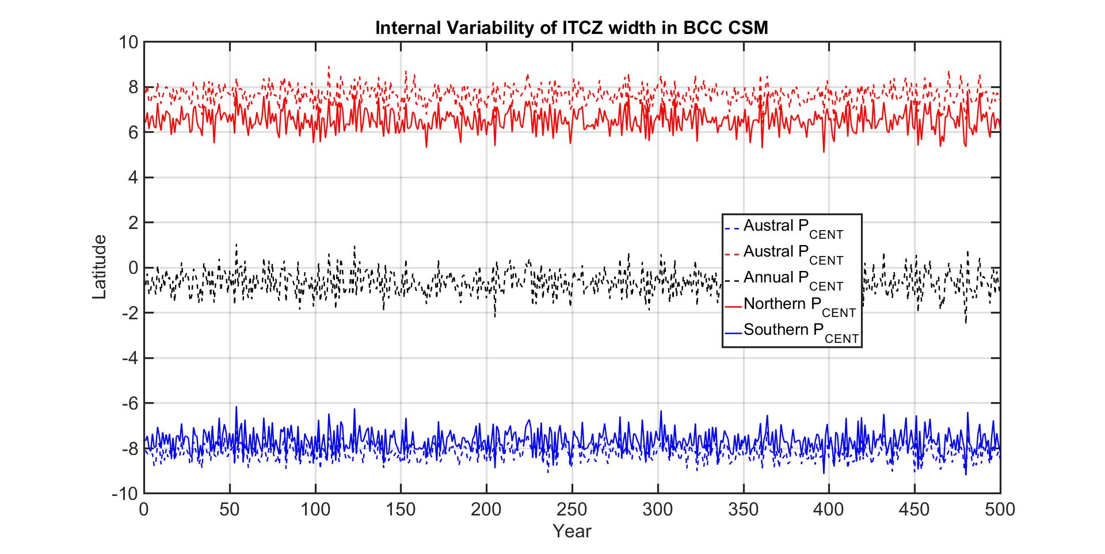

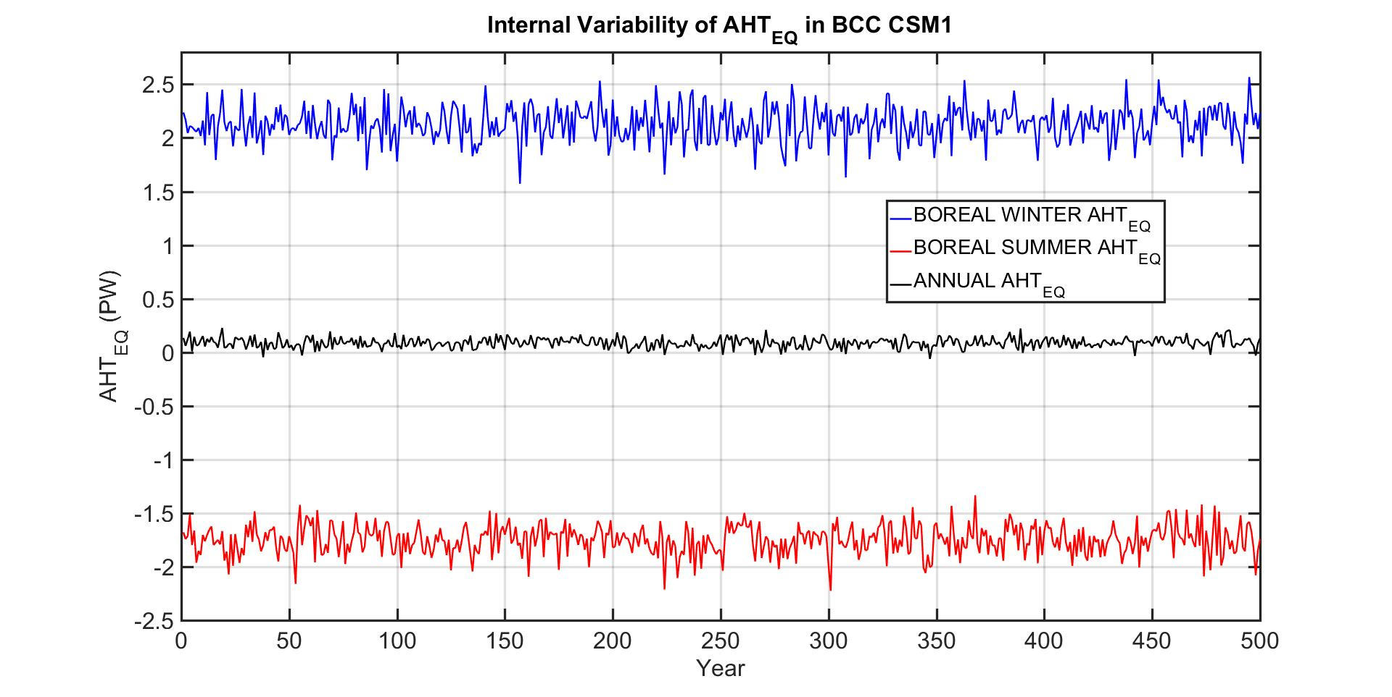
The year-to-year variability – cited here as one standard deviation—of SR_{ITCZ} (Boreal P_{CENT}-Austral P_{CENT}) is 0.31º. The standard deviation of year-to-year variability in ||AHT_{EQ}|| -- defined here simply as the Boreal winter (DJF) minus Boreal summer (JJA)—is 0.15 PW. Both SR_{ITCZ} and ||AHT_{EQ}|| have a decorrelation time scale of less than 1 year; the lag one year autocorrelation is less than zero for both time series as can be seen by the lack of low frequency variability in both time series. Therefore, our 50 year averages used to compose the climatology each have 50 effective degrees of freedom and, thus, reduce the contribution of internal variability to the by a factor of 1 divided by the square root of 50 = 0.14. The resultant contribution of internal variability to climatological average ||AHT_{EQ}|| is 0.02 PW and that of SR_{ITCZ} is 0.04º. These values are small compared to the changes in a given model (Figure 1).

Conclusions:
I think the conclusions could be strengthened by making the framework more
quantitative and including more model scenarios. Please see my suggested
improvements below.

Suggested Improvements:
I think the paper would be more impactful if the authors
1) Make their framework more quantitative. Namely demonstrate the
approximations they are making in (2) and (3) hold in CMIP5 models (see 3)
above),

Please see response to points 2 and 3 and the supplemental information of the revised manuscript.

2) Quantify the contribution to AHT (see decomposition in equation 1) that is
associated with the large model spread of AHT and thus the double-ITCZ bias
in CMIP5 models,

We apologize, but we do not understand the reviewer’s point here.

3) Demonstrate the robustness of the conclusion connecting changes in the
ITCZ width to the tropopause height using additional CMIP5 simulations, e.g.
RCP8.5 and AMIP4K where there is also a robust increase in tropopause
height.

This is a thoughtful suggestion. However, we chose to focus on long term averages in the 4XCO₂ simulations to maximize the signal to noise ratio and also thought it was important to use coupled model simulation to demonstrate the robustness of these results to coupling with the ocean that has been identified as an important moderator of ITCZ shifts (Green and Marshall, 2017, Coupling of Trade Winds with Ocean Circulation Damps ITCZ Shift).

Minor comments:
Page 5: The sensitivity of seasonal precipitation to slab-ocean depth was previously
examined by Bordoni & Schneider (2008).

Citation added.

Page 10: The discussion of mechanism #1 assumes the denominator is fixed. Please
make that clear in the text.

Clarification added.

Page 12: How did the authors choose the 2.7, 2.6 and 2.0 PW values?

These values delineate composite with nearly (6-5-6 members in each composite) equal model numbers in each composite.

Page 12: I don’t see a large difference in the bimodality of the blue and red lines in Fig.
2B (they are both bimodal and don’t agree with the black dashed line). The blue and
dashed black line in Fig. 2B agrees somewhat better than the red, green and dashed
black line but there is still a large discrepancy.

The different widths between the bi-modal peaks is evident in the figure as well as the relative magnitudes of the precipitation peaks and the amplitude of precipitation of the local minimum near the equator. Both these features are qualitatively consistent with the expected annual mean precipitation from a modified seasonal migration of the ITCZ. We discuss the differences between the observed and modeled precipitation in terms of annual mean energetics in the text.

Page 14: According to equation (3) the slope in Fig. 3A should be related to the inverse
of the GMS. However, Fig. S2 shows the GMS histograms are not distinguishable (they
overlap) unlike the slopes in Fig. 3B. Can you please explain the discrepancy? Is the
SR correlated with the inverse GMS as expected from equation (3)?
Please see response to major point 2 above.

