We thank both Dr. Hill and Professor Back for their thoughtful criticism and helpful suggested revisions. Their expertise has help us craft a more precise revised manuscript in terms of how we discuss the gross moist stability and the metrics used to quantify the width of tropical precipitation. We also appreciate the suggested expanded citations and discussion of previous work. Please find the Reviewer comments in red and our responses in black

Response to Reviewer 1

They then somewhat speculatively attribute these changes to changes in the gross moist stability- this last part is the weakest link in the argument and it is phrased as speculation in the paper, so the authors acknowledge this.
The discussion of things that influence the gross moist stability could be strengthened. In particular, there are two competing effects of warming on gross moist stability, and which of these wins out in which situations is not clear. For example, Arnold, Kuang and Tziperman (2012) argue that gross moist stability decreases with warming due to the larger moisture gradients in the lower troposphere, and in fact the original Neelin and Held work argued something similar for the relationship with SST. In fact, the posited relationship with SST is not borne out in observations (see Back and Bretherton 2006, Inoue and Back, 2017- there are lower GMS is colder SST regions, though it's likely relative SST that matters, so this can't be applied to climate change). However, it's probably worth mentioning that this possible effect exists in addition to the effect the authors discuss where the vertical motion profile shifts up and if the MSE profile shifts up less, then GMS goes up. In addition, the neglect of eddy fluxes seems like it is probably significant in actually evaluating the GMS. (Though in the spirit of GMS studies, you could just redefine the GMS you're looking at since there are so many versions already). None of this is a deal-breaker for the paper, just suggestions for the authors to consider.

Thank you for your thoughtful suggestions on how to expand our discussion of the GMS changes. We have added the following discussion to the revised manuscript:

One definition of the GMS – which varies widely in the literature– is the ratio of
308 the MSE flux in the Hadley cell divided by the mass flux [Held, 2001] which reduces
309 to the equivalent potential temperature contrast between the upper and lower levels if the
310 flow is concentrated in narrow layers on the upper and lower boundaries [Hill et al., 2015].
311 We analyze this relationship by way of the seasonal regression between the tropical mass
312 overturning streamfunction and atmospheric energy transport in each model (see supple
313mental Fig. A3). The inferred equivalent potential temperature contrast between the upper
314 and lower branches of the Hadley cell based on the seasonal slope between AHTEQ and
315 PSIEQ (GMS), increases in all but one climate model under 4XCO2 (statistically significant
316 at the 99.9% confidence interval). The ensemble average inferred GMSEQ increases from
317 9.7K to 10.8K under 4XCO2 (Fig. A3) which amounts to a 10% change that more than
318 accounts for the 5% ensemble average decrease in SRITCZ. This finding is consistent with
319 the enhanced GMS of the tropical atmosphere associated a rising tropopause [Wu and Tan,
320 2013; Lorenz and DeWeaver, 2007]. We note that this analysis neglects the contribution
321 of transient eddy MSE fluxes and their changes and we return to a discussion of the GMS
322 changes in the discussion section.

And in the discussion section

361 Future changes in GMS are uncertain due to competing effects from increases in the ver
362tical moisture gradient in the lower troposphere [Arnold et al., 2013], raising the upper
363 branch of the circulation (with tropopause lifting) toward higher equivalent potential tem
364perature air [Wu and Tan, 2013] and, changes in the vertical structure of the meridional
365 winds [Wei and Bordoni, 2018]. Theory suggests that GMS is controlled by the SST gra
366dient between the ITCZ and the location of interest [Hill et al., 2015] and that regions that
367 are cooler then the SST near the ITCZ should have enhanced GMS [Merlis et al., 2013]
368 although this relationship is not seen in the observed spatial variability [Inoue and Back,
369 2017; Back and Bretherton, 2006].

Response to Reviewer 2
Confusion regarding how the different metrics are defined and calculated
A lot of weight is given to the result that the seasonal range metric and the annual width metric
are correlated. But the two quantities do not stem from independent data sources: precipitation
in July-August and in January-February is used in both (directly in the case of the seasonal range,
and through those months’ contribution to the annual mean for the annual width). In other words,
the two quantities are not independent, and so it seems like by construction they will be at least
somewhat correlated. (The phrase "As expected" on L87 seems to confirm this.)
Phrased another way: In either hemisphere, the summer months will dominate that hemisphere’s
annual-mean centroid. So the difference between the two annual mean centroids is largely sampling
the local summer precipitation in either hemisphere. . . which is exactly the same data that’s
going into the seasonal range metric! Some discussion of this and justification for the physical
meaningfulness of their correlation is necessary.

We agree with Dr. Hill that the annual mean precipitation peak in each hemisphere is primarily a consequence of the precipitation distribution during the local summer – this is the central point we are trying to make in regards to both the inter-model spread and the response to global warming. While the two metrics we analyze (WA_{ITCZ} and SR_{ITCZ}) do rely on the same data (solstitial season precipitation) there is no requirement that they be well correlated. For instance, if the tropical precipitation did not vary seasonally and was bi-modal during each season, these metrics would not be strongly correlated. Similarly, if the ITCZ migration jumped rapidly into one hemisphere during its seasonal march and lingered toward the opposing hemisphere, these metrics would also not be strongly correlated. Stated otherwise, the correlation between WA_{ITCZ} and SR_{ITCZ} is expected in a system where, as Dr. Hill points out, the annual mean precipitation peak in each hemisphere is dominated by the contribution in the local summer and the seasonal march of the ITCZ is symmetric about its annual mean location. Advancing the connection between the seasonal precipitation and annual mean tropical precipitation width is the central focus of the manuscript and these connections have not been made in the literature to date regarding the inter-model spread and contraction of precipitation under global warming. We have added a line the revised manuscript to clarify the physical meaningfulness of the correlation “suggesting that the location of the annual mean precipitation peak in each hemisphere is a consequence of the ITCZ location during the local summer as opposed to the bi-modality of the precipitation during a given season”
Separately, the paper initially claims that the centroid is preferable to the location of the zonal-mean
precipitation maximum as an indicator of the ITCZ. But for the SRITCZ metric, an involved iterative
procedure is described that ultimately yields a value "near the latitude of maximum precipitation".
So why bother with the complicated procedure at all? As an alternative, why not just use the
precipitation centroid in either hemisphere, i.e. restricting to 0-20S or 0-20N? C.f. Adam et al.
(2016), who also include an exponential factor "N". Their alternative metrics should probably be
tried out and the results discussed.
Similarly, for the northern and southern centroids (S.I. L68-71), how different are the results if the
simpler definition is used of splitting at the equator rather than at the annual-mean centroid?

The primary findings of our manuscript are unaffected by the definitions of WA_{ITCZ} and SR_{ITCZ} used. Specifically, as demonstrated below, the strong correlation between WA_{ITCZ} and SR_{ITCZ} seen in the inter-model spread and the robust decrease in WA_{ITCZ} and SR_{ITCZ} under global warming are seen using the alternative definitions of seasonal and northern and southern annual mean precipitation centroids. We regret that confusion with text from a previous version of the manuscript used the iterative procedure in the description of methodology for calculating the boreal (JA) and austral (JF) P_{CENT} while the procedure we used for all figures and statistics presented in the manuscript used the following definition of the boreal and austral P_{CENT} (as stated in the revised supplement): “the austral P_{CENT} is defined as the latitude delineating regions of equal magnitude (spatially weighted) JF precipitation between the annual mean P_{CENT} and 15º south of the annual P_{CENT} the boreal P_{CENT} is defined as the latitude delineating regions of equal magnitude (spatially weighted) JA precipitation between the annual mean P_{CENT} and 15º north of the annual P_{CENT}.” In our analysis (some of which is shown below repeated below) we used many different definitions of the seasonal and annual mean ITCZ location and found that all metrics found both strong correlations between the inter-model spread in WA_{ITCZ} and SR_{ITCZ} and a robust contraction of WA_{ITCZ} and SR_{ITCZ} under global warming although the quantative relationship between WA_{ITCZ} and SR_{ITCZ} did depend on the exact definition used. We have decided to use the definitions used in the original figures (annual mean P_{CENT} based metrics) and avoid the complicated iterative approach at the suggestion of Dr. Hill as this approach is least straightforward and provides similar results to the “Exponential factor” method of Adam et al. (2016).

We present additional figures below showing both the location of the various metrics of the seasonal and annual mean northern and southern precipitation peaks. In addition to the metrics used in our original and revised manuscript (iterative and annual P_{CENT} based) we also consider the metrics proposed by Dr. Hill of the the P_{CENT} north and south of the equator and the “Exponential factor”. The 4 metrics considered are:
Annual mean northern and southern P_{CENT}
- Annual P_{CENT} based: After identifying the annual mean P_{Cent} as the latitude delineating equal areas of precipitation from 20S to 20N, the northern P_{CENT} is defined as the latitude delineating regions of equal magnitude (spatially weighted) annual precipitation between the annual mean P_{CENT} and 15º north of the annual P_{CENT} and the southern P_{CENT} is defined as the latitude delineating regions of equal magnitude (spatially weighted) annual precipitation between the annual mean P_{CENT} and 15º south of the annual P_{CENT} .
- Fixed latitude: the northern (southern) P_{Cent} is the latitude delineating regions of equal magnitude (spatially weighted) annual precipitation between the equator and 20ºN (S).
- Exponential factor. The northern (southern) P_{Cent} is defined as the precipitation to the 10th power weighted latitude between the equator and 20ºN (S). This follows Adam et al. (2016) who introduced general power weighting latitudes and seem to prefer a 10th power to characterize the seasonal peak of precipitation

Seasonal austral and boreal P_{CENT}
- Annual P_{CENT} based: After identifying the annual mean P_{Cent} as the latitude delineating equal areas of precipitation from 20S to 20N, the austral P_{CENT} is defined as the latitude delineating regions of equal magnitude (spatially weighted) JF precipitation between the annual mean P_{CENT} and 15º south of the annual P_{CENT} and the boreal P_{CENT} is defined as the latitude delineating regions of equal magnitude (spatially weighted) JA precipitation between the annual mean P_{CENT} and 15º north of the annual P_{CENT} .
- Fixed latitude: the boreal (austral) P_{Cent} is the latitude delineating regions of equal magnitude (spatially weighted) JA (JF) precipitation between the equator and 20ºN (S).
- Exponential factor. The boreal (austral) P_{Cent} is defined as the JA (JF) precipitation to the 10th power weighted latitude between the equator and 20ºN (S).
- Iterative approach: for each season, we iteratively search for the latitude that delineates regions of equal area weighted precipitation within a 15º wide region. In the first iteration, we define the boreal and austral P_{CENT} as done in the fixed latitude approach. Thereafter, we define the latitude that delineates equal areas of precipitation over the bounds 7.5º north and south of the previous iteration of P_{Cent} calculation. In this method, the bounds used for the P_{Cent} calculation are defined by the precipitation distribution itself. We repeat this iterative process until the definition of seasonal P_{Cent} stabilizes (20 iterations).

We show two additional sets of plots using these definitions: (i) the location of these metrics defined from the ensemble mean precipitation for the PI control and 4XCO₂ simulations (Fig. S1) and (ii) the correlation between WA_{ITCZ} and SR_{ITCZ} defined using all 4 of the proposed SR_{ITCZ} metrics above and the 3 WA_{ITCZ} metrics (12 plots total) (Fig. S3).

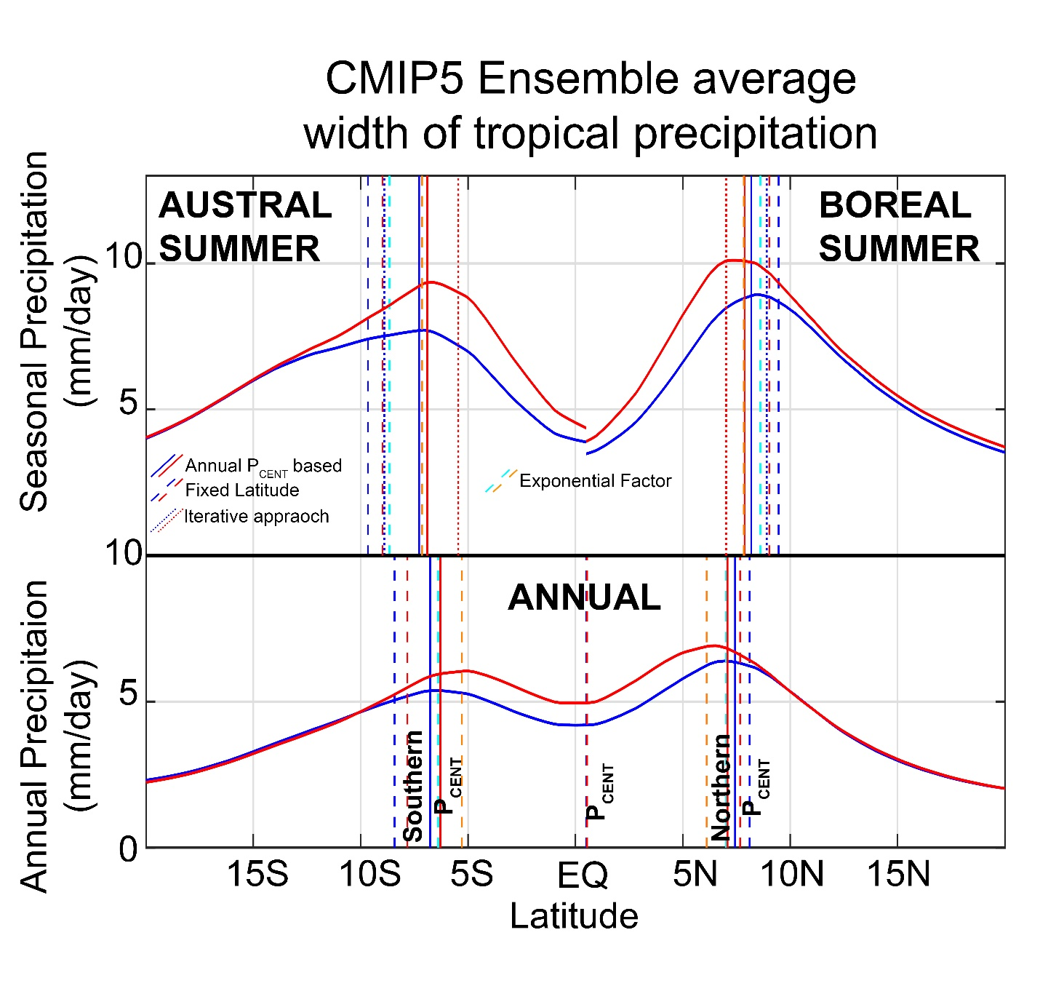
Figure S1. Demonstration of the different definitions of seasonal range of ITCZ (SR_{ITCZ}) and width of annual tropical precipitation (WA_{ITCZ}). The CMIP5 PI ensemble and zonal average precipitation is shown. Austral summer is shown on the upper left and boreal summer in the upper right. The vertical lines represent the different definitions of austral and boreal P_{CENT}: (i) solid red and blue show the annual P_{CENT} based metric, (ii) dashed red and blue lines show the fixed latitude (equator to 20º) based metric, (iii) solid cyan and orange lines show the exponential factor precipitation weighted latitude with power 10 used and, (iv) dotted red and blue lines show the iterative approach based metrics. The annual mean precipitation is shown in the bottom panel alongside the definitions of the northern and southern peak precipitation locations used above. Note, we do not show the iterative approach for the annual mean since the northern and southern peaks are nearly the same magnitude and make the process unstable.
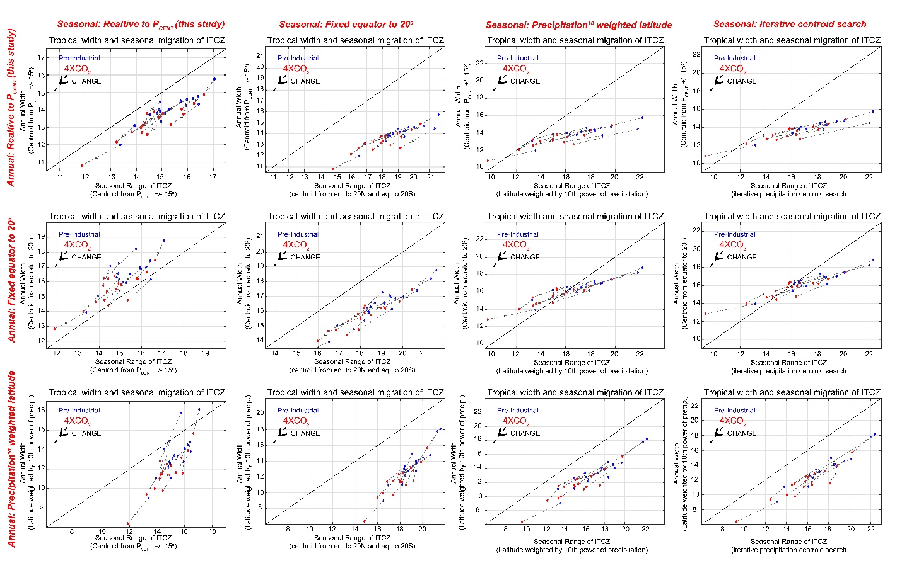
Figure S2. Comparison of the relationship between WA_{ITCZ} and SR_{ITCZ} and its change under global warming using the different metrics for P_{CENT}. The columns show the different metrics used to define SR_{ITCZ} moving from left to right: (i) annual P_{CENT} based, (ii) fixed latitude from equator to 20º, (iii) exponential factor and (iv) iterative P_{CENT.} The rows show the different metrics used to define WA_{ITCZ} moving from top to bottom: (i) annual P_{CENT} based, (ii) fixed latitude from equator to 20º and, (iii) exponential factor. Each panel shows the scatter plot of (abscissa) the SR_{ITCZ} and the (ordinate) WA_{ITCZ} for each CMIP5 simulation. Blue and red dots represent the PI and 4XCO₂ values in individual models respectively, and arrows indicate the change.
In all sets of metrics, there is a significant correlation between WA_{ITCZ} and SR_{ITCZ} in the mean state. We highlight the results using like pairs of metrics (the three plots on the main diagonal of Fig. S2). The correlation between inter-model spread between WA_{ITCZ} and SR_{ITCZ} is R=0.91 using the annual P_{CENT} based metrics (as cited in the manuscript), R=0.94 using the fixed latitude between the equator and 20ºN/S metrics and, R = 0.93 using the exponential factor metrics.

In all sets of metrics there is a robust decrease in both WA_{ITCZ} and SR_{ITCZ} under global warming. The ensemble mean change (and standard deviation of the mean change) in annual mean tropical precipitation width, WA_{ITCZ}, under 4XCO₂ is -0.79±0.09º using the annual P_{CENT} based metrics (result used in the manuscript), -1.02±0.09º using the fixed latitude between the equator and 20ºN/S metrics and, -2.00±0.26º. The ensemble mean change (and standard deviation of the mean change) in the seasonal range of ITCZ, SR_{ITCZ}, under 4XCO₂ is -0.66±0.11º using the annual P_{CENT} based metrics (result used in the manuscript), -1.13±0.13º using the fixed latitude between the equator and 20ºN/S metrics , -2.25±0.29º using the exponential factor metrics and -2.28±0.34ºusing the iterative metric. We note that our used of the annual P_{CENT} based metrics is actually the most conservative of the metrics used in terms of the amplitude of the WA_{ITCZ} and SR_{ITCZ} and emphasize how robust the results are across all metrics considered.

Strictly speaking, GMS is the ratio of the MSE flux (MSE times v integrated over the whole column)
to the mass flux (v integrated over half the column). It reduces to an upper- minus lower-level MSE
or other thermodynamic tracer only if the flow is concentrated into narrow layers near the upper and
lower boundaries. This is a useful conceptual starting place for GMS, but inadequate for assessing
its quantitative and even qualitative behavior over the annual cycle and in response to external
forcing. In particular, GMS can be very sensitive to how "top-heavy" the meridional wind profile
is. In all of these studies, GMS is explicitly calculated and its behavior directly investigated, which
doing so here would be much more satisfying than "speculating" (c.f. L289).
We used the GMS definition suggested by Dr. Hill – ratio of MSE flux to mass flux-- in our evaluation of GMS in the supplemental figure and described in the main text of the manuscript. We have rewritten and reorganized the text to better highlight this analysis that unfortunately, due to length restrictions, could not be included as a figure in the manuscript. Strictly speaking, our MSE flux includes contributions from the eddies. It is unclear to us if these should be included in the preferred definition of GMS.

Our use of the word “speculating” was in recognition (emphasized by a lengthy review process) that no single definition of GMS satisfies the entire community. Evaluating the diverse and complicated range of GMS definitions is beyond the scope of the present manuscript and we elect to evaluate a single metric of GMS that is most germane to the focus of the manuscript and soften the language of the text to acknowledge alternative GMS definitions.

One definition of the GMS – which varies widely in the literature– is the ratio of
308 the MSE flux in the Hadley cell divided by the mass flux [Held, 2001] which reduces
309 to the equivalent potential temperature contrast between the upper and lower levels if the
310 flow is concentrated in narrow layers on the upper and lower boundaries [Hill et al., 2015].
311 We analyze this relationship by way of the seasonal regression between the tropical mass
312 overturning streamfunction and atmospheric energy transport in each model (see supple
313mental Fig. A3). The inferred equivalent potential temperature contrast between the upper
314 and lower branches of the Hadley cell based on the seasonal slope between AHTEQ and
315 PSIEQ (GMS), increases in all but one climate model under 4XCO2 (statistically significant
316 at the 99.9% confidence interval). The ensemble average inferred GMSEQ increases from
317 9.7K to 10.8K under 4XCO2 (Fig. A3) which amounts to a 10% change that more than
318 accounts for the 5% ensemble average decrease in SRITCZ. This finding is consistent with
319 the enhanced GMS of the tropical atmosphere associated a rising tropopause [Wu and Tan,
320 2013; Lorenz and DeWeaver, 2007]. We note that this analysis neglects the contribution
321 of transient eddy MSE fluxes and their changes and we return to a discussion of the GMS
322 changes in the discussion section.

This is thoroughly investigated by Wei and Bordoni (2018), who investigate ITCZ migrations and
the energetic framework throughout the annual cycle. They show that during the annual cycle
low-latitude GMS sometimes becomes negative due to changes in the meridional wind structure.
This and many other of their results are highly germane to this paper, and as such they should be
cited and properly discussed.
Separately we investigated changes in Hadley cell GMS under SST perturbations in Hill et al.
(2015), positing simple mechanisms by which the full meridional field of GMS throughout the tropics may change due to SST mean warming/cooling and changes in SST meridional gradients. This
mechanism yields a “stable-get-stabler“ response of GMS under mean warming (although admittedly
the evidence for this mechanism in simulations both in that paper and since then have been mixed).
This work was a direct extension of some of the ideas of Merlis et al. (2013).

Thank you for these thoughtful suggestions. We have incorporated these ideas and a discussion of the literature into the following text of the revised manuscript (in the discussion section):

361 Future changes in GMS are uncertain due to competing effects from increases in the ver
362tical moisture gradient in the lower troposphere [Arnold et al., 2013], raising the upper
363 branch of the circulation (with tropopause lifting) toward higher equivalent potential tem
364perature air [Wu and Tan, 2013] and, changes in the vertical structure of the meridional
365 winds [Wei and Bordoni, 2018]. Theory suggests that GMS is controlled by the SST gra
366dient between the ITCZ and the location of interest [Hill et al., 2015] and that regions that
367 are cooler then the SST near the ITCZ should have enhanced GMS [Merlis et al., 2013]
368 although this relationship is not seen in the observed spatial variability [Inoue and Back,
369 2017; Back and Bretherton, 2006].

The meridional extent of the ITCZ as a coherent rainbelt is increasingly studied, including by one of
the co-authors. This is, in principle, a different question than that of how far separated are the two
annual-mean peaks in tropical precip. But both are described as "width". I recognize that in this
paper the term "ITCZ width" (which those other studies use) is not used, with "width of tropical
precipitation" used instead, but these are close enough to cause confusion (for me at least). So I
recommend more explicitly discussing this in the introduction, and maybe also consider different
phrasing (although nothing catchy immediately came to my mind).
Popp and Lutsko (2017) is relevant; they consider the different ways of quantifying the zonal
mean precipitation distribution and how to interpret them. . . I believe their _s is identical to your
WAITCZ.

Thanks for this suggesting this clarification and we agree that clarifying how our focus differs from that used in the previous literature is helpful to the reader. We have added a short discussion in the introduction and a citation to Popp and Lutsko (2017) since their ϕ_{S} is at least conceptually similar to our WA_{ITCZ} though we wish they had come up with a catchier name:

We note that while other studies have defined the
46 ITCZ width as the boundary between upwelling and downwelling atmospheric motion
47 [Lau and Kim, 2015; Byrne and Schneider, 2016a], we focus on the meridional distance
48 between the tropical precipitation peaks in each hemisphere that [Popp and Lutsko, 2017]
49 previously identified as the “distance between the two ITCZs”.

Minor Comments
L16-20 The first sentence of the abstract is a re-statement of existing work (although "unanimous"
is a strong claim. . . is that really true?). But I can’t tell if the following two sentences are.
Has each of these claims been clearly documented in the past? Or, are they new claims being
made? If the latter, they should be presented with something like "We argue. . . ". If the
former, it would help to include something like "Past studies have shown".

All models (unanimously) simulate a narrowing of WA_{ITCZ} (lines 95-98 of original manuscript). We have added a “We argue that” to the second line of the abstract. These claims have not been made explicit elsewhere in the literature to our knowledge although they are often invoked in the paleoclimate literature.

L34 "Previous studies have primarily focused. . . " Is this fair anymore? There is a budding literature
on ITCZ width, including works cited farther below and others, some by one of the co-authors.
Although I agree with the claim that, historically, subtropical expansion has been an especially
popular topic.

We use “primarily” to emphasize the predominant focus (in the literature and popular media) on subtropical expansion. As written, the introduction juxtaposes the contrast between the subtropical expansion and contraction of tropical precipitation. We immediately acknowledge the literature on ITCZ width while also emphasizing (see response to major points) that our focus differs from these studies by focusing on the meridional separation of the rainfall peaks in each hemisphere.

L45 This is a very abrupt end to Section 1. There is no roadmap provided for the rest of the
paper or a preview of the arguments you are making. These are very useful in orienting the
reader and should be included. Preceding that, I think it would make sense for the first two
paragraphs of Section 2 to go into Section 1 instead.

Great suggestion. We have moved the transition between the introduction and 2nd section by tow paragraphs.

L47 As defined how?

Defined as the precipitation centroid, citation to Donohoe et al (2013) and Chiang and Freidman (2012) added.

L49-50 This reads a bit too casual; maybe just insert "loosely speaking," before "regions within. . . "

Added.

L60-63 This is maybe pedantic, but is this strictly true? Certainly in the E. Pacific there are
periodically true double ITCZ events on daily to weekly timescales, mostly in boreal spring.
See e.g. Haffke et al. (2016).

This discussion is in regard to the zonal mean, as stated and now reemphasized in the revised manuscript in the opening to the paragraph.

L72 Worth noting in this paragraph that other metrics exist and remain in use. E.g. Adam et al.
(2016), Section 2.

Discussion and citation of the Adam et al. metrics (see response to major point above) added:
“We note that alternative metrics for ITCZ location include precipitation (raised to a power) weighted latitude (Adam et al., 2013) and yield similar results to the P_{CENT} metrics used here.”

L97-100 Are the reasons for these arguments thought to be self-evident, or are you going to supply
them later? They do not seem self-evident to me, but then I wasn’t sure when reading this
if you were going to then justify them later on, so this tripped me up. More precise language
and a little more signposting would help. Also, I thought the argument was that the annual
mean was controlled by the seasonality. But here you’re saying they are orthogonal?

Revised to state that to annual mean ITCZ location has been the focus of previous work and that we will argue in this manuscript that the WA_{ITCZ} is controlled by seasonal energetics (which by definition have annual means removed so are orthogonal).

L112 "governed by" What justifies going from a correlation to this statement of causality?

Edited to “is correlated with”

L117 Name of model and relevant citation needed.

Revised to include that this is done in the GFDL AM2.1 model and a citation to Donohoe et al. (2013a)

L117-133 This is useful but qualitative. What are the WAITCZ and SRITCZ values for these
simulations, and what is their correlation across the runs compared to that of the CMIP
models? That would help in determining just how much we can learn from the simple model
re: the more complex ones.

We prefer to keep this discussion qualitative as the seasonal ITCZ migration is outside of the bounds used to define the SR_{ITCZ} (in all but the now abandoned iterative metric) in the shallow slab depth simulations. We would have to substantially modify the definitions of WA_{ITCZ} and SR_{ITCZ} to generalize the results to this idealized simulation.

L157 What motivates this assumption of invariance?

As stated in the opening of the paragraph: “AHTEQ and ITCZ location are highly (R2 = 0.99) correlated over the observed (and modeled) climatological seasonal cycle [Donohoe et al., 2013b].”

L196-198 As I understand it, this statement doesn’t directly follow from the preceding statements.

The increase in solstitial season <SHF> demand larger magnitude AHT_{EQ} from Eq. 2 (in the absence of compensating changes <OLR>. The increase in SR_{ITCZ} then follows via Eq. 1 (in the absence of compensating changes in EFF_{AHT}.

L225 C.f. major comment above, the approximation also stems from the two layer assumption

This stated assumption has been added to the revised manuscript. See response to major point above.

L257-264 What is the actual value of the correlation between SRITCZ and the slopes? It is not
obvious to me from the plot that it should be negligible compared to that of AHT.

The correlation is 0.32. We prefer not to present statistical insignificant correlations.

L286 I know this isn’t the focus of the present paper, but isn’t this counter to the claim of 3
degrees/PW being invariant?

We agree that this runs counter to the claim that the ITCZ/AHT_{EQ} is nearly invariant at 3º PW⁻¹ ranging from the seasonal cycle, to inter-annul variability to the forced climatological response to external forcing. Perhaps the resolution is that changes in annual mean AHT_{EQ} are larger than the impact of mean state AHT_{EQ} times the change in slope. This is plausible given that both mean state AHT_{EQ} and the annual mean perturbations are near zero (and can differ in sign between models and with external forcing). We hope to pursue the impact of slope changes on previous interpretations of ITCZ shifts, especially in the context of paleoclimate records.

L352-357 I think I understand your point here, but it took me a few tries. . . This is potentially an
important claim and as such would be nice to have spelled out more explicitly/clearly.

We have rewritten this argument and are in the process of writing a more detailed paper about this subject.

Figure 1 Consider omitting the arrows. They are redundant, since the change is always going
from the blue to the red dots, and the connecting line already makes clear which are paired
together. It would make the panel less busy, which would help since there are a lot of symbols
clumped together near the observations.

We prefer to keep the arrows to emphasize the point that changes are all in the same direction and follow the pattern of inter-model spread.

Figure 2b The green and red curves are very similar, so why separate them? Probably cleaner
to combine them, leaving just two categories: large (>2 PW) vs. small (<2 PW) equatorial
AHT

This is a good point. Our selection of 3 groups was made to satisfy a different reviewer who thought two groups were made at arbitrary cut offs to cherry pick the data. We, thus chose three evenly spaced composites and we think the figure as it is is a honest representation of the limitations of the argument presented.

Figure 2c Note what the dashed line is (presumably a linear regression)

Noted

S.I. It’s a little odd for the Appendix to be in a separate Supplement. I would put it in main text
if space permits. If not, then just call it the Supplemental Information.

We have renamed the Appendix “supplemental Information”

S.I. L29-41 Is this consistent with any existing studies on observed trends? I.e. based on this
paragraph, one would expect that there has been no discernible trend over the historical
period.

Correct, there is no discernible trend in the historical model simulations. We know of no studies that have looked at the modeled trend in a metric similar to WA_{ITCZ} or SR_{ITCZ} over the historical simulations.

S.I. A.2 I don’t understand the iterative procedure.

We have removed the iterative procedure from the revised manuscript. We apologize the our description was so confusing.

