We thank the two Reviewer’s for thoughtful comments and suggestions on our revised manuscript. Please find the Reviewer comments in red and our responses in black.
We note that Reviewer 1 and 2 seem to be referencing line numbers from different versions of the manuscript. Reviewer 1 is referencing line numbers from submission in September 2019 which we subsequently shortened and resubmitted on 10/04/2019 at the request of the Editor. Reviewer 2 is referencing line numbers from the shortened manuscript.
Reviewer #1: The authors have revised the manuscript to address the concerns and questions raised by the reviewers to include more details on the methodology and discussion. I only have some minor comments:
Line 76: What does SIC stand for? It is not defined in the text.
Thanks for pointing this out. SIC (sea ice concentration) is now defined on line 73 of the revised manuscript.
Line 143: It is unclear what does "this region" indicates? Do you mean "a region"?
This was revised to say “the Arctic” in the most recent submission (10/04/2019). We apologize that the Reviewer seems to have been given an earlier submission.
Line 159: "end-member values": it is cleaer to use "maximum and minimum values".
This sentence was omitted from the most recent submission (10/04/2019). We apologize that the Reviewer seems to have been given an earlier submission.
Line 499: typo, SIAB
Fixed.
Line 598 - 601: please break this sentence into shorter ones.
Broken into two sentences in the revision.
...................................................................................
Reviewer #2:
General comments:
The main body of the manuscript (p.16) continues to need a more detailed description of the technique used to derive observational albedo change from the APP-x data. The response to reviewers clarifies that two techniques are applied to derive the OBE, but this could be made much more clear in the manuscript.
Thank you for this suggestion. We have revised the paragraph that introduces the observational estimate of the ice-sensitivity (lines 322-332) to emphasize that our estimate combines data from two different data sets (NSIDC and APP-x). We hope this clarifies the general approach.

Please also provide more detail on how the albedo change is derived from APP-x data. Are albedo changes calculated at the monthly or seasonal timescale? Are all-sky or clear-sky albedos used? Are the APP-x albedo values used directly, or is albedo derived from the ratio of surface upwelling and downwelling fluxes in APP-x?
APP-x radiative fluxes are computed by a neural network approximation of a radiative transfer model. Surface albedo is derived from the narrowband surface reflectance by converting to broadband and adjusting for observed atmospheric conditions and surface type. We use all-sky broadband albedo output at the monthly timescale and we use monthly RS and IS fields to calculate the SIAF. The monthly APP-x data was generously prepared by Xuanji Wang. All sky, broad band albedos provided by the data set are used. We have added that all-sky albedos are used to the revised manuscript (line 330) and the temporal resolution in now included on line 326 (prioir to introducing the two albedo data-sets. Additional information on the APP-x dataset is available in the dataset documentation (https://www1.ncdc.noaa.gov/pub/data/sds/cdr/CDRs/AVHRR_Extended_Polar_Pathfinder/AlgorithmDescription_01B-24b.pdf).

Related, there is considerable uncertainty in the APP-x surface albedo dataset that I don't think is sufficiently communicated or folded into the analysis of uncertainty. For example, in working with APP-x data I recall finding albedo values of 1.0, or when deriving albedo from the ratio of upwelling to downwelling flux, finding albedo values greater than 1.0 (!). I suggest acknowledging a bit more clearly that structural uncertainty in the APP-x albedo data might lead to even greater uncertainty in the IS estimate than calculated here.
The APP-X algorithm theoretical basis provides errors relative to measurements made at SHEBA with a bias of -0.05 (absolute) and RMSE 0.1 (absolute) at the orbital timescale (two orbits per day). If these biases are random (temporally uncorrelated) that would translate to order 0.01 errors at monthly timescale and the absolute bias will not contribute to the decadal trend (if stable). These errors are rather small at the gridpoint compared to both the impact of inter-annual variability (assessed by bootstrapping) and the inter-data set (APP-X versus NSIDC) differences.
We appreciate the Reviewer’s note that the ratio of upwelling to downwelling surface radiation exceeds one. We find no such values for the months considered (May-September) in the surface albedo data-set (Figure R1).
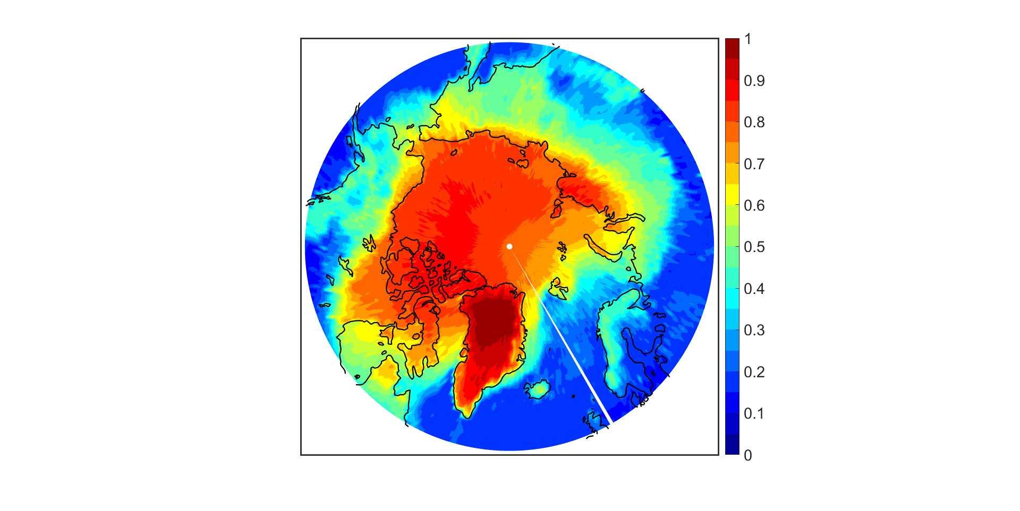
Figure R1. APP-x maximum surface albedo from May to September over all years (1982-2017).
There are many cases where RS is erroneously reported in units of W/m2/K instead of W/m2/% (e.g., pages 10-14).
Thanks for pointing this out. The units of RS have been fixed throughout.
Minor comments:
Abstract, line 31-32: Please clarify what this amplification of global surface temperature change is relative to. (Later, the paper nicely describes that this is relative to a world with no albedo feedback but all other feedbacks operating.)
Revised to say “relative to a climate system with no SIAF.”
line 47: Again, please clarify what this 30% increase in response is relative to. And why does this smaller feedback estimate (0.26 compared with your estimate of 0.37) lead to a larger amplification than your estimate (30% compared to 14%)?
We have edited the feedback gain calculation from the IPCC AR5 SIAF to be consistent with the calculation we present later in the manuscript (the total feedback from Armour 2017) which now gives a value of 22%. We also state that this is relative to a system with no SIAF in the revised manuscript. Our 14% amplification is based on the observational estimate of the Arctic sea ice albedo feedback of 0.16 W m⁻² K⁻¹ that does not include changes in albedo to snow changes or ant changes in the Southern Hemisphere. The 0.37 W m⁻² K⁻¹ number is the revised global climate mode ensemble mean.

We have also clarified the meaning of the Pistone and Eisenmann (2014) statement that SIAF contributes a 25% amplification of radiative changes relative to the anthropogenic forcing to date in the revised manuscript.
Equation 2: RI is also obviously time-dependent (e.g., by month or season in your analysis). Consider adding a time/month dependency to this equation.
Thanks for this suggestion. We felt including a time dependence (and the associated time averaging operator) to the equation would make the equation cumbersome. Instead, we have added the statement (lines 69-70 of the revised manuscript, “RS and α changes are calculated for each month and then their product is time averaged.”
line 136: Typo with two periods.
Fixed.
line 170: "all of the atmospheric absorption occurs above cloud top..." - It is a bit concerning that absorption by water vapor is neglected with this technique, though this issue is discussed later. I think it would be worth acknowledging this here and informing readers that the implications of this are discussed later.
Suggestion followed: “We further analyze the limitations of these assumptions at the end of this subsection.”
Several places in the text touch on uncertainty in observational albedo feedback associated with the relatively short time duration of measurements (e.g., discussion of natural vs forced variability on 436-437, Summary on 567-569). This issue is explored somewhat by Schneider et al. (2018, doi:10.1002/2017GL076293), who examined multidecadal feedback variability in CMIP5 models and concluded that short timescale estimates of albedo feedback agree rather well with century-scale estimates when the temperature change occurring during the period of analysis exceeds roughly 0.5K.
Thanks for pointing us to this study. We now cite and discuss this result in our initial discussion of the role of internal variability (line 441) in SIAF uncertainty.
line 516: The multi-model mean global IAF of 0.37 W/m2/K found here agrees well with the CMIP5 RCP8.5 21st century multi-model mean global albedo feedback of 0.40 W/m2/K found by Schneider et al (2018) using the CAM5 all-sky radiative kernel.

A discussion and citation has been added to the introduction of section 5A.

