Project Narrative:
Heat waves have large societal impacts with an estimated global impact of 16 trillion USD since 1992 (Calahan and Mankin, 2022). Heat waves disproportionately impact poorer nations with an estimated present-day economic loss of almost 7% for the poorest 10% of nations globally. Increases in heat induced mortality are projected to be the leading economic impact of climate change in the United States for global warming exceeding 2C (Hsiang et al. 2017) and account for the vast majority of US economic impacts for global warming exceeding 3C. Therefore, understanding how heat wave intensity will change in a warming world is one of the most societally relevant projections that climate science can provide stakeholders nationally and globally.
Heat waves are often defined as the number of days exceeding a threshold temperature (Meehl, 2004) with thresholds often defined by a certain percentile of the temperature distribution at each location. More sophisticated heat wave metrics account for changes in climate variables such as specific humidity (i.e. wet bulb temperature) and the duration of heat extremes both of which impede the human body’s ability to cool off during hot events (Coffel et al. 2017). We focus primarily on days exceeding a threshold temperature in this proposal for simplicity of presentation but intend to remain mindful of alternative societally relevant metrics of heat stress.
Heat wave intensity is projected to increase with global warming with the simplest impact being a uniform shift of the temperature distribution at a given location toward warmer temperatures. For example, consider the observed distribution of summertime (JJA) maximum daily temperatures in Las Vegas Nevada in which 3.8% of days exceed the threshold value of 105F as represented by the shaded black area in Fig. 1A. If summertime temperatures uniformly increase by 2F in Las Vegas with no assumed change in the shape of the temperature distribution, an additional 6.0% of summertime days will exceed the 105F threshold as represented by the dark black shaded area in Fig. 1B. Heat wave intensity can also change due to changes in the shape of the daily temperature distribution such as the width of the distribution which is characterized by the temporal variance of daily temperature. A 20% increase in temperature variance in Las Vegas with no time mean warming would result in a 4.7% change in days above 105F, comparable to that of a uniform 2F warming. Concurrent changes in time mean warming and temperature would have compounding and non-linear impacts on heat wave intensity (Fig. 1D) with the combination of 2F uniform warming and 20% increase in variance resulting in an 11.7% increase in days over 105F which is slightly more than the summed impact of uniform warming and increased variance (10.7%). Thus, it is critical to understand how daily temperature variance will change in order to provide societally relevant projections of heat wave changes.
How robust are the modeled changes in temperature variance? While modeled changes in daily temperature variance are included in previous work on projected heat wave changes (Meehl and Tebaldi, 2004), the relative contributions of time mean warming and changes in temperature variance remain unclear. We propose to address projected changes in variance by first examining whether models adequately simulate the temporal distribution of surface temperature variability across the globe at the timescales relevant for the simulation of heat waves.

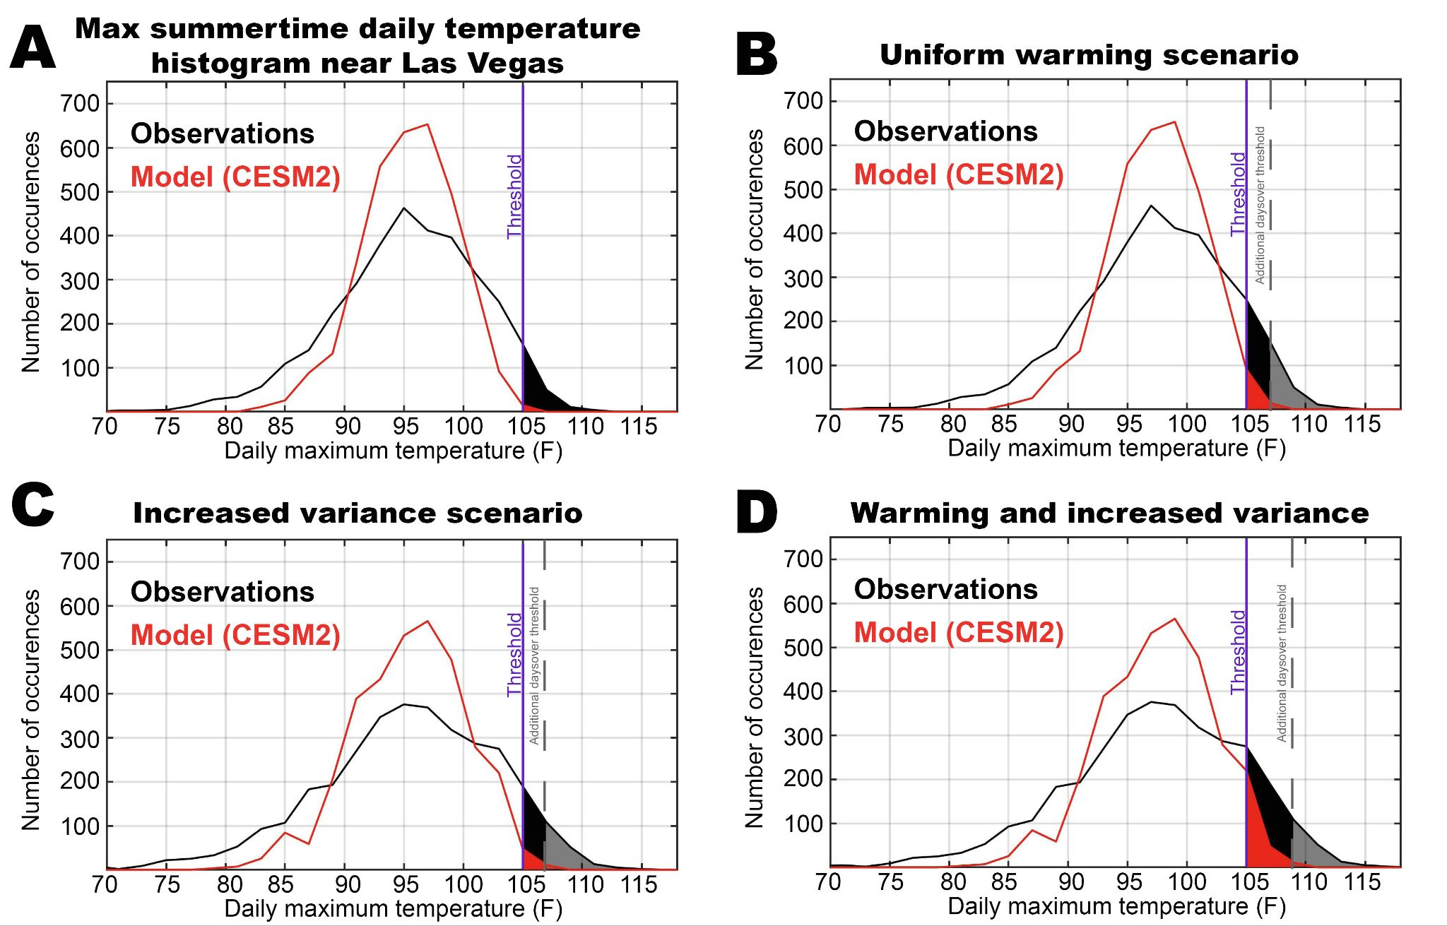

Fig. 1. (A) Comparison between the distribution of daily summertime maximum surface temperatures observed in Las Vegas (black) and that simulated by the CESM2 climate model at the nearest gridpoint. The shaded area represents the number of days over 105F. Panel (B) shows the additional number of days over this temperature threshold for a uniform warming of 3F for the observed and modeled distributions. Panel (C) shows the increase in the number of days above this threshold if the daily temperature variance is increased by 20% of its climatological value. Panel (D) shows the increase in threshold exceedances if time mean warming is combined with a 20% increase in daily variance.

Vargas Zeptello et al. (2020) recently demonstrated that models simulate too much monthly temperature variance due to soil moisture biases over many regions. The simulation of heat wave intensity – in both the present-day climate and changes under global warming– depends on daily (as opposed to monthly) temperature variance. Yet, there is no existing literature on model biases in daily temperature variance. We demonstrate, through our initial results presented in this proposal, that temperature variance at monthly and daily timescales are controlled by different physical processes and model biases at monthly timescales are not representative of those at the daily timescales pertinent to heat wave simulations. Our results suggest that models may have major deficiencies in representing processes that are essential for prediction of future heat waves and the proposed work will leverage the inter-model spread and process level understanding of the underlying physics to diagnose and improve the robustness of predicted changes in heat wave intensity.
To demonstrate the magnitude of model deficiencies in simulating daily temperature variability, we return to the distribution of daily summertime temperature observed at Las Vegas versus the distribution simulated by the NCAR CESM2 model (the only model we have analyzed to date) at the nearest model gridpoint. We have made a small additive adjustment to give the two temperature distributions the same mean temperature to emphasize the differences in the shape of the distribution. The simulated distribution has much less variability than observed (c.f. the red and black lines in Fig. 1A) and rarely (0.1% of days) exceeds the threshold of 105˚F. We note that observational reanalysis at a similar resolution to the model adequately represents the observed distribution (not shown) which suggests that the model bias toward too little temperature variability is regional as opposed to local with this region having a particularly strong bias (as elaborated on later in this proposal). How do model biases in the present-day temperature distribution impact predicted changes in heat waves under the warming scenarios previously discussed? A uniform warming of 2˚F only results in 1.2% increase in days over 105F in the model as compared to the 6% increase for the observed distribution. A 20% increase in variance results in 0.8% more days over 105˚F in the model (as compared to 4.7%). Interestingly, the combination of warming and increased variance increases days over 105˚F by 3.5% which is smaller but more non-linear than the thought experiment performed on the observations. These results highlight the impact that model biases in daily temperature variance have on predictions of future heat wave intensity and suggest that this particular model would likely underpredict future changes in heat wave intensity compared to a model that adequately represented modern-day variability.
Are all models biased toward too little daily temperature variability in this region? Our work seeks to understand how the potential misrepresentation of the underlying physical processes could impact simulated changes in heat wave intensity in a warmer world. The proposed work will analyze model biases in daily temperature variability across CMIP models and the SPEAR ensemble and additionally use a novel set of diagnostics to mechanistically understand why and where models are biased in their simulations of present-day daily temperature variance. This information will be leveraged to understand the robustness of simulated changes in temperature variance in the context of both the inter-model spread and large ensembles within a single model.
Surface temperature variability is influenced by atmospheric dynamics, radiative processes and surface properties – particularly soil moisture, which is known to influence the sensitivity of surface temperature to atmospheric and radiative forcing. Past research efforts have primarily focused on the influence of soil moisture biases on biases in simulated surface temperature variability at monthly timescales while ignoring the potential role of model biases in the magnitude of natural variability in atmospheric dynamics and radiative processes. We will analyze the mechanisms of model biases in summertime temperature variance using a novel conceptual framework which consists of: i) diagnostics of the atmospheric energy budget at daily timescales and; ii) a simplified surface energy budget model representing the coupling between the surface and atmosphere as a function of surface properties. This framework can be applied to both observations (atmospheric reanalysis and satellite radiation data) and models for a like-with-like comparison of the combined atmospheric, radiative and surface processes contributing to present day surface temperature variability. This framework will be used to answer the following questions:

- Are climate models biased relative to observations in their simulations of regional patterns of daily summertime temperature variance? Are the identified biases sensitive to the limited duration of the observations as discerned from the internal variability of large ensembles?
- What are the relative roles of atmospheric dynamics, radiative processes and soil moisture in determining the spatial pattern of summertime temperature variability? How are these processes represented in the latest generation of global climate models and how do model deficiencies in the simulated processes lead to regional biases in daily temperature variance?
- How robust are model predictions of future changes in daily temperature variance? Can the regional biases in modern day daily temperature variance and the underlying mechanism identified in (1) and (2) be used to identify more and less robust predicted changes? How will future heat wave intensity be impacted by changes in daily temperature variance?

The dynamics of daily anomalies has received little attention in part because these timescales sit at the nexus of weather forecasting and climate processes. We emphasize that the proposed work will analyze a novel set of questions which is possible for the first time ever due to: i) the availability of daily model output across a large set of global climate models; ii) advancements in the closure of the atmospheric energy budget at daily timescales which allow for a model-observation comparison of the processes driving daily temperature variability.

Section 2: Identifying model biases in temperature variance at timescales relevant for heat waves

This component of the proposed work asks if coupled climate models adequately represent near-surface temperature variability at the timescales relevant for heat waves. Vargas Zeppetello et al. (2020) showed that, on average, models are biased high by 25% to 100% (regionally) in monthly summertime variance – shown here in Fig. 2. The spatial pattern of biases in monthly temperature variance has been linked to soil moisture biases (Kotlarki et al., 2014 and Lorenz et al. 2016) by the following mechanism: temperature variance induced by atmospheric and radiative forcing is muted over moist soil due to efficient evapotranspiration whereas the same forcing will lead to larger temperature variance over moisture limited surfaces. Heat-waves are typically defined as events lasting longer than 3 days (Perkins-Kirkpatirck and Lewis, 2020) and depend on daily temperature variability. No previous work has analyzed model biases in daily temperature variance. It is unclear if the previously identified model biases toward too much monthly temperature variability are also seen at daily timescales relevant for simulating heat wave intensity and duration.
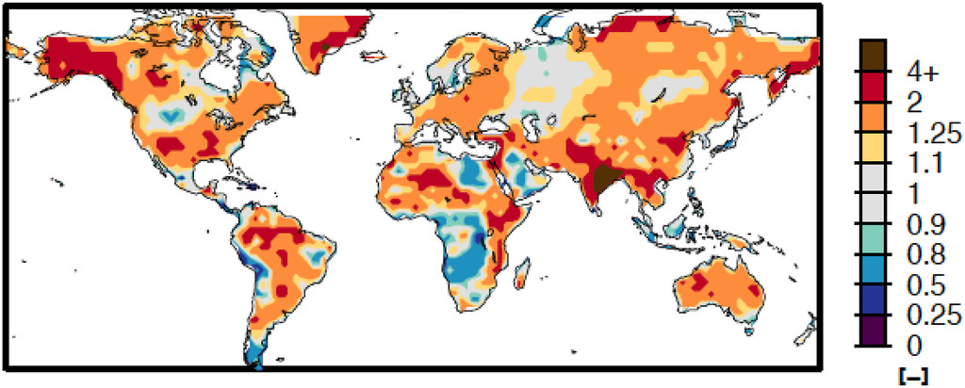
Fig. 2. Model bias in monthly summertime surface air temperature variability. The colors show the ratio of CMIP5 ensemble mean monthly air temperature variance divided by that observed over the historical period. This figure is taken from Vargas Zeppetello et al. (2020).

We present preliminary results in a single climate model (CESM2) to demonstrate that model biases in surface temperature variance at monthly timescales may not be indicative of biases at the (daily) timescales relevant for simulating heatwaves. CESM generally has greater than observed summertime monthly temperature variance (presented here as one standard deviation, σ) with most pronounced enhanced variability over the North-Eastern United States and Western Europe (c.f. Figs. 3C and D). These biases are emblematic of the CMIP5 ensemble mean bias toward enhanced monthly variance throughout the extratropical continents that were identified by Vargas Zeppetello et al. (2020) and shown in Fig. 2. In contrast, CESM generally has smaller than observed daily surface temperature variance with most pronounced of biases of 50-100% in the Western United States and Western Europe (c.f. Fig 3A and B). Importantly, the daily temperature variance differs from monthly temperature variance in the following ways: (i) daily temperature variance (1σ) is approximately three times the magnitude monthly temperature variance – note the different colorbar in the upper and lower panels of Fig. 3; (ii) daily temperature variance has a different spatial pattern than monthly temperature variance especially in the observations and (iii) model biases in monthly temperature variance are not suggestive of biases at daily time scales both in terms of the spatial pattern and the direction of the biases more generally.
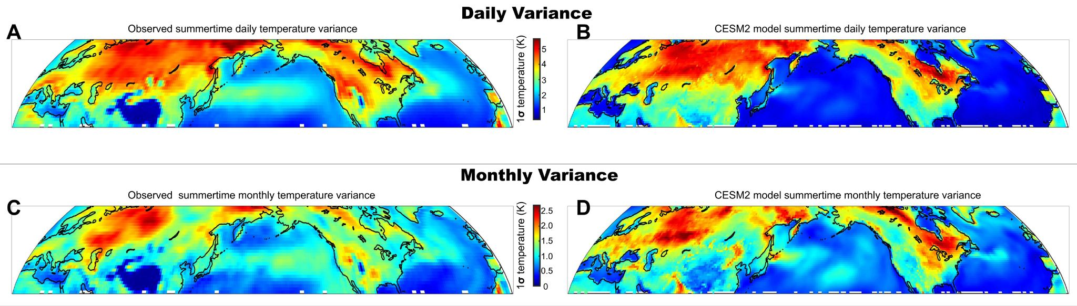

Fig. 3. Comparison of summertime surface temperature variance between a single model (CESM - left) and observations (right). The top panels show one standard deviation of daily temperature anomalies (from a smoothed seasonal cycle) and the bottom panels show the standard deviation of monthly temperature anomalies with a reduced range on the colorbar.

We are cautious to draw too many conclusions from analysis of a single model. Nonetheless, this preliminary analysis suggests that if daily and monthly temperature variability are driven by fundamentally different processes, then the literature to date on model biases in monthly temperature variability may not help us understand the models’ ability to simulate the natural variability responsible for heat waves. This motivates a need for a more comprehensive analysis of model biases in daily temperature variance across ensembles of different models and within a single model to diagnose how consistent the biases are across models and the inter-model diversity of the underlying processes.

2A: CMIP model biases in daily temperature variance
We will diagnose model biases in daily temperature variance across all the coupled climate models in the CMIP ensemble that output the daily surface temperature required for the analysis. We will analyze both pre-industrial simulations and historical simulations to ask: is surface temperature variability in the historical period significantly different from the natural variability in the same model without historical radiative forcing? Our primary focus will be on summertime temperature variability over the continents, but we will also analyze winter-time temperature variance which may be relevant for the simulation of extreme cold events.
Daily temperature variance will be defined as the standard deviation of anomalies from a smoothed seasonal cycle at daily resolution. Specifically, the smoothed seasonal cycle will be defined as the spline fit to all years of data using 8 knots as in Donohoe et al. (2020) which is continuous, has good spectral properties – as compared to the commonly used sliding monthly-mean boxcar window– and makes no underlying assumptions about the temporal shape of the seasonal cycle. This procedure isolates temperature variability at synoptic and sub-seasonal timescales from the climatological seasonal cycle and thus removes model biases in the temporal evolution of the seasonal cycle from out analysis. We note that the commonly used anomaly from monthly means (i.e. Kotz et al., 2021) conflates the climatological seasonal cycle and daily variability/ Additional spectral analysis will be performed to analysis at what timescales the model biases are most prevalent.
Models will be compared to several (daily) observational surface (2 meter air) temperature products including the National Oceanographic and Atmospheric Administration (NOAA) 20th Century Reanalysis Version 3, Berkely Earth Land/Ocean daily temperature (Rohde amd Hausfather, 2020) ERA5 reanalysis (Hersbach et al., 2020), the Japanese 55 year Reanalysis (Kobayashi et al., 2015), and the MERRA2 reanalysis (Gelaro et al., 2017). We will ground truth the reanalysis data against 2-meter air temperature station data from the Global Historical Network (GHCN: Peterson and Vose 1997). Donohoe et al. (2020) compiled station data from over 100,000 stations and found 3096 globally dispersed stations that have more than 20 years of nearly continuous data to statistically constrain the timing of the climatological seasonal cycle. They also found that the seasonal cycle of surface temperature was well represented in the nearest neighbor ERA interim data across the globe. We will use a similar set of analysis to ask: is the daily surface temperature variance measured at stations well represented in the different sets of reanalyses or is one set of reanalysis better than the others? This analysis will ensure that the comparison between model and observed surface temperature is not contaminated by the atmospheric model used for the reanalysis and represents a true comparison to observations.
Overall, this task will address whether the CESM2 bias toward too little daily temperature variance (Fig. 3A,B) is unique to CESM2 or universal across models. Through answering this question, we will begin to understand the inter-model spread in temperature variability at the timescales relevant for heat waves. We will also ask how these biases impact the simulated occurrence of heat waves above a given threshold temperature within the current climate state (akin to the analysis in Fig. 1).

2B Using the GFDL SPEAR ensemble to understand the natural variability of daily temperature variance
Is the historical period long enough to identify robust model biases in daily temperature variance? Stated otherwise, if the models were not biased in their natural variability, how likely would we be to identify a difference between observations and models over a period of length equal to the observational record. Two issues could contaminate our ability to diagnose genuine model biases: (i) if the year-to-year variability in temperature variance is large, the uncertainty in our observational evaluation of surface temperature variance may be larger than the biases we seek to identify in climate models and; (ii) if temperature variance over land is governed by low-frequency climate processes such as tropical sea surface temperature fluctuations, the model may be biased due to failure to simulate the observed historical climate patterns and not due to the physics relevant for heat-waves. Large ensembles of model simulation such as the SPEAR ensemble are well suited to answer these two questions.
The general analysis strategy will be to treat the 30 different GFDL SPEAR simulations of the historic period as a different possible realizations of the historic record and ask how different the surface temperature variance could have been due to natural variability alone. These questions cannot be asked from observational data alone because, although inter-annual variability can be used as a guide for the uncertainty in daily temperature variance, it is possible that lower (i.e. decadal) frequency processes that are poorly observed over the limited observational record impact our estimates of temperature variance. We will additionally ask what climate patterns contribute to inter-annual and inter-ensemble member differences in daily temperature variance – where daily temperature variance is computed as the time averaged variance over a month or a season or the climatological value for a given ensemble member. This question will be addressed through multiple covariance analysis (MCA) between daily temperature variance and sea surface temperature (SST) and will answer: what patterns of SST give rise to inter-annual or inter-ensemble-member spread in daily temperature variance? This analysis can be used to ask if SST patterns over the observed historical period may have led to more or less daily temperature variance in certain regions and can also investigate whether certain (natural variations in) SST patterns lead to more temperature variance (and more extreme heat waves) in certain areas.
We note that the daily temperature data needed to do this analysis is currently output by the SPEAR ensemble and this component of the proposed work could be accomplished with no additional SPEAR output. In section 3A we discuss additional diagnostics that we would like to perform with the SPEAR ensemble should additional daily SPEAR output be made available.

2C: Daily temperature variance in atmosphere-only models forced with historic SSTs
The previous task analyzed how coupled models with a free-running ocean are biased in daily temperature variance. We hypothesize (expanded on in Section 3) that temperature variance is forced by atmospheric circulation patterns which themselves are impacted by mean state SST, as well as SST variability on inter-annual and decadal scales. This task will ask if atmosphere only (AMIP) models with prescribed historically observed SST have the same daily temperature variance as their fully coupled counter-parts. This analysis removes the impact of model biases in SST patterns – both mean state and variability – in controlling daily temperature variance and its trends over the historic period. Specifically, the historical record has been characterized by warming of the Western Tropical Pacific warm pool and cooling of the Southern Ocean which are not simulated even in large ensembles (Wills et al. 2022). We will analyze if prescribing the SSTs to match the observed historical records leads to better agreement with the observed spatial pattern (and inter-annual) variability of daily temperature variance.

Sections 3: Process level understanding of mechanisms responsible for model biases in daily temperature variance.
The previous task diagnosed the spatial pattern and robustness of model biases in surface temperature variance at timescales relevant for heat waves. In this task, we wish to understand the physical processes that give rise to model biases in daily temperature variance. This analysis will help us understand the broader question of whether we can trust model predictions of future heat wave intensity in light of their deficiencies in representing the processes responsible for modern day daily temperature variance.
Our general strategy for diagnosing the root cause of model biases in present day daily temperature variance is to analyze the processes responsible for heating the atmospheric column on daily time scales and how strongly the atmospheric heating is coupled to the surface. The proposed analysis makes use of two novel tools developed by PIs that make this analysis possible for the first time: (i) closure of the atmospheric energy budget at daily timescales in both models and observations and; (ii) a diagnostic model of surface atmosphere interactions which allows for mutual interaction between the surface and atmospheric radiation. Importantly, this framework can be used to compare models and observations in a like-for-like comparison and diagnose the relative importance of atmospheric dynamics, radiation, and surface processes on heating events. We provide details on the atmospheric energy budget component of the proposed work in section 3A and the diagnostic surface energy budget in Section 3B.

3A: Surface temperature variability through the lens of the atmospheric energy budget
We will analyze the physical processes responsible for heat waves through the lens of the atmospheric energy budget:
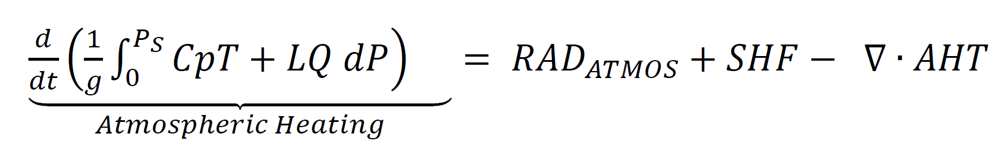 (1)
in which the net heating of the atmospheric column (left hand side of the equation below) is the sum of processes adding and removing energy from the atmosphere (right hand side of the equation). RAD_{ATMOS} is the net radiative heating of the atmospheric column, SHF is the (non-solar) exchange of energy from the surface to the atmosphere and consists of upward turbulent (latent plus sensible) energy fluxes and the net upward longwave flux at the surface and -$∇∙AHT$ is the atmospheric heat flux convergence which represents the heating of the atmosphere due energy transport by winds. Donohoe and Battisti (2013) used this budget to show that over the observed climatological seasonal cycle atmospheric heating over the ocean domain is driven by shortwave absorption in the atmospheric column (positive RAD_{ATMOS}) and damped by SHF. In contrast, over the land domain, surface solar heating during the summer and the limited heat capacity of the land surface demand an upward SHF which is the primary mechanism of seasonal atmospheric heating.
In the proposed work we will extend this analysis to daily time scales in both models and observations to ask; what processes contribute to the heating of the atmosphere at timescales relevant for heat waves and, are these processes well represented in climate models? Two contrasting hypotheses of how the atmosphere is heated leading to a heat wave event are:
- Solar heating of the surface causes upward turbulent heat fluxes that heat the atmosphere: dominant energy balance is between atmospheric heating and SHF
- Advection of warm and moist air heats the atmospheric column: dominant energy balance between atmospheric heating and -$∇∙AHT$
We present preliminary results below that suggest that hypothesis (2) characterizes the processes responsible for heat waves over the majority of the globe in a single climate model. To our knowledge, these questions have not been analyzed before in part because the required analysis sits at the nexus of climate and weather modeling and timescales. Great advances (elaborated on below) have been made in our ability to close the atmospheric energy budget in both observations and climate models (Donohoe et al. 2020b, Cox et al. 2022) and allow an observational-model comparison of the daily atmospheric energy budget leading to heat waves.
The strategy we take to diagnosing the daily atmospheric energy budget in climate models is documented thoroughly in Donohoe et al. (2020) and we summarize the technique here. SHF, RAD_{ATMOS}, and atmospheric heating are readily calculated from climate model output of top of atmosphere radiative fields, surface fluxes, and the vertical profile of atmospheric temperature and humidity. This constrains the vertical integral of -$∇∙AHT$ diagnosed from Eq. 1 as a residual. Analysis of the summertime variability of the atmospheric energy budget in the CESM2 model finds that the dominant balance is between -$∇∙AHT$ and column-averaged atmospheric heating with a temporal correlation exceeding 0.90 over the extratropical continents (Fig. 4A). This important result suggests that radiative processes and surface heat fluxes contribute very little to the heating of the atmospheric column and, instead, the magnitude of daily variations in atmospheric temperature are determined solely by the variability in -$∇∙AHT$.
The above analysis focused on column-average temperature whereas society cares about surface temperature. In CESM2, the heating of the surface in strongly correlated with the heating of the atmospheric column as a whole and as a result, surface heating is also strongly correlated with -$∇∙AHT$ (Fig. 4B). However, the magnitude of surface heating per unit of -$∇∙AHT$ is spatially variable which suggests that, while surface heating events are initiated by atmospheric heat transport, the degree of coupling to the surface depends on surface processes and atmospheric stability. We note that there are regions in the interior of the United States (e.g. the blue region in Fig. 4B) where heating of the surface is dominated by surface solar input as oppose to -$∇∙AHT$.
This preliminary analysis suggests a novel finding: Daily temperature variability is set by variability in atmospheric heat transport (-$∇∙AHT$) and modified by the degree of coupling to the surface. This relationship is encapsulated in Fig. 4C which co-plots the daily temperature variance (colors) and variance in -$∇∙AHT$ (contours) for CESM2 and shows that the spatial pattern of daily temperature variance is primarily set by atmospheric forcing of the surface with the exception of Eastern Eurasia and the Southeast United States where the surface is decoupled from the atmosphere. We previously showed that CESM2 is biased toward too little daily temperature variance over the Western United States and we now see that the model has very little variability in -$∇∙AHT$ in this region. Is it possible that the model bias in daily temperature variance is due to less than observed atmospheric forcing of heating events and unrelated to surface processes in the model? The proposed analysis will answer this question.

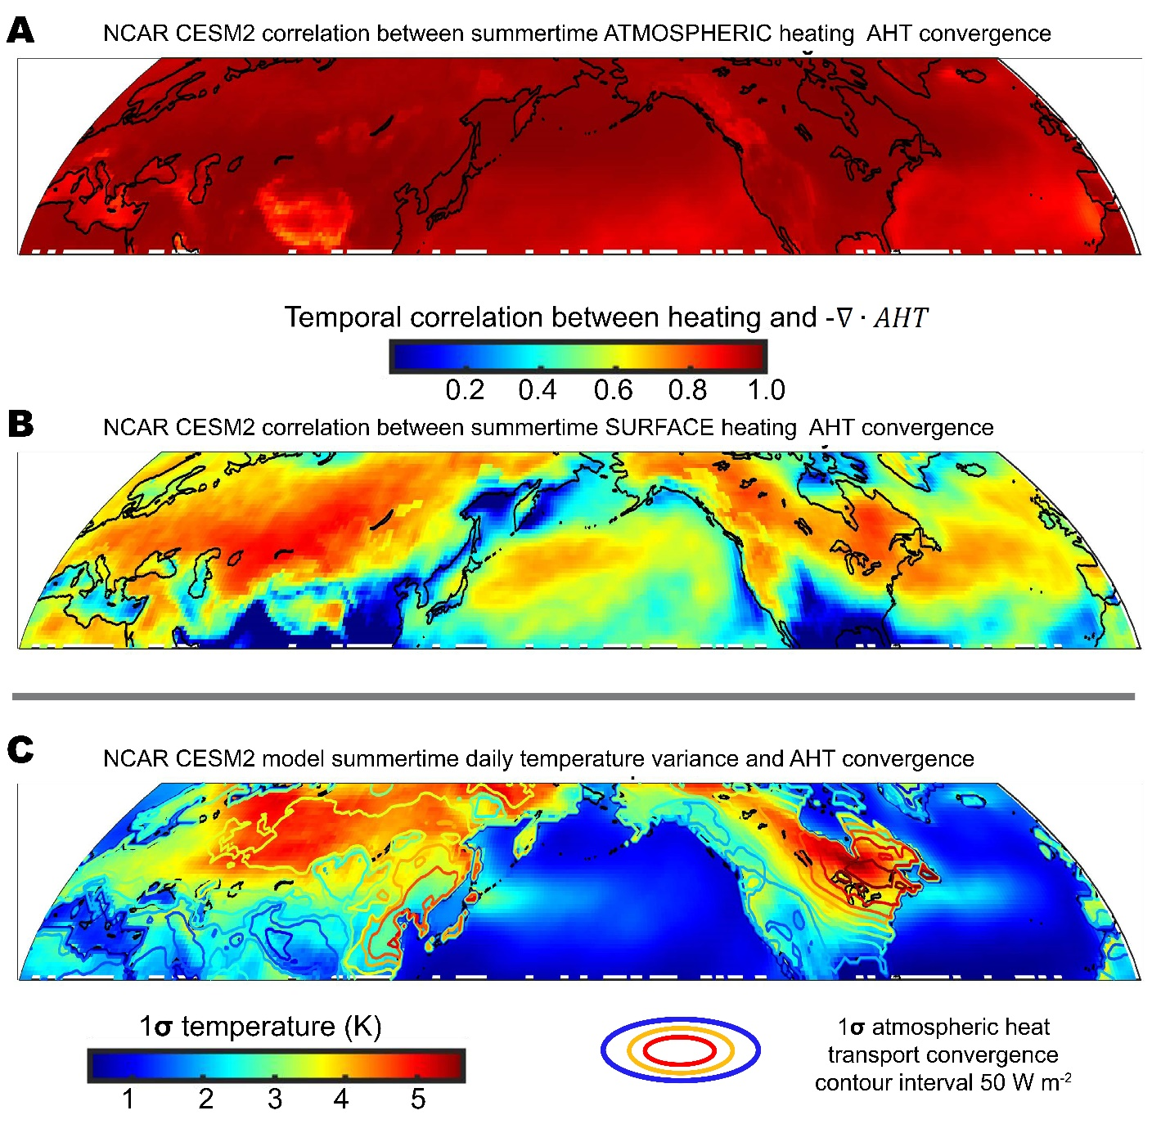

Figure 4. The relationship between heating events and atmospheric heat transport convergence in the CESM2 model. (A) Temporal correlation between -$∇∙AHT$ and atmospheric heating. (B) Temporal correlation between -$∇∙AHT$ and surface heating. (C) Map of daily surface temperature variance (1σ ) co-plotted with contours of the daily variance (1σ ) in atmospheric heat transport divergence with a contour interval of 50 W m⁻².

Proposed work: observational-model comparison of energetic processes leading to heat waves We will repeat the energetic analysis of processes governing temperature variance in all CMIP models (with daily output) for both pre-industrial control and historical simulations. This analysis will ask if the inter-model diversity in the spatial pattern of daily temperature variance (Section 2) is a consequence of the inter-model spread in the variability of -$∇∙AHT$, radiative processes or the decoupling of the surface and atmospheric energy budgets. We will compare the atmospheric energy budget in models to that in observations to ask if the daily variability of processes adding energy to the atmosphere is systematically biased in models in ways that would lead to regional biases in daily temperature variance.
Because turbulent energy fluxes are poorly constrained in the observed record, Eq. 1 cannot be used to calculate -$∇∙AHT$ as a residual of the other terms in observations. Instead, we will follow the methodology of Donohoe and Battist (2012) and Donohoe et al. (2020b) to calculate -$∇∙AHT$ which we summarize as follows. -$∇∙AHT$ at each longitude ($φ$) and latitude ($θ$) will be calculated by vertically integrating the flux of moist static energy (MSE) in the atmosphere calculated from ERA5 atmospheric reanalysis and 6-hourly timescales using the advective form of the transport equation:

$∇∙AHT(θ,φ)=\frac{1}{g}\int_{0}^{P_{S}}{}\left(U,V\right) ∇MSE +{MSE}^{†} ∇∙(U,V) dP$ , (2)
where${}^{†}$represents the anomaly from the vertical average and U and V are zonal and meridional winds respectively. The $∇∙AHT$ calculated from (2) removes contributions from non-zero mass fluxes which are unrelated to the heating of the atmosphere (Liang et al. 2018) and is consistent with the atmospheric energy budget of climate models (Donohoe et al. 2020b). Stated otherwise, the $∇∙AHT$ calculated from Eq. (2) is consistent with the $∇∙AHT$ diagnosed from the energy budget using Eq. (1) in climate models (see Donohoe et al. 2020b for details) which suggests that we can compare models and observations despite the differing availability of climate fields. This recent advance, led by the lead PI, allows the comparison of observation and model atmospheric energetics at timescales down to 6-hours (Cox et al., 2022a) for the first time.
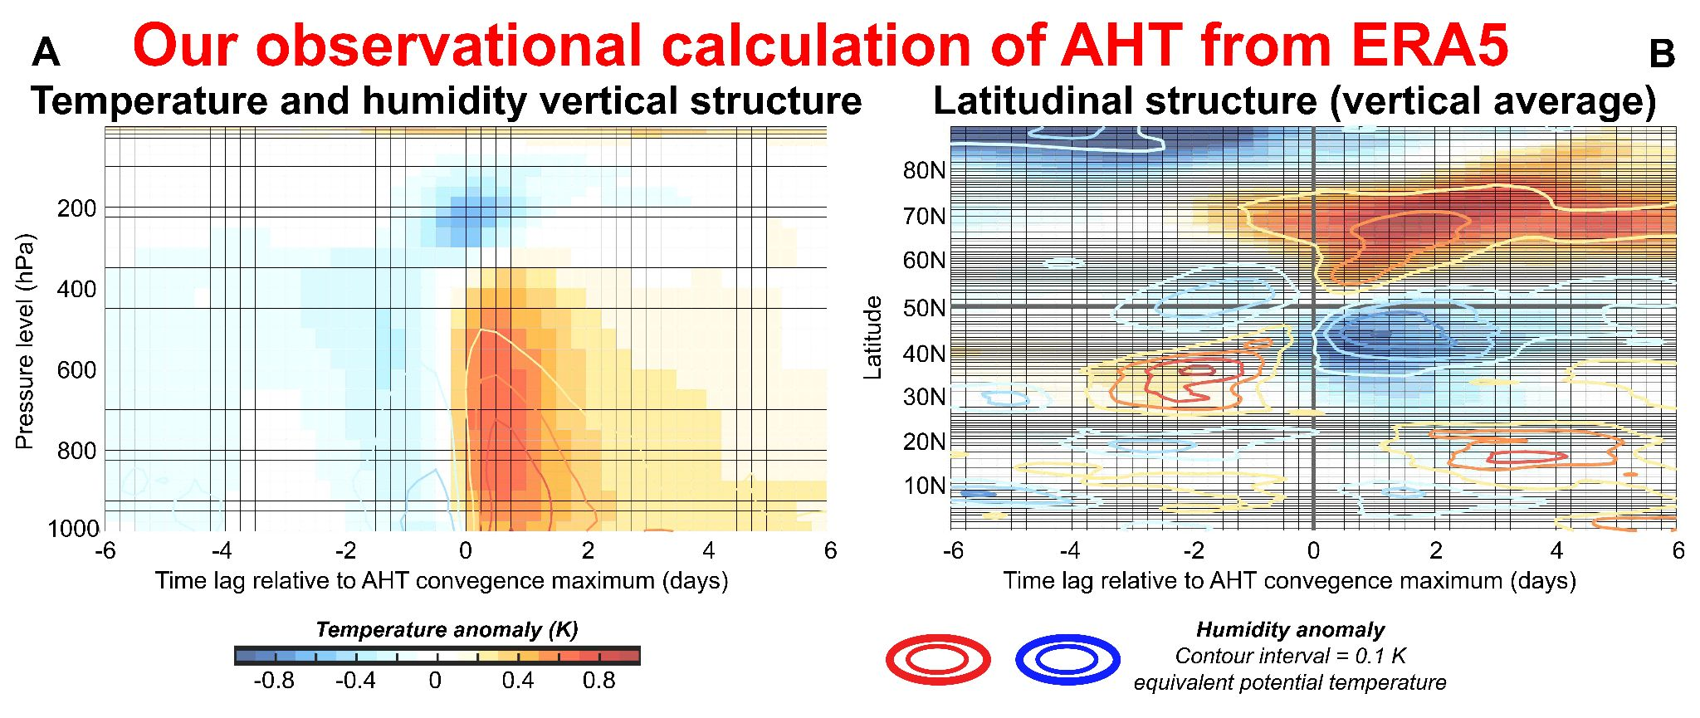
Figure (5). Observed temperature and humidity anomalies associated with a 1 standard deviation zonal mean AHT anomaly calculated from 6 hourly ERA5 data. (A) The vertical structure of lagged regressions against normalized AHT convergence at 50N. (B) Lagged regressions of the vertically average atmospheric temperature and humidity against normalized AHT at 50˚N. Temperature composites are shown in colors and humidity composites (in units of equivalent moist potential temperature with contour interval of 0.1K) are shown by the contours.

Our AHT calculations have been performed using 6 hourly reanalysis data (from 1979-2020) in the zonal average only at 6 hourly intervals in the ERA5 reanalysis and at monthly timescales in the MERRA and JRA reanalysis (Cox et al. 2022b). In the proposed work, we will extend these calculations to include the longitudinal structure of $∇∙AHT$ using Eq. 2 and additionally calculate AHT in the MERRA and JRA reanalysis products. To demonstrate the connection between our novel method of calculating AHT and the heating of the atmospheric column, we show the time evolution of zonal mean temperature anomalies associated with a (zonally integrated) AHT anomaly at 50˚N during the winter months (DJF). The lower and mid troposphere clearly heat up following an anomalous poleward AHT event and this warming lasts for of order 2 days extending over a swath of greater than 20 degrees latitude (Fig. 5). Overall, our calculation of AHT is temporally correlated with atmospheric heating with a domain average value of 0.85 which exceeds the value of alternative calculation that include contributions from non-zero mass fluxes (not shown) but is slightly weaker than that seen in CESM2 (Fig. 4A).
The remaining terms in the observational atmospheric energy budget (Eq. 1) will be calculated as follows: (i) RAD_{ATMOS} will be calculated from the satellite derived CERES EBAF top of atmosphere and surface products (Loeb et al., 2018); (ii) atmospheric heating will be calculated from the finite time difference of vertically integrated atmospheric temperature and humidity in atmospheric reanalysis; (iii) SHF will be derived as the residual of the other terms in Eq. (1) following the approach of Trenberth (1997).
We will compare our observational calculation of the atmospheric energy budget and the processes contributing to daily temperature variance to that in models to answer the following questions:

- Is the predominant energy balance between atmospheric heating and -$∇∙AHT$ seen in CESM universal across models or are there regions that atmospheric heating is dominated by other processes in some models/observations?
- Is the magnitude of daily variability in -$∇∙AHT$ biased in models and what are the regional and seasonal distribution of biases?
- Otherwise, is the daily variability of SHF or RAD_{ATMOS} systematically biased in models due to cloud properties or water vapor radiative processes (e.g. the variability of solar radiation reaching the surface)?

In addition to using the observational-model comparison, we will also use our observational calculations to analyze historic heat waves in the context of the magnitude of climate variability over the historical period. We will ask: are historical extreme heating events such as the Dome C Antarctica warm anomaly in March 2022 and the Pacific Northwest heat wave of June 2021 -- that were both of order five standard anomaly temperature events (Overland, 2021) – associated with comparable magnitude anomalies in AHT convergence? Our hypothesis from analysis in a model setting is that atmospheric column heating is tightly constrained by AHT convergence and, thus, extreme surface events are either caused by extreme AHT events or anomalous coupling between the atmosphere and ocean due surface propoerties. We will decompose the role of AHT variations and surface coupling on surface heating events over the globe and additionally consider winter cooling events.
3B. Diagnostic model of how surface temperature responds to atmospheric forcing
The previous section demonstrated (in a model setting) that the heating of the atmospheric column is initiated by -$∇∙AHT$ throughout the globe but the degree of coupling between the atmosphere and the land surface varied regionally. As a result, the amount of daily temperature variance per unit of atmospheric forcing varies spatially. Here, we introduce a diagnostic model to understand the degree of coupling between the land surface and the atmosphere and how model biases in surface coupling may impact the daily temperature variance and the magnitude of heat waves.
The diagnostic model developed by co-PI takes monthly anomalies in solar radiation and precipitation and solves for monthly temperature variance (Vargas Zeppetello et al. 2020a). By using the coupled surface energy and moisture budget, this approach allows observational products (like CERES EBAF surface radiation and CPC monthly gridded precipitation estimates) to be compared to climate model output of the same quantities and evaluate the way both atmospheric forcings influence monthly temperature variability. A tacit assumption built into this diagnostic model of monthly temperature variability is that the atmospheric heat transport convergence -$∇∙AHT$ fluctuations average to zero on monthly timescales - the fact that this diagnostic model is able to reproduce key features of the monthly temperature fields suggests that the timescales associated with atmospheric heat transport are too fast to contribute meaningfully to monthly averaged temperature variance. However, the discussion above has shown that this is emphatically not the case for daily variability - by combining the analysis above with an improved version of the diagnostic model developed in Vargas Zeppetello et al. 2020a, our proposed work will help us evaluate the influence of surface climate variables like soil moisture on the way atmospheric heat transport convergence translates into extremely high near-surface temperatures. This simplified diagnostic model will be used to evaluate biases in the more complex coupled climate models, and help constrain projections of future variance changes driven by anthropogenic warming.
In recent work, the co-PI used a simplified model of the coupled surface energy and moisture budgets to understand the different statistics of daily and monthly summertime temperatures (Vargas Zeppetello et al. 2022). While high frequency variability was found to be a key determinant of overall daily temperature variance, the relationship between high frequency variability and extremely high temperatures was tightly connected to soil moisture variability. Figure 6 shows the fraction of extremely hot days (above the local 99th temperature percentile) that occurred when the soil was drier than average over the past 10 years. In regions where soil moisture meaningfully varies during the summertime (i.e. outside of deserts and boreal forests), between 90-100% of extremely hot days were associated with drier than normal soils. While atmospheric heat transport has been shown above to be a key determinant of overall daily temperature variance, correct representation of soil moisture variations is still integral for determining the duration and intensity of a heat wave.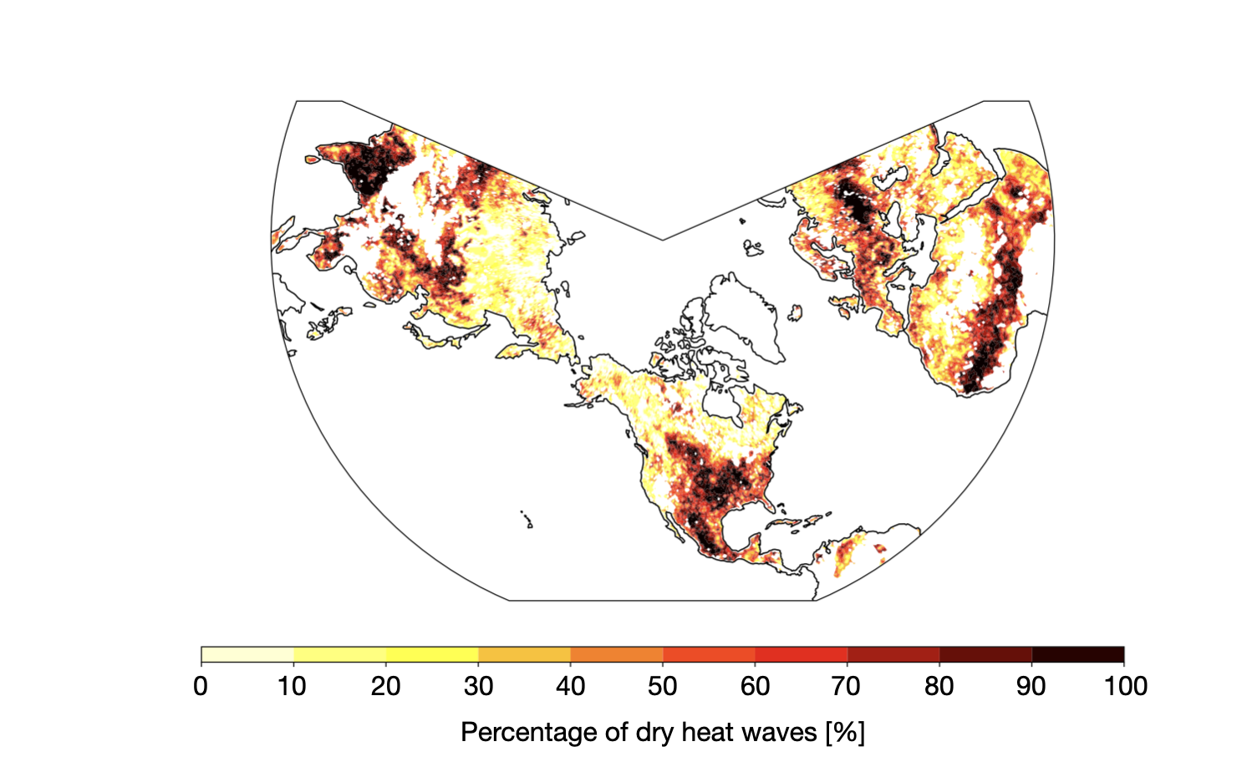
Figure (6): Fraction of days above the 99th local daily temperature percentile that also occurred when the underlying soil moisture was within the local first quantile (dry). Data were collected from the CPC daily gridded temperature data set and the ESA-CCI daily soil moisture dataset and cover 2010-2020. Figure adapted from work forthcoming from Bauer, Vargas Zeppetello, and Proistosescu.

The model used in Vargas Zeppetello et al. (2022) can be driven by daily radiation, precipitation, and atmospheric heat flux variability by including a basic physical representation of atmospheric stability and its impact on the way variations in atmospheric heat flux convergence translates into variations in near-surface temperature. By using several case studies as points of departure, we will evaluate how model and observational estimates of these three key environmental forcings impact the simple model’s representation of daily temperature variance and, in particular, its representation of extreme events. Doing so will allow us to separate the influence of fluctuations in solar radiation (mostly driven by low cloud variability) from those associated with atmospheric heat flux convergence (driven by atmospheric motions). This distinction is extremely important for projections of future change, as the sensitivity of low clouds in climate models is very high, whereas the sensitivity of dominant atmospheric patterns is likely less so. By evaluating whether model representations of daily temperature variance are tied to AHT convergence rather than solar radiation variability and comparing these representations to the observed physical processes we will be able to better constrain projections of future change.
In its most basic form, the simple model is composed of two equations for the coupled surface energy and moisture budget that diagnose the temporal evolution of surface temperature and soil moisture anomalies. Expanded to include variations in atmospheric heat transport, our equations are:
$C\frac{dT}{dt} =F_{Net} -ϵ∇∙AHT - ν_{H}(T-T_{o}) - Lν_{L}mV$, (3)
$μ\frac{dm}{dt} = P -ν_{L}mV -\frac{mμ}{τ}.$ (4)

In Eqs. 3-4, the net surface daily radiation is given by ${F'}_{Net}$, $ν_{H}$ and $ν_{L}$ control the strengths of the surface dry and moist heat fluxes, respectively. The C, $μ$, and $τ$ parameters control the surface heat capacity, the land surface potential for storing liquid water, and the timescale on which soil moisture anomalies drain out of the surface layer, respectively. V represents the vapor pressure deficit - anomalies and the mean state values are important for this analysis, which allows us to track how this model responds to global climate change by applying increased vapor pressure deficit to the model (Vargas Zeppetello et al. 2020b used this procedure to understand climate model projections of increasing temperature variance). Finally, we have included $ϵ$, the parameter that connects column integrated atmospheric heat transport to variations in surface temperature. Our observational case studies will allow us to determine characteristics of the land surface and surrounding atmospheric environment that govern changes in this parameter, and comparison of these case studies to model representations will allow us to determine whether i) the degree of variability in atmospheric heat flux convergence, radiation, and precipitation or ii) the way these environmental forcings are connected to surface temperature and soil moisture are more responsible for the biases in daily temperature variance. Again, we will pay particular attention to the way extreme events are reproduced in the model - applying large ensembles of forcing generated by the SPEAR ensemble to the simple model will allow us to tightly constrain our simple model parameters in this particular context, which is crucial for evaluating how the forcings on the land surface interact with the state variables.

This analysis will also help us understand the sensitivity of daily temperature variance to future changes in climate. Importantly, the radiation and atmospheric heat flux convergence terms in the surface energy budget are additive (see Eq. 3), while the moisture contribution is multiplicative because of the coupling between vapor pressure deficit, evapotranspiration, and near-surface temperature. Small mean changes in vapor pressure deficit have been shown to amplify monthly temperature variance by 30-50% by the end of the 21st century in climate model projections where anthropogenic CO2 emissions are not curtailed. This same mechanism should impact changes in daily temperature variance in the absence of changes in atmospheric forcing. It is not clear if the magnitude of changes in daily variability of solar radiation and atmospheric heat transport swamps the impact if time mean vapor pressure deficit on daily temperature variance. By using our simple model to conduct counterfactual “global warming” experiments, we will be able to make projections of daily temperature variance in a warmer world, explore the sensitivity of our results to the background climate state (arid vs. humid), and evaluate model projections of daily temperature variance changes driven by global warming.

3C. Process level understanding of inter-ensemble spread in surface temperature variance in the SPEAR ensemble
In this task, we wish to understand the processes responsible for the ensemble spread in daily temperature variance in the SPEAR ensemble (Section 2B) through the lens of the atmospheric energy budget and the diagnostic coupling between the surface and the atmosphere. We are hopeful that the daily vertical profiles of atmospheric temperature and humidity will be made available as SPEAR output in the future so that we can complete this task.
We will analyze if differences between ensemble members in their simulated daily temperature variance in the present day climate is a consequence of differences in variability in -$∇∙AHT$, radiative processes or in the coupling between the surface and atmosphere (analyzed with the diagnostic model) as might be expected from differences in soils moisture. The latter could be associated with the natural variability land-atmosphere-climate feedbacks whereby a soil moisture anomaly results in atmospheric drying which further enhances the soil moisture anomaly through changes in the atmospheric circulation resulting in persistent regional soil moisture anomalies (Lague et al., 2019).

Section 4. Changes in daily temperature variance under global warming
In this task, we will analyze the simulated spatial pattern of changes in daily temperature variance under anthropogenic forcing, its robustness across models and the underlying physical processes responsible for these changes as seen through the lens of the atmospheric energy budget and diagnostic surface model. Kotz et al. (2021) recently looked at forced trends in daily temperature variance in a 10-member ensemble of bias corrected climate models and found daily temperature variance increased in the low-latitudes and decreased in the extratropics. We will extend this analysis to a wider array of coupled climate models and develop a process level understanding of the root cause of changes accounting for mechanisms of mean state biases using the diagnostic framework introduced in Section 3. We will primarily analyze changes in coupled CMIP models under abrupt CO2 quadrupling to isolate a large anthropogenic signal but will scale these results to near future changes through additional analysis of different Representative Concentration Pathway (RCP) simulations. We will also analyze changes in SPEAR ensemble over the latter half of the 21st century (under RCP8.5), using the inter-ensemble spread to evaluate robustness of detected trends.
The diagnostics developed in Section 3 will be applied to the anthropogenically forced climate model simulations to analyze robust mechanisms and spatial patterns of changes in daily temperature variance. For ease of presentation, we present our leading hypotheses of what physical mechanism might be responsible for forced changes in daily temperature variance and what the signature of these mechanisms would be as viewed through the diagnostic framework we have developed.
Hypothesis 1: Changes in surface temperature variance result from changes in the coupling between the atmosphere and the surface
Given the near balance between -$∇∙AHT$ an atmospheric heating at daily timescales (Fig. 4A), this case is characterized by unchanged variance in -$∇∙AHT$ (ad, thus column integrated heating). Any changes in daily temperature variance would result from changes between the coupling of the atmosphere and surface. The latter can be diagnosed through analysis of the surface energy budget associated with heating events in the model output and our diagnostic surface energy balance model. Additional insights will be gained from composites of the vertical anomalies of temperature anomalies associated with heating events (akin to Fig. 5A).

Hypothesis 2: Changes in surface temperature variance result from changes in the magnitude of atmospheric forcing either radiative of dynamic
This scenario is characterized by either: (i) changes in the daily variance of -$∇∙AHT$ or (ii) changes in the variance of radiation, for example, downwelling solar radiation at the surface which would be conveyed to the atmosphere via upward turbulent energy fluxes (SHF in Eq. 1). -$∇∙AHT$ variance could change do to changes in the atmospheric circulation (e.g. baroclinic eddy kinetic energy) or by changes in the temperature or moisture gradients with the atmosphere. For example, Screen (2014) argued that the weakened equator-to-pole temperature gradient associated with the Arctic amplification of global warming results in weaker thermal advection for the same magnitude winds and results in decreasing daily temperature variance in the Northern Extratropics during winter (Kotz, 2021). We will explicitly test this mechanism using the atmospheric energy budget. We will additionally consider advection from the ocean to land domain, separate moist and dry AHT, analyze the space-time spectra of AHT and analyze the vertical structure of AHT (Cardinale et. al, 2020) and its change. Changes in radiative forcing of daily temperature variance will be diagnosed through the radiative budget of the atmosphere and surface.

Hypothesis 3: Changes in surface temperature variance result from changes in the efficiency of radiative feedbacks or the effective heat capacity of the climate system
This scenario is characterized by nearly unchanged variance in -$∇∙AHT$ but less atmospheric heating due to more energy being radiated to space. We think this scenario is unlikely given the near balance of -$∇∙AHT$ and atmospheric column energy tendency in the mean climate. Nonetheless, we mention two possible relevant mechanisms. Increased atmospheric water vapor under global warming results in less efficient radiative emission to space from the lower atmosphere and would amplify temperature variability for lower tropospheric warming events. This impact can be diagnosed using radiative kernels (Pendergrass, 2018). A moist atmospheric column also has a larger heat capacity (due to the latent heating required assuming fixed relative humidity) which would decrease the atmospheric temperature response to a given forcing (e.g. -$∇∙AHT$). Moisture changes account for approximately 1/3rd of the atmospheric column energy changes in the mid-latitudes and thus, a Clasius Clapeyeron change in moisture (7% per Kelvin) would result in a 2% per kelvin change in the effective heat capacity of the atmospheric column. This change is small but non-trivial and may impact future expectations for changes in daily temperature variance.

Section 5. Societally relevant robust predictions of heat wave occurrence in a warming world
The ultimate objective of the proposed work is to provide more detailed and accurate predictions of how heat wave intensity will change across different regions of the globe. The guiding principle behind the improved projections is to use knowledge of mean state biases in temperature variability at the timescale relevant for heat waves and a process level understanding of the underlying processes to identify an improved estimate of changes in daily temperature variance. We refer to this projection as “the bias corrected projection of daily temperature variance changes” and we discuss how we will derive that estimate in this section after discussing how this work will improve projections of heat wave intensity.
The projected changes in heat wave intensity will use 3 pieces of information: i) we will start from the observed distribution of surface temperature and then add; ii) the spatial pattern of time mean temperature from coupled climate models and iii) the bias corrected prediction change in daily temperature variance that will be developed in the proposed work. The combination of these three fields will improve projections of heat waves because model biases will be removed in both their impact on present day heat waves and future changes in the distribution of temperature. We acknowledge that higher order moments of the distribution of temperature and changes in the persistence of temperature anomalies may have important impacts on heat waves intensity and the proposed work has not explicitly addressed the shape of the tail of the temperature distribution (though it is included in the diagnostic surface model). However, much progress can be gained by simply considering the mean and width of the distribution and in our past research experience higher order moments of the distribution (such as skewness) are increasingly statistically uncertain and make only a small contribution to the distribution of extremes (Donohoe and Battisti, 2009, Cox et al. 2022) and, thus, robust patterns of changes in temperature variance will our primary (but not exclusive) focus.

Toward a bias corrected estimate of future changes in daily surface temperature variance:
Mean state biases can impact projected climate changes in counter-intuitive ways. For example, Vargas Zepetello et al. (2020) showed that soil drying results in enhanced monthly temperature variance and, therefore, models that have a mean state bias toward drier than observed soils projected weaker changes in temperature variance than should be expected. We wish to remove the role of mean state biases from model projections of DTSTD changes. We will take a two-pronged approach using our diagnostic framework and ask:

- If models had no biases in the atmospheric forcing (e.g. -$∇∙AHT$ and radiation variability), what changes in daily temperature variance would they project given the robust changes in atmosphere surface coupling
- If models had no biases in mean state surface properties (e.g. soils moisture and atmospheric stability) what changes in daily temperature variance would they project given the robust changes in atmospheric forcing

To give a tangible example of how this process would work, consider the CESM2 simulation of the present day climate system which is severely biased toward too little daily temperature variance over the Western United States (Fig. 3B) which we speculate is a consequence of too little variability in -$∇∙AHT (Fig. 4C)$. If this region robustly dries out under global warming resulting in stronger coupling of atmospheric heating to the surface (Section 3C) daily temperature variance will go up in the model even if -$∇∙AHT$ variance is unchanged. However, the change in daily temperature variance due to soil drying alone will be underestimated by the model due to the mean state bias toward too little variability in -$∇∙AHT$. To account for this, we can take the soil drying predicted by the model and ask how much the daily temperature variance would have changed if the model had the right amount (observationally derived) variability in -$∇∙AHT$ using the diagnostic surface energy balance model constrained by observed atmospheric energetics. We can do this across all models to isolate a bias corrected change in daily temperature variance due to changes in surface properties alone.
Similarly, if all models simulate a reduction of the variance in -$∇∙AHT$ ove the Northern extratropics as suggested by Screen (2014), then we can ask how this reduction of atmospheric forcing would impact daily temperature variance given the observed surface properties again using the diagnostic surface model. In this case, if a model was biased toward too little soil moisture in the mean state, we would expect the model to overestimate the impact if changes in -$∇∙AHT$ variance on daily temperature variance. We will perform this analysis over all models to derive a bias corrected estimate of the changes in daily temperature variance due to changes in atmospheric forcing. It may be necessary to consider the role of model biases in atmospheric forcing and surface properties on projected changes in daily temperature variance in conjunction (i.e. how mean state biases in one may impact the simulated changes in the other). We hope to develop strategies to account for the interaction of biases and changes through the duration of the project.
Our bias corrected estimate of future changes in temperature variance will be combined with model estimates of time mean warming to provide societally relevant projections of future heat wave-intensity (i.e., number of days exceeding a threshold at any location). This improved estimate combines robust predictions of climate models but uses observational constraints and process level understanding to remove the impact of model biases on future projections.

References:
Callahan, C.W., and Mankin, J.S. (2022): Globally unequal effect of extreme heat on economic growth. Science Advances, 8 (43), doi: 10.1126/sciadv.add3726

Cardinale, C.J., Rose, B.E.J., Lange, A.L. and Donohoe, A.. Stratospheric and tropospheric flux contributions to the polar cap energy budgets. J. Climate. 34 (11), 4261-4278. https://doi.org/10.1175/JCLI-D-20-0722.1
Coffel, E.D., Horton, R.M., Sherbinin, A. (2017): Temperature and humidity based projections of a rapid rise in global heat stress exposure during the 21st century. Environ. Res. Lett. 13, 014001.

Coumou, D., Robinson A, Rahmstorf S. (2013): Global increase in record-breaking monthly-mean temperatures. Clim Chang. 118:771–82. doi:10.1007/s10584-012-0668-1.

Cox, T., A. Donohoe, G.H. Roe, and D.M.W. Frierson (2022a). The gaussian nature of zonally-integrated atmospheric heat transport. Geophysical Research Letters. In Press.

Cox, T, A. Donohoe, D.M.W. Frierson G.H. Roe (2022b) Comment on “Moist Static Energy Transport Trends in Four Global Reanalyses: Are They Downgradient?” by Clark et al., 2022. Geophys. Res. Lett., in review.

Deser, C., Lehner, F., Rodgers, K., Ault, T., Delworth, T., DiNezio, P (2020): Insights from Earth system model initial-condition large ensembles and future prospects. Nature Climate Change, 1–10

Donohoe, A. and Battisti, D.S. (2009): The amplitude asymmetry between synoptic cyclones and anticyclones: implications for filtering methods in feature tracking. Mon. Wea. Rev., 137, 3874-87.
Donohoe, A., Dawson, E.J., McMurdie, L, Battisti, D.S. and Rhines, A (2020a): Seasonal asymmetries in the lag between insolation and surface temperature. Journal of Climate. 33 (10), 3921-3945. DOI: 10.1175/JCLI-D-19-0329.1
Donohoe, A., K.C. Armour, G.H. Roe and D.S. Battisti (2020b). The partitioning of atmospheric energy transport and changes under climate forcing in coupled climate models. Journal of Climate. 33 (10), 4141-4165. DOI: 10.1175/JCLI-D-19-0797.1
Gelaro, R., McCarty, W., Sua´rez, M. J., Todling, R., Molod, A., Takacs, L., and others (2017). The Modern-Era Retrospective Analysis for research and applications, version 2 (MERRA-2). Journal of climate, 30 (14), 5419–5454.

Hersbach, H., Bell, B., Berrisford, P., Hirahara, S., Hora´nyi, A., Mun˜oz-Sabater, J., and others (2020). The ERA5 global reanalysis. Quarterly Journal of the Royal Meteorological Society, 146 (730), 1999–2049.

Hsiang, S., Kopp, R.E., Jina, A., Rising, J., Delgado M., Mohan, S., Rasmussen, D.J., Muir-Wood, R., Wilson, P., Oppenheimer, M., Larsen, K., and Houser, T. (2017). Estimating economic damage from climate change in the United States. Science. doi:10.1126/science.aal4369

Hsu, A., Sheriff, G., Chakraborty, T. et al. Disproportionate exposure to urban heat island intensity across major US cities. Nat Commun 12, 2721 (2021). https://doi.org/10.1038/s41467-021-22799-5
Jnglin Wills,R.N, Dong, Y., Proistosecu, C, Armour, K.C. and Battisti, D.S.Systematic climate model biases in the large-scale pattern of recent sea-surface temperature and sea-level pressure change. Geophysical Research Letters. DOI: 10.1002/essoar.10512012.1

Kobayashi, S., Ota, Y., Harada, Y., Ebita, A., Moriya, M., Onoda, H., and others (2015). The JRA-55 reanalysis: General specifications and basic characteristics. Journal of the Meteorological Society of Japan. Ser. II , 93(1), 5–48.
Kotlarski, S., and Coauthors, 2014: Regional climate modeling on European scales: A joint standard evaluation of the EURO-CORDEX RCM ensemble. Geosci. Model Dev., 7, 1297–1333, https://doi.org/10.5194/gmd-7-1297-2014.

Kotz, M., Wenz, L. amd Levermann, A. (2021): Footprint of greenhouse forcing in daily temperature variability. PNAS, 118 (32), https://doi.org/10.1073/pnas.2103294118.
Laguë,M, Bonan, G.B., Swann, A.L.S. (2019). Separating the Impact of Individual Land Surface Properties on the Terrestrial Surface Energy Budget in both the Coupled and Uncoupled Land--Atmosphere System. Journal of Climate.
Liang, M., Czaja, A., Graversen, R., & Tailleux, R. (2018). Poleward energy transport: is the standard definition physically relevant at all time scales? Climate Dyn., 50 , 1785-1797.
Loeb, N. G., & Coauthors. (2018). Clouds and the Earth’s radiant energy system (CERES) energy balanced and filled (EBAF) top-of-atmosphere (TOA) edition 4.0 data product. J. Climate, 31 (2), 895-918.
Lorenz, R., E. Davin, and S. Seneviratne, 2012: Modeling land–climate coupling in Europe: Impact of land surface representation on climate variability and extremes. J. Geophys. Res., 117, D20109, https://doi.org/10.1029/2012JD017755.
Meehl, G.A. and Tebaldi, C (2004). More intense, more frequent, and longer lasting heat waves in the 21st century. Science 305, 994–99.

Perkins-Kirkpatrick, S.E., Lewis S.C. (2020): Increasing trends in regional heatwaves. Nature Communications, 11, 3357. doi: 10.1038/s41467-020-16970-7.

Screen, J.A. (2014) Arctic amplification decreases temperature variance in northern mid- to high-latitudes. Nat. Clim. Chang. 4, 577–582.
Rohde, R. A. and Hausfather, Z. (2020): The Berkeley Earth Land/Ocean tempertuare record. Earth Syst. Sci. Data, 12, 3469–3479. https://doi.org/10.5194/essd-12-3469-2020.

Trenberth, K. E. (1997). Using atmospheric budgets as a constraint on surface fluxes. J. Climate, 10, 2796-2809.
Vargas Zeppetello, L.R., Battisti D.S., Baker M.B (2020): A New Look at Land Surface Summertime Temperature Variance. Journal of Climate, 33 (13) 5465-5477, doi: 10.1175/JCLI-D-19-0887.1

Vargas Zeppetello, L. R., & Battisti, D. S. (2020). Projected increases in monthly midlatitude summertime temperature variance over land are driven by local thermodynamics. Geophysical Research Letters, 47, e2020GL090197. https://doi.org/10.1029/2020GL090197

Vargas Zeppetello, L.R., Battisti D.S., Baker, M.B. (2022): The Physics of Heat Waves: What Causes Extremely High Summertime Temperatures? Journal of Climate, 35, (7), 2231-2251, doi: 10.1175/JCLI-D-21-0236.1

