We thank the reviewer for insightful comments and the very detailed editorial suggestions. We are very grateful for the amount of time and thought the reviewer put into the review. The review has helped us focus and clarify the manuscript. Below we include the reviewer’s comments in red, and our responses in black.
Major Comments
1. The inter-­‐hemispheric SST gradient metric.
a. Have you explored the sensitivity of your results to how this is defined? It seems likely to me that precipitation features could respond sensitively to smaller-­‐scale gradients in SST that pull the precipitation maximum north or south without having a large hemispheric-­‐scale signature.

We have regenerated the plot of the seasonal cycle of ΔSST and P_{CENT} using different regions to define ΔSST ranging from 15S-15N to 30S-30N (included below). The R² values between P_{CENT} and the different definitions of ΔSST are nearly identical (0.938 for 15º, 0.937 for 20º and 0.942 for 30º). The regression coefficient between P_{CENT} and ΔSST decreases as the cutoff latitude increases because the seasonal variation in SST increase with latitude and including higher latitudes in the definition in ΔSST results in larger magnitude seasonal variations in ΔSST. The regression coefficients range from 4.6 to 2.1 º per K for the definitions considered here. While these results support the reviewers contention that the ITCZ responds more sensitively to small scale SST features in the tropics, the near invariance of the correlation coefficient to the region used to define ΔSST suggests to us that seasonal variations in the hemispheric contrast of SST are well correlated between the deep tropics and the subtropics (and maybe even the extratropics). Further investigation would be required to deduce the sensitivity of the ITCZ to isolated, equal magnitude SST perturbations in different regions.
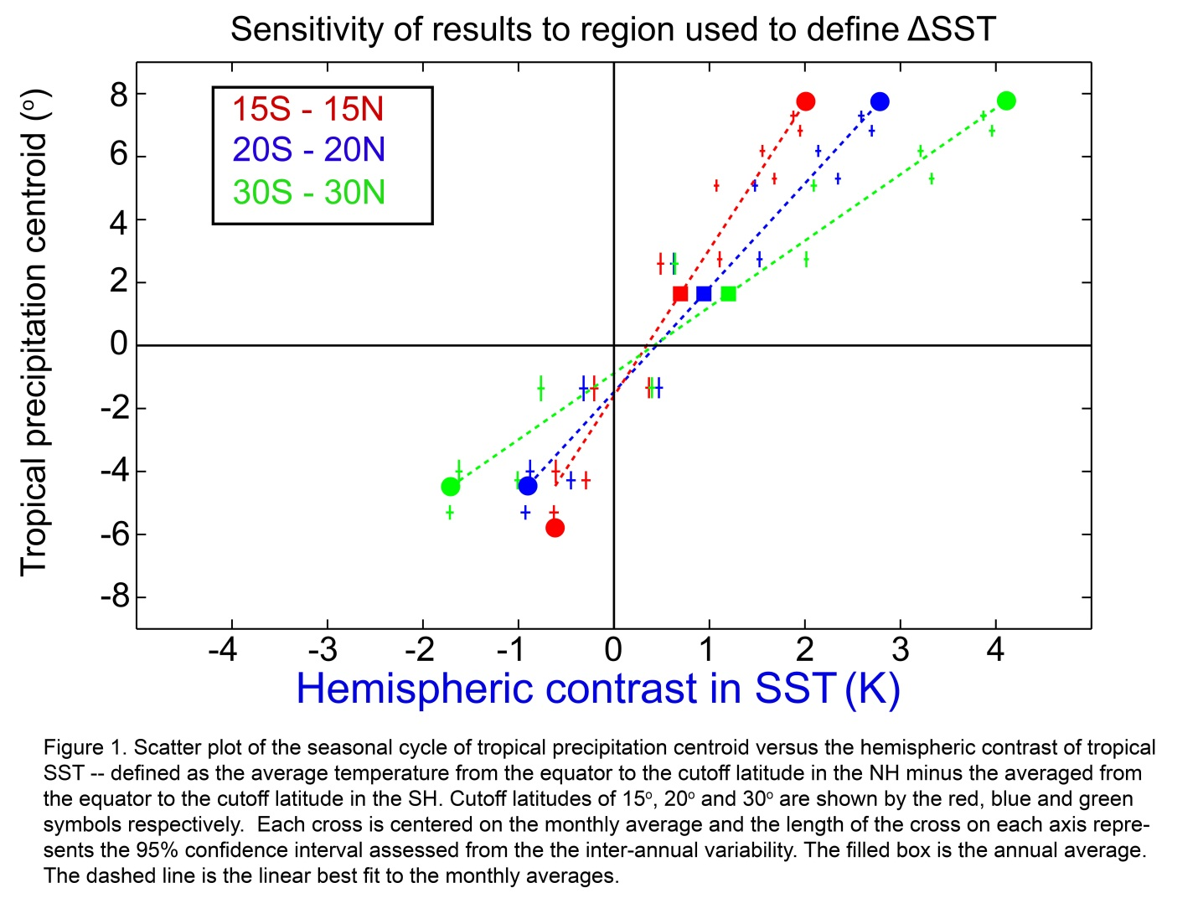
b. It never became clear to me whether the inter-­‐hemispheric gradient in SST or the inter-­‐hemispheric atmospheric heating gradient (manifested in a requirement for heat transport across the equator) is more important in determining ITCZ shifts. Perhaps you did not set out to contrast these drivers, but now that you have shown both I wonder which matters more, or if that is a poorly posed question, or one that cannot be answered with the diagnoses performed in this study. Comparing the top and bottom panels of Figure 10 suggests to me that - compared with the AHTEQ metric - the SST gradient metric’s relation to PCENT exhibits less invariance to timescale and climate state. Is this a reasonable conclusion to take away from this paper? If so, it should be brought out more strongly. If not, I wonder whether it is essential that this aspect of the study be included in an already long paper, considering it is not even mentioned in the title or abstract.

We view the relationship between AHT_{EQ} and P_{CENT} to be fundamental to the system. We believe this relationship will be nearly invariant to climate state due to the mutual dependence of the tropical rainfall and the atmospheric heat transport on the Hadley cell. The near invariance of these relationships relies on 3 factors: (1) the seasonal migrations of the Hadley cell off the equator are greater those induced by climate forcings such that the spatial structure of the Hadley cell (e.g. the asymmetry between the summer and winter cell) is well represented by the seasonal cycle, (2) the static stability in the tropics (the vertical gradient of moist static energy) is climate state invariant, and (3) the atmospheric heat transport is dominated by the Hadley cell. We hope to pursue how valid these assumptions are in future work. Our analysis thus far suggests that these assumptions are valid across the perturbation experiments we have analyzed.
In contrast, we view the relationship between P_{CENT} and ΔSST to be empirical; there is no reason for the quantitative relationship to be climate state invariant and our work presented in the current manuscript suggests that this relationship may change from one climate state to the next (and is sensitive to the definition of ΔSST used). We have included the analysis of the relationship between P_{CENT} and ΔSST in the manuscript because SST proxy data is widely available and ,thus, ΔSST can be reconstructed. Therefore, we hope the community can use our analysis to calculate the implied ITCZ shift and AHT_{EQ} change for various climate epochs from the existing paleoproxy data. We have added a discussion of these points to the revised manuscript.

c. Given the results shown in the bottom panel of Figure 10, is it appropriate to claim that the ITCZ shift suggested by Sachs et al. (2009) would be associated with a change in the SST gradient of 2.5 K (lines 745-­‐747)? It seems to me that the SST gradient implied by a given PCENT shift is unconstrained in your analysis. At the very least, a range should be given.

We give a range of ΔSST associated with the 5º ITCZ shift during the little ice age in the revised manuscript. The range is calculated from the different regression coefficients between P_{CENT} and ΔSST found in our study.

2. How would the results differ if an ocean-­‐only definition of PCENT were used, thereby removing a large portion of the huge meridional shifts of rain that occur over the continents in association with monsoons. For example, in lines 227-­‐228, you state that the reason for the non-­‐zero y-­‐intercept of the best-­‐fit line between PCENT and SST gradient is unclear. What if ocean-­‐only precipitation is included in PCENT?

Great suggestion. We have repeated our analysis using only the ocean domain to calculate P_{CENT} in Figure 2 below. Our results change very little. In particular, the intercept of the linear best fit moves farther from the origin. The cause of the non-zero intercept of the observed seasonal relationship between P_{CENT} and AHT_{EQ} (and ΔSST) is under further investigation.

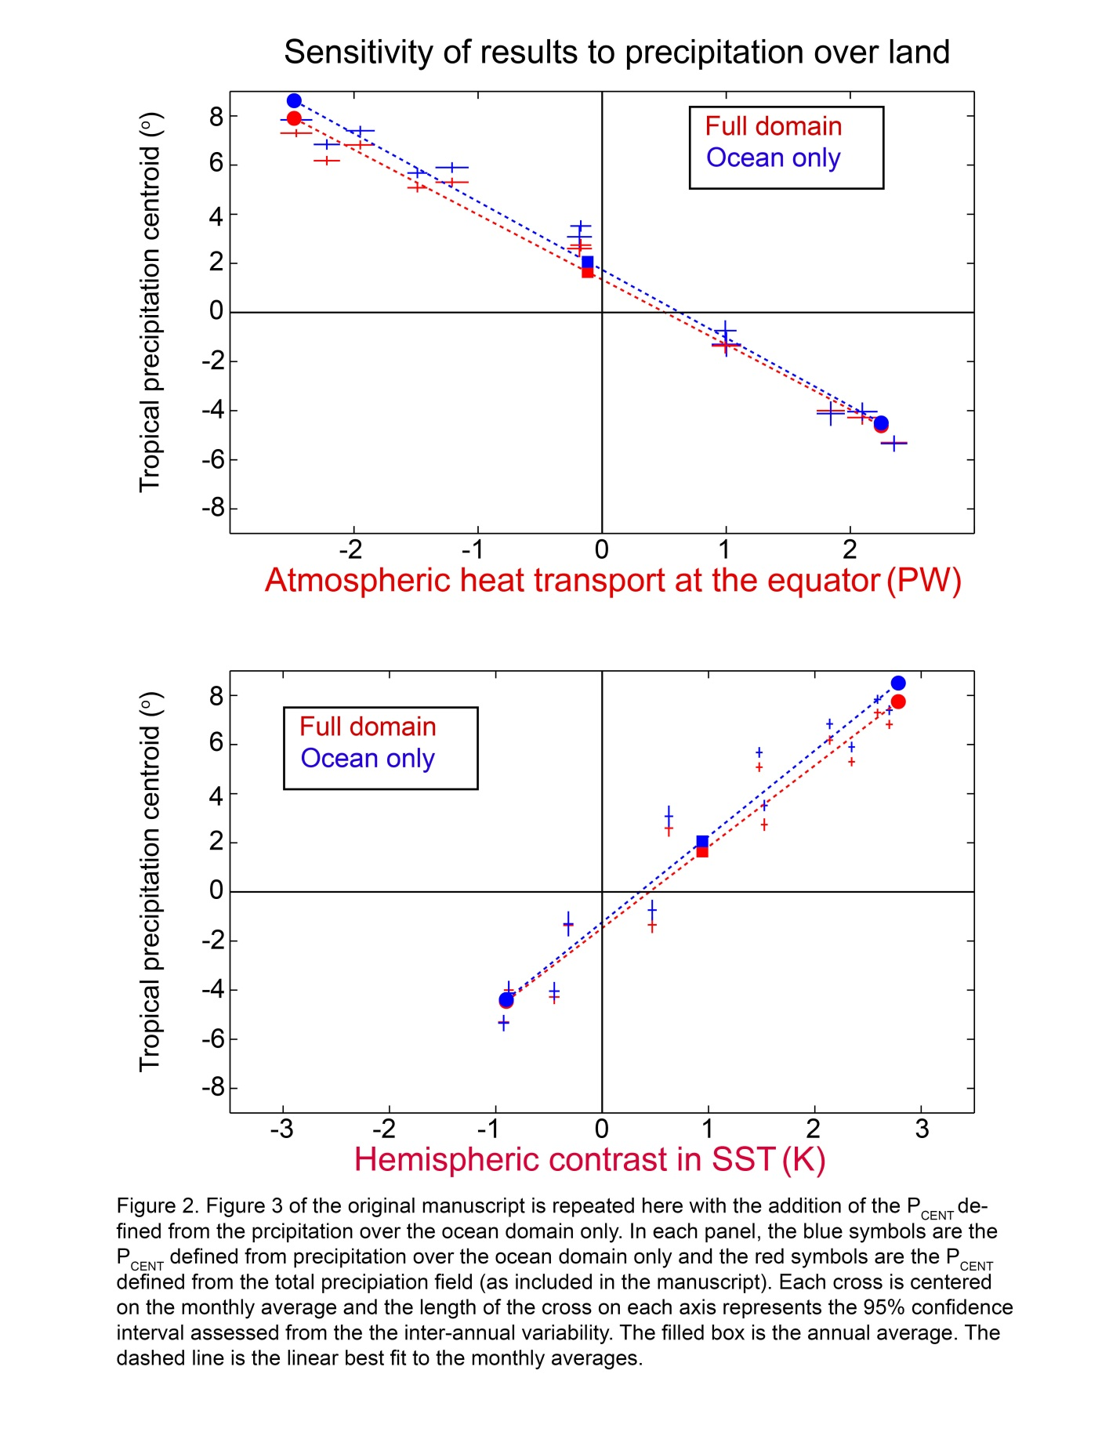

3. A significant portion of Section 4 deals with explaining why the seasonal slope between the precipitation centroid and the poleward heat transport at the equator should be realized in the annual mean shift, even though intuition may suggest otherwise.
a. To me it seems odd that lines 676-­‐697 are spent discussing reasons why one might expect the slope to be different for annual mean shifts compared to seasonal shifts, when these have already been discussed and shown to be incorrect expectations based on the argument presented in lines 429-­‐462. Isn’t this a step backwards?
We have rewritten this entire discussion in terms of the processes that set the relationship between P_{CENT} and AHT_{EQ} from the lessons learned in the aquaplanet simulations. We believe the revised discussion is less redundant with the points made in the aquaplanet section and advances the ideas discussed earlier in the manuscript.
b. More importantly, I found the italicized explanation (lines 72-­‐724; lines 732-­‐733)
- that the annual mean shift occurs along the seasonal linear best fit - to be simply a re-­‐statement of the basic result. I don’t see an explanation for why this must be. I think the point you are trying to make is that the relation between AHTEQ and PCENT is strongly constrained on a seasonal timescale (by all the physics explained in the paper); thus if the annual mean shift is simply the small residual of larger and generally asymmetric shifts in the seasonal extremes, it is also constrained to follow the seasonally-­‐derived relationship. To me, it is the line just prior to the italicized statement on lines 720-­‐721 that requires explanation: why should we expect a priori that the seasonal relationship between PCENT and AHTEQ is the same regardless of climate state? Perhaps an argument for why physically this relationship holds regardless of climate state is buried somewhere in the text, but it needs to be brought out more strongly. I could envision different climate states being associated with varying effective ocean heat capacities, thereby making the seasonal relationship vary with climate state in a way analogous to Figure 8.
We agree with the Reviewer’s comments; the key point we are trying to make is that the annual average is the small residual of the extreme seasons (the two modes of the system), and thus the annual average is highly constrained by the seasonal relationship. We also agree with the Reviewer’s statement that the invariance of the seasonal relationship between P_{CENT} and AHT_{EQ} is critical to our argument and we wish we could provide an a priori explanation for this result beyond the empirical evidence we have presented for the model runs analyzed in the manuscript. We note that, the seasonal anomalies in how far off the equator the Hadley cell moves (and the hemispheric asymmetry of energy input into the atmosphere) are larger than the perturbations to the climate system considered in this manuscript. Therefore, the seasonal cycle captures the response of the system to a wide range of hemispherical asymmetric forcing. We have included a more explicit discussion of these points in the revised manuscript.
We note that, the ocean heat capacity differences between climate states are taken into account in our assessment of AHT_{EQ} through Equation 3 of the revised manuscript. Perhaps the Reviewer is suggesting that the seasonal amplitude of AHT_{EQ} could be drastically different in altered climate states leading to a change in the relationship between P_{CENT} and AHT_{EQ} (as in Figure 8). This possibility warrants further investigation. In the simulations we have analyzed thus far, the seasonal amplitude of AHT_{EQ} does not change very much. We believe that this result is due to the seasonal cycle of AHT_{EQ} being driven primarily by the hemispheric asymmetry of shortwave radiation absorbed directly in the atmosphere which we define as <SWABS>. <SWABS> is a consequence of the mean shotwave absorptivity of the atmosphere (water vapor and ozone) and the Earth sun geometry (solar constant and obliquity) both of which do not change drastically in the simulations we have analyzed. We believe that the ocean heat capacity plays a secondary (damping) role in determining the seasonal amplitude of AHT_{EQ} (via <SHF>).

Minor Comments
1. Line 10: Provide the R2 for the climate models as well.
Added (0.79).
2. Lines 17: “onto” should be two words
Changed.
3. Line 30: What is meant by “nearly co-­‐located”? Aren’t these exactly co-­‐located?
“Nearly” has been removed.
4. Lines 38-­‐42: This sentence is somewhat unwieldy and should probably be broken up into
two sentences. Also, the first instance of “and paleoclimate states” on line 39 should be
deleted.
This sentence has been revised.
5. Line 88: Delete “sea” before “SST”
Fixed.
6. Lines 99-­‐100: I think this statement should be cited; it is not obvious that the excess
insolation should necessarily heat the atmosphere.
Citation to Donohoe and Battisti (2012) added.
7. Line 100: Insert comma after “mean”
Added.
8. Line 101: Insert comma after “mean”
Added.
9. Line 102: “largely balanced” Please provide quantitative values, including the relative
importance of local ocean-­‐atmosphere exchange versus transport from the other
hemisphere.
The statement made is that the net energy input into the atmosphere (SWABS +SHF) is primarily balanced by meridional energy transport. These ideas, as they apply to the hemispheric asymmetry of atmospheric energy input and AHT_{EQ}, are pursued in depth in the forthcoming section. We are unaware of a previous publication that gives the quantitative result for the hemispheric asymmetry of energy fluxes. We intended to highlight the general result that seasonal anomalies in atmospheric heating are primarily balanced by meridional atmospheric energy transport and secondarily by OLR anomalies and energy storage in the atmospheric column. The numbers found in this study suggest that, over the seasonal cycle, the hemispheric asymmetry of atmospheric heating is balanced primarily by AHT_{EQ} (42%) and secondarily by atmospheric storage (30%) and OLR anomalies (28%) as judged by the seasonal amplitude of the energy fluxes in phase with the net atmospheric heating.
10. Line 103: Insert comma after “cooling”
Added.
11. Line 105: Insert comma after “SSTs”
Added.
12. Line 144: Suggest adding the word “downwelling” after “net”. Also, insert a space
between “atmosphere” and “(TOA)”
“Downwelling” and space added.
13. Footnote 1 and Equation (1): Usually the specific humidity is denoted by a lowercase q.
Changed throughout.
14. Lines 153-­‐156: I suggest the authors specify in this sentence that OHT+S is defined to be
positive for Northward oceanic heat transport and/or greater oceanic storage in the
Southern Hemisphere.
The sign convention is noted in the revised manuscript.
15. Line 159: It is not entirely clear what is meant by “compensating energy fluxes at the
TOA and surface” Where there is more energy coming in the top of the atmosphere,
there is more going out the bottom?
Yes. This is because the atmosphere is shortwave transparent and, thus, the vast majority of seasonal anomalies of incident radiation pass through the atmosphere into the surface. For this reason, we advocate that the seasonal energy fluxes be analyzed in terms of SWABS and the net exchange of energy between the surface and atmosphere (SHF, which does not include the surface solar fluxes).
16. Line 167: Change “and the atmosphere” to “into the atmosphere”
Fixed.
17. Equations 3-­‐4: I think the addition of one intermediate step would help the reader.
Specifically, I suggest adding a note that -­‐<OHT+S> = <SWNET,SFC> + <SHF>
We have added this statement as a footnote (the SHF must be negated because it is defined as positive when the flux is into the atmosphere.)

18. Line 180: The annual average ITCZ position is north of the equator. Is the annually
averaged NH atmospheric heating greater than the annually averaged SW heating?
Yes. The annual mean atmospheric heating in the NH exceeds that in the SH by 0.13 PW which is balanced by 0.13 AHT_{EQ} from North to South. The 0.13 PW of additional atmospheric heating in the NH is a consequence of the 0.34 PW of OHT_{EQ} from South to North and is counterbalanced by 0.21 PW of net radiation at the TOA in the SH (and -0.21 PW in the NH). This result suggest that the Southward annual mean AHT_{EQ}, and the associated ITCZ location North of the Equator, is primarily a consequence of the ocean heat transport. We are currently pursuing these ideas (see also Frierson et al. “Why does tropical rainfall peak in the Northern Hemisphere? The role of the oceanic meridional overturning circulation”, submitted to Science).
19. Line 232: Please provide a quantitative value (fraction) rather than “vast majority”
The percentage (83%) is quantified after the semi colon in the same sentence.
20. Lines 254-­‐255: That the atmospheric heat storage leads the insolation by 60 days is
counterintuitive to me. Any explanation for this would be welcome.
The heat storage is the tendency of the atmospheric column energy. In a sinisuidally forced system with no negative feedbacks (no damping) the balance is between the forcing and the tendency (inertia) and the storage is in phase with the forcing (insolation in this case). In contrast, in a system where the heat capacity (inertia) is much smaller than the negative feedbacks (damping) the predominant balance is between the forcing and the negative feedbacks and the column energy is in phase with the forcing while the storage (energy tendency) leads the forcing by 90 degrees. In the case of the hemispheric contrast of the atmospheric energy budget, the column energy tendency is the inertia while the OLR and meridional heat transport are the negative feedbacks. It has been argued (Donohoe and Battisti, 2012b – What determines meridional heat transport in climate models?, J. Climate ) that the feedbacks are substantially larger than the inertia in the system and, thus we would expect the storage to lead the forcing. This system is akin to the counter-intuitive result that the response of a damped harmonic oscillator leads that of an un-damped harmonic oscillator. We have added a brief discussion to the revised manuscript.
21. Line 258: Should be “STORATMOS”
Fixed.
22. Lines 264-­‐266: Here might be a good time to remind the reader of some mean-­‐state
numbers to put these numbers in perspective. Specifically, the peak in poleward
atmospheric heat transport is around 5 PW in midlatitudes (Trenberth and Caron 2001), so a 1 PW change per 3˚ shift is pretty large.
Added. We reference the annual mean AHT_{EQ} as well as the peak AHT in the revised manuscript.
23. Equation 7: It would help the reader to be reminded of the sign convention for Ψ (e.g.,
>0 means northward upper branch)
Added.
24. Line 285: I believe this should be “…in the lower panel of Figure…”
Correct. Fixed.
25. Line 294: I believe this should be “zero streamfunction”
Replaced with “location of zero streamfunction”.
26. Line 300: “International” should be “Intergovernmental”
Fixed.
27. Line 322: Should be “…origin than do the observations…”
Fixed.

28. Lines 330-­‐333: Here you note that the precipitation centroid lags AHTEQ by a month in
the models, unlike in observations, but the reasons for this are not discussed until lines
363-­‐374. That is fine, but please tell the reader now that you will discuss this later.
Done.
29. Figure 7: Is the annual mean PCENT location more strongly correlated across models with
its maximum northward extent or southward extent?
Good question. The correlation between the inter-model spread in annual mean P_{CENT} has nearly equal (statistically indistinguishable) correlation coefficients with the Northern and Southern seasonal extremes of the ITCZ ( 0.64 and 0.57 respectively). This result can be understood as follows. If all models had the same seasonal amplitude of ITCZ migration, then the Northern and Southern extent of the ITCZ are both perfect predictors of the annual mean P_{CENT} location by construction (because the annual mean is the average of the Northern and Southern extents). In contrast, if the Southern extent of the ITCZ was invariant between models, but the Northern extent differed, then the models with a more Northward extent of the ITCZ will have a more Northward annual mean ITCZ and a larger seasonal amplitude of ITCZ migration. The Northern extent of the ITCZ will be a better predictor of the annual mean ITCZ location if there is a positive covariance between the seasonal amplitude of ITCZ migration and annual mean ITCZ location (the seasonal amplitude is greater in the models with a more Northern annual mean ITCZ). Similarly, the Southern extent of the ITCZ would be a better predictor of annual mean ITCZ location if there was a negative covariance between annual mean ITCZ location and the seasonal amplitude of ITCZ migration as would be the case if the Northern extent of the ITCZ was model invariant. The covariance of the seasonal amplitude of ITCZ migration and annual mean ITCZ location is small and positive (0.06) which makes the Northern extent a slightly better predictor of the annual mean ITCZ location. We interpret this result to mean that neither the Northern or Southern extent of the ITCZ is fixed in the models and independent variations in the seasonal amplitude decrease the correlation between intermodal difference in the Northern and Southern extent of the ITCZ and its annual mean location.

30. Line 403: “2.6” should be “2.4”
Fixed throughout.
31. Line 445: “stream function” should be one word
Fixed.
32. Line 503: “amount” should be plural.
Fixed.
33. Throughout: I would replace “6K” with “6Kyr” so as to not confuse people who aren’t
reading closely with an experiment in which SSTs are perturbed by 6 Kelvin.
Changed throughout (and in the figures).
34. Line 536: “themselves” is misspelled
Fixed.
35. Lines 572-­‐573: Remind the reader how the radiative contribution from increased
cloudiness is being quantified.
Added.
36. Line 588: “decreased” should be “increased” I believe
Correct. Changed.
37. Lines 678-­‐680: This wording is very awkward and unclear. I would suggest showing the
differential form of Eq. 7; something like ∆AHTEQ ≈ -­‐ ∆θψ=0 dψ/dθ, where ∆θψ=0 is a proxy
for the shift in PCENT .
This sentence has been removed from the revised manuscript.
38. Lines 742:747: Can this proxy evidence be reconciled by considering that Sachs et al.
(2009) may simply be seeing shifts in on extremity of the ITCZ, which may not require a large shift in the ITCZ’s mean position? As you have already demonstrated, the ITCZ is seldom located at its mean position and spends most of its time in its seasonal
extremes. By my eye, the northern red circle in Fig. 11 (bottom) shifts farther
southward than does the southern red circle, so perhaps a large shift in one extremity of the ITCZ occurred during the Little Ice Age. Still, 5˚ is a stretch.
We hope to explore these ideas, in conjunction with experts in the paleoproxy data for ITCZ reconstructions, in future work. Our manuscript has considered changes in the zonal mean precipitation and we first must establish if these results can be scaled down to make statements about the paleo-records, which are inherently local. As the reviewer has suggested, the seasonality of the ITCZ shifts may be equally important as the annual mean shift when interpreting these proxy records. However, it is our impression that the seasonal amplitude of AHT_{EQ} is fairly constrained by the Earth sun geometry and the absorptivity of the atmosphere. Thus, we would not anticipate first order changes in the seasonal amplitude of the ITCZ migration.
39. Line 750: “shifts noted above” Please specify which study you are referring to. I initially
thought that you were referring to the present study.
We have added a citation to Sachs et al. (2009) here.
40. Table 3: I suggest placing the inter-­‐model spread immediately after each ensemble
average in parenthesis or with plus/minus rather than on its own line. If you do not do this, please update the units in row 6 to be K. Also, the range of uncertainty on the regression coefficients is necessary.
We have added 95% confidence intervals to all quantities in the table and the uncertainties appear after the value in the table. We assess uncertainites in the seasonal amplitude of observed P_{CENT}, ΔSST, and AHT_{EQ} from the interannual variability over the 1981-2010 period.
41. Figure 5: The black dashed line should be labeled in some manner (e.g., “Eq. 7
prediction”).

Label added.

42. Figure 9: The dashed lines are somewhat hard to see. I suggest increasing their thickness or making them bolder somehow. Also, somewhere it should be specified that this is Northern Hemisphere Summer.

The thickness of the dashed lines has been increased, the light blue line has been replaced with a dark orange, and diamonds have been added to the top and bottom of the lines to make them more visible. We have added “Boreal Summer” to the figure caption to specify the NH summer.

