We thank the two reviewers for thoughtful comments and criticism. The reviews have helped us craft a more precise and clear manuscript. Please find the reviewer comments in red below and our responses in black.
Reviewer 1
Major Comments:
-The discussion of the ocean surface behavior in Section 4b is highly unclear. It is clear from Figure A2 that SST and Surface Air Temperature produce quite different values of ASYM, and the authors also state that the timing of SST evolution lags that of surface air temperature. However, in the discussion of the mechanisms of the ocean temperature asymmetry in Section 4b, the authors switch between discussing the ocean mixed layer temperature, sea surface temperature, and ocean-based surface air temperature as if they are interchangeable. Section 4b needs to be greatly clarified to specify the connections that the authors are trying to draw between the 3 ocean temperature metrics. Additionally, given that the only temperature variable for which observational data is provided is SST, the ASYM analysis is conducted in Ts, and the mechanistic model is structured around To, the authors should provide some discussion of the expected coupling/decoupling of SST, Ts, and To.
Overall, this portion of the discussion is extremely difficult to parse, and would benefit from a clearer summary of the takeaway.
We agree with the Reviewer that the original manuscript conflated SST and surface air temperature (T_{2m}) and thank the Reviewer for this criticism. We have eliminated the use of T_{S} for surface air temperature and replaced it with T_{2m} to make clear when we refer to atmospheric temperature. Ocean temperature is now referred to as SST. We have also remade the introductory figures to only include T_{2m} data (replacing the Ocean Weather Ship SST data with air temperature data from the same Ocean Weather Ships); we hope this resolves the confusion between SST and T_{2m}. Additionally, we have completely rewritten the section on timing of the seasonal cycle over the ocean and devote several new pages and two new figures to a discussion of the coupling/decoupling of SST and T_{2m}. This new section documents the seasonal energy budget of the troposphere and surface ocean, and discusses the impact of coupling between the atmosphere and ocean on the phasing of the annual cycle (and ASYM) of T_{2m} and SST. The new material addresses the Reviewer’s concern about the disequilibrium between T_{2m} and SST.
-The discussion of the Indian monsoon mechanism in Section 4d is extremely thin given the frequency with which this feature is discussed in the presentation of the results. The manuscript would benefit from enhancing the discussion in this section. For example, the discussion only correlates Ts and precipitation rather than the direct mechanisms (cloud cover, DSR, and soil moisture) that the authors propose. Does the expected phasing appear in all variables in which it would be expected to appear if that mechanism were true? Is there the possibility of co-correlation rather than causation? Why is this not seen in the East Asian monsoon region?
We have expanded our discussion of the Indian Monsoon. The phasing of τ_{MAX} is entirely due to the reduction of downwelling solar radiation (and increase in soil moisture) when the monsoon rains move northward into the Bay of Bengal and spread westward over India. The recent literature on the south Asian monsoon, does not support that land temperature is a driver of the monsoon; rather, the monsoon is driven by changes in near surface moist static energy in the Bay of Bengal (e.g., Boos and Kwang 2010; Battisti et al 2014).
We note that we do not consider the seasonal timing of temperature in the Southeast Asian monsoon in this study because this region is primarily equatorward of 25N and thus has a significant semi-annual component of insolation, T_{2m} and precipitation which makes the definition of τ_{MAX} problematic. We have added this note to the revised manuscript.
-The authors use Figure 2 to argue that there is a close correspondence between the station observations and the reanalysis data. However, the error is close to 25% of the total lag. Are the errors symmetrically distributed? Is there clear bias in one direction or the other, or greater error focused in certain regions? These seem like important questions to address, given the centrality of the reanalysis data in the analysis that follows, particularly over the ocean.
First, please note the updated spatial correlations and absolute differences in τ_{MAX}, τ_{MIN} and ASYM in the station data and the ERA reanalysis. In the original manuscript, a subset of station observations used a longitude format of -180 (W) to 180(E) rather than the 0-360 format used by ERA and this resulted in a misidentification of the nearest neighbor ERA gridbox. Correcting this error has led to greater spatial correlations between ERA reanalyses and observations and a reduction in absolute differences between ERA and the station data: for ASYM, the spatial correlation between ERA reanalyses and observations is 0.86 and the mean absolute difference in ASYM between the two data sets is only 4.4 days. We note that these stations were plotted correctly in the original figure 1 (although figure 1 has been revised to show the observed air temperature instead of SST).
We have also included a scatter plot of ASYM calculated from the station data and that at the nearest neighbor ERA gridbox in Appendix figure A1. This figure shows ASYM calculated from these two data sets is strongly correlated along a 1:1 line. Averaged over all stations, ASYM in the ERA product is only 2.2 days more negative than that in the station data and this difference results from island stations where the ASYM in the station data is near zero or slightly positive but the nearest ERA gridbox is predominantly ocean and thus has negative ASYM values. We have added a discussion of these points to the revised manuscript.
Minor Comments:
-Although the authors provide one land-based observation that is positioned at mid-tropospheric altitudes, it is worth noting that there is relatively little validation available for the tropospheric patterns of the reanalysis data.
This point has been noted at the end of section 3a in the revised manuscript.
-The abstract would benefit greatly from addition of a description of why the seasonal asymmetry is worth analyzing (e.g. a version of the language at L87-88 in the main body of the manuscript). It would also benefit from a brief summary of the outcomes of the mechanistic analysis.
Thank you. We have added a statement of why the seasonal asymmetry is interesting to the revised abstract.
-L173: "surface air temperature base ASYM" - clearer language would be useful here, e.g. replace with "surface air temperature from ERA-Interim reanalysis"
Thank you. Done.
-L257-259: What is the underlying cause of the double minimum seen in this region? Would the authors expect this kind of artifact to emerge and affect the methodology anywhere else or at other points in the future evolution of the climate system? Given that this methodology has utility as a detection & attribution tool, these questions would be valuable to address or at least highlight as needing addressing.
In the revised appendix (and copied below), we now include time series of the (smoothed) surface temperature on each side of the τ_{MIN} discontinuity and present the following explanation (in the appendix):
“In the region of the Southern Ocean just south of Australia there is a 100 day period where temperature is very close to the seasonal minimum with a slight warming (≈0.1K) in the middle of this period (see Fig. A4) resulting in two local temporal minima of T_{2m} at locations throughout the region. East (west) of Australia, the absolute minimum temperature occurs early (late) in this 100 day interval. (The minor local maxima in the middle of this 100 day interval is likely due to seasonal variations in upwelling).”
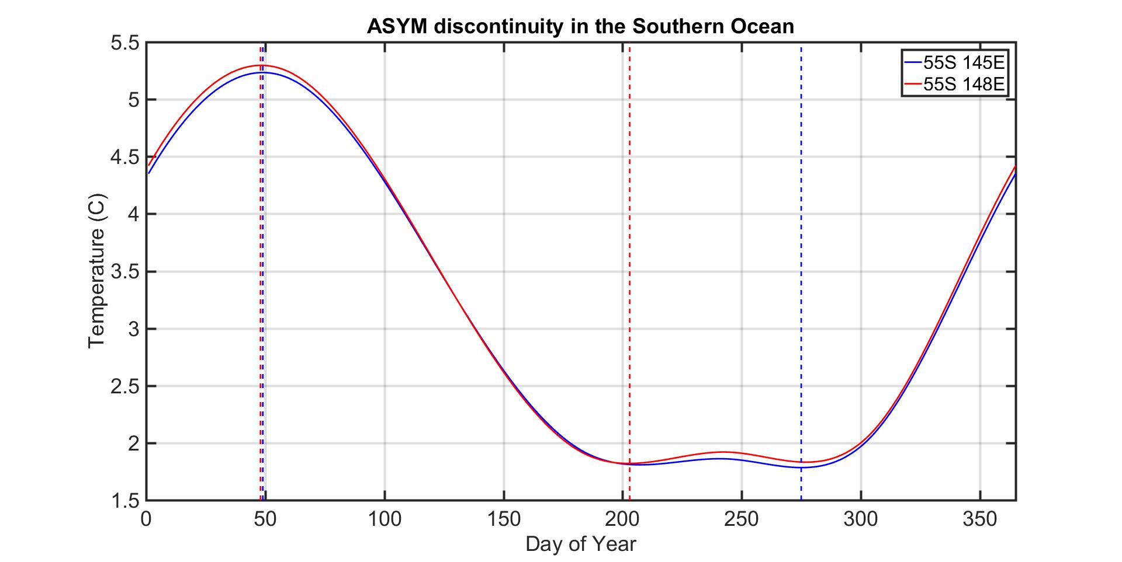

-L265: "prominent semi-annual Ts" - I'm assuming the authors are attempting to refer back to the double minimum discussed in the previous paragraph? However, this is a very confusing way of referring to it. Recommend replacing it with "double minimum in Ts." If this is referring to something else, it needs further clarification.
Thanks. We have changed this to read “double minimum”.
-L289-291: The North American continent experiences maritime advection both from the Pacific and from the Gulf of Mexico. Therefore, another explanation for the difference in the mid-continental structure of the asymmetry in North America versus Europe could be the re-injection of maritime air that happens over the mid-continent in North America, but not in Europe, rather than differences in the vertical coupling. The authors should test the role of this mechanism.
Thank you for suggesting this mechanism of ASYM contrast between North America and Europe. However, the advection of Gulf of Mexico air onto the continent is primarily a summer phenomenon and does not extend west of 130W. The ASYM contrast between Europe and North America primarily results from differences in the phasing of the winter temperature minimum (τ_{MIN}) and extends westward to the Pacific coast. Therefore, we find this mechanism an unlikely explanation for understanding the spatial structure of ASYM.
We agree that some idealized modeling experiments to understand the role of the Gulf of Mexico in ASYM would be useful. However, these studies are beyond the scope of this (purely observational) study and would greatly lengthen an already lengthy manuscript.
-L317: Indication of the latitude band in the text (47-57N) and figures (45-55N) do not match.
Thanks. We have changed the Figure caption to read (47-57N).
-L324-326: A specification here of the mechanism via which the wintertime stationary wave generates the large tau_min would be helpful here.
Please see lines 327-330 of the revised manuscript (this discussing is also on lines 299-305 of the original manuscript).
-L404-408: The validation of CERES data should be based on more than just Seattle. That region has a very particular climate regime and is not necessarily the regime in which CERES is most likely to exhibit biases.
In the revised manuscript we now include additional land based DSR records for validation of the timing of DSR in the CERES data-set. Please see appendix figure A5 (repeated below) and the discussion of this figure in the main text. Specifically, station data confirm the positive RAD_{ASYM} values seen in the northern latitudes of the Unites States extending from the Pacific coast to the mid-west and the negative RAD_{ASYM} values seen in southwest region (influence of the North America monsoon), the southeast (i.e. Florida) and in Alaska.

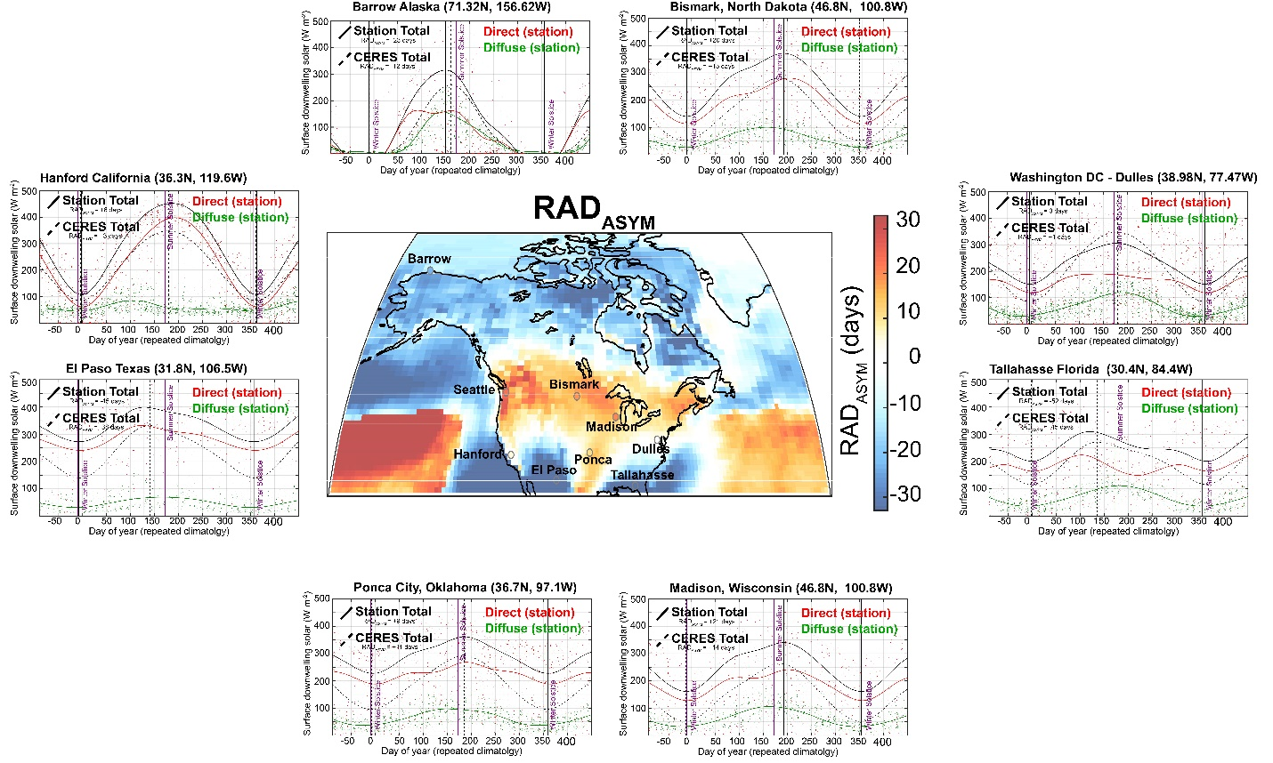
Comparison of RAD_{MAX}, RAD_{MIN} and RAD_{ASYM} calculated in the gridded CERES data to that calculated using DSR measurements from the US. The dots show the observed daily mean DSR and the solid lines show the smoothed climatological seasonal cycle. The direct radiation is shown in red, the diffuse in green and the total observed DSR in black. The dashed black line shows the smoothed seasonal cycle of total DSR from CERES data at the nearest neighbor gridbox. Vertical lines show the time of RAD_{MAX} and RAD_{MIN} identified in the smoothed timeseries of the same linetype. The purple vertical lines show the winter and summer solstices. The inset map shows the RAD_{ASYM} values at each of the stations (colored dots circumscribed by gray) overlayed on (colors) RAD_{ASYM} calculated from the CERES DSR data.
-L437-440: This explanation seems unlikely, given the relative influence on DSR variability from clear-sky transmissivity vs. cloud variations. Recommend cutting this postulation, as there is no data provided to support it.
Good point. We have removed this speculation from the revised manuscript.
-L461-464: Would recommend putting this statement at the top of this section, as it is otherwise somewhat difficult to follow the multiple points being made in this section.
Thank you for this suggestion. We have added a note to the introduction of the section to say that the relationship between seasonal asymmetry in DSR and T_{2m} seen at Seattle does not hold globally.
-L478-488: The discussion of Figure 7a is highly confusing. It seems that the reference to Figure 2a is meant to refer to Figure 7a, as there are no lines in 2a. However, Figure 7a doesn't have red or blue lines either. What figure is this discussion referring to?
We apologize for two errors in the original text: (i) we indeed meant to refer to Figure 7, and (ii) the text referred to line colors that we had used in an earlier figure, but later changed: the text should have referred to green and purple lines. These errors have been fixed in the revised manuscript and we apologize for the unnecessary confusion.
-L542-543: The statement that tau_min in these regions is typical of marine climates followed by the statement that these regions are isolated from marine influence year round appears contradictory. Please clarify.
We have removed the statement “typical marine climate” from the revised manuscript.
-L583-589: The introduction of new data in the conclusion in the discussion of Figure 7C is somewhat jarring, and requires too much parsing of new information to be helpful as an illustrative summary.
The T_{2m} data shown in the figure is not new; it has been used to calculate ASYM in the paper as part of the global analysis. Our goal here is to allow the reader to visualize several examples of differing temporal shapes of T_{2m} that engender ASYM. The four examples highlighted in this figure are meant to serve as a summary of disparate seasonal cycles of T_{2m} that are governed by different processes and emblematic of widespread areas of Earth.
Typographic comments:
-L43: "amplitude Ts" "amplitude of Ts"
Fixed.
-L255: "minimum" minima"
Fixed.
-L352: "andshortcomings" "and shortcomings"
Fixed.
-L438: "tranmissivity" "transmissivity"
Sentence removed from revised manuscript.
-L584: "Sam Francisco""San Francisco"
Fixed.
-L626: remove duplicate "of"
Fixed.

Cited Literature:
Battisti, D.S., Ding, Q. and Roe, G.H., 2014. Coherent pan‐Asian climatic and isotopic response to orbital forcing of tropical insolation. Journal of Geophysical Research: Atmospheres, 119(21), pp.11-997.
Boos, W.R. and Kuang, Z., 2010. Dominant control of the South Asian monsoon by orographic insulation versus plateau heating. Nature, 463(7278), p.218.

Reviewer 2
Major points
1. The authors nicely identify a component of the seasonal cycle that has been over-
looked in prior analyses. However, I found that the manuscript was trying to do
too many things, and thus did none of them sufficiently well. The majority of the
explanations for the asymmetry are entirely speculative, perhaps based upon a small
number of references, and belong in a discussion section. I would suggest that the
authors focus on a smaller number of proposed mechanisms and then present analyses
that are more complete.

We thank the Reviewer for the criticism. We have greatly expanded the analysis and discussion of the mechanisms of ASYM in the revised manuscript. We now include: (i) a much more thorough discussion of the seasonal evolution of T_{2m} and SST, supported by analysis of the seasonal cycles at Ocean Weather Ships and an analysis of the seasonal energy budget of the troposphere and upper ocean; (ii) an expanded literature review on the timing of the monsoon; and (iii) a more extensive analysis of the surface solar radiation data.

Many of the mechanisms we discuss are straightforward and surely important. However, we agree that some of the mechanisms we propose are still somewhat speculative in nature and our analyses should be seen as a starting point for understanding ASYM as opposed to a comprehensive understanding of the global structure of ASYM. We considered confining the manuscript to a simple documentation of the global structure of ASYM but felt that such a manuscript would be too dry. Instead, we decided to present explanations – supported by analyses – of what we believe are the most important mechanisms. Our focus is consistent with the purpose of the Journal of Climate: to “advance basic understanding of the dynamics and physics of the climate system on large spatial scales.” Specifically, our manuscript (i) documents the asymmetry in the timing of the seasonal cycle, (ii) advances the basic understanding of the relevant processes, and (iii) identifies regions where the timing of the seasonal cycle remains puzzling. We also document instances where there is a mismatch between reanalyses and station data. We have added a statement to the beginning of the discussion section of the revised manuscript to emphasize the scope of the current work. We hope this work will inspire future studies that further quantify the processes involved in determining ASYM.

2. While the focus on Seattle was sometimes an easy way to be introduced to the
concepts, in other cases it hurt the paper. For example, the authors demonstrate
that, in Seattle, the seasonal cycle in near-surface air temperature has a consistent
lag with respect to DSR, giving the reader the feeling that this will be a general
explanation, only to show that it only holds for the western edges of continents.

We now alert the reader that the DSR/ T_{2m} relationship at SEATAC is representative of a regional phenomenon that does not hold globally.

In same section, a dataset (CERES) is validated against only the Seattle DSR record,
which is insuffcient.

In the revised manuscript we now include additional land based DSR records for validation of the timing of DSR in the CERES data-set. Please see appendix figure A5 (repeated below) and the discussion of this figure in the main text. Specifically, station data confirm the positive RAD_{ASYM} values seen in the northern latitudes of the Unites States extending from the Pacific coast to the mid-west and the negative RAD_{ASYM} values seen in southwest region (influence of the North America monsoon), the southeast (i.e. Florida) and in Alaska.

Comparison of RAD_{MAX}, RAD_{MIN} and RAD_{ASYM} calculated in the gridded CERES data to that calculated using DSR measurements from the US. The dots show the observed daily mean DSR and the solid lines show the smoothed climatological seasonal cycle. The direct radiation is shown in red, the diffuse in green and the total observed DSR in black. The dashed black line shows the smoothed seasonal cycle of total DSR from CERES data at the nearest neighbor gridbox. Vertical lines show the time of RAD_{MAX} and RAD_{MIN} identified in the smoothed timeseries of the same linetype. The purple vertical lines show the winter and summer solstices. The inset map shows the RAD_{ASYM} values at each of the stations (colored dots circumscribed by gray) overlayed on (colors) RAD_{ASYM} calculated from the CERES DSR data.

3. The differences between the τ values estimated from station data and reanalyses
seem large, given that the seasonal cycle is such a dominant mode of variability in
the climate system. Additional evidence is needed for the claim that the differences
are due to the gridboxes averaging over a range of conditions and land surfaces rather
than biases in the reanalyses.

First, please note the updated spatial correlations and absolute differences in τ_{MAX}, τ_{MIN} and ASYM in the station data and the ERA reanalysis. In the original manuscript, a subset of station observations used a longitude format of -180 (W) to 180(E) rather than the 0-360 format used by ERA and this resulted in a misidentification of the nearest neighbor ERA gridbox. Correcting this error has led to greater spatial correlations between ERA reanalyses and observations and a reduction in absolute differences between ERA and the station data: for ASYM, the spatial correlation between ERA reanalyses and observations is 0.86 and the mean absolute difference in ASYM between the two data sets is only 4.4 days. We note that these stations were plotted correctly in the original figure 1 (although figure 1 has been revised to show the observed air temperature instead of SST).
We have also included a scatter plot of ASYM calculated from the station data and that at the nearest neighbor ERA gridbox in Appendix figure A1. This figure shows ASYM calculated from these two data sets is strongly correlated along a 1:1 line. Averaged over all stations, ASYM in the ERA product is only 2.2 days more negative than that in the station data and this difference results from island stations where the ASYM in the station data is near zero or slightly positive but the nearest ERA gridbox is predominantly ocean and thus has negative ASYM values. We have added a discussion of these points to the revised manuscript.

Minor points
Many typos throughout, including in figure titles/text.
We apologize. In the revised manuscript, we have corrected these typos.

2. Line 36: suggest using T2m rather than Ts, which typically denotes surface/skin
temperature.
Replaced throughout.

3. Line 64: `Similarly' is an odd choice to group these two statements.
Replaced with “furthermore”.

4. Line 141: Why have you chosen 1000 hPa ERA-Interim rather than their estimate
of near-surface air temperature? In regions of topography, the surface will be higher 1 than 1000 hPa.

We use the 1000 hPa temperature from ERA-Interim instead of the T_{2m} because the former has a better correspondence with nearest neighbor station data. We have also included results using T_{2m} from the NCEP reanalysis product which are very similar to those found using the ERA-interim data and the station data (see Appendix Fig. A2). We elected to use the 1000 hPa temperature from ERA reanlaysis because it has a finer horizontal resolution.

5. Line 257: what is the origin of this double minimum? More generally, suggest masking
out regions where the methodology fails.

In the revised appendix (and copied below), we now include time series of the (smoothed) surface temperature on each side of the τ_{MIN} discontinuity and present the following explanation (in the appendix):
“In the region of the Southern Ocean just south of Australia there is a 100 day period where temperature is very close to the seasonal minimum with a slight warming (≈0.1K) in the middle of this period (see Fig. A4) resulting in two local temporal minima of T_{2m} at locations throughout the region. East (west) of Australia, the absolute minimum temperature occurs early (late) in this 100 day interval. (The minor local maxima in the middle of this 100 day interval is likely due to seasonal variations in upwelling).”

We chose to not mask out regions in the figures that have a double minimum because – after establishing a methodology for calculating ASYM – we believe it is important to note where and for what reason this methodology may lead to difficulties.

6. Line 264: There are a number of other locations with positive values: North Atlantic
south of Greenland, generally the east coast of Southern Hemisphere continents,
Gulf of Mexico, the west coast of Africa/Southern Europe.

These locations are now noted in the revised text.

7. Line 286: The argument that advection occurs primarily at levels where the amplitude
and phase of the seasonal cycle is zonally homogenized does not seem to explain
how you get zonally asymmetry at lower vertical levels?
The lower levels are more strongly coupled to the surface and thus zonally asymmetries in the seasonal cycle of temperature are strongly influenced by the underlying surface type (ocean or land).

Relatedly, Fig. 3 in Stineand Huybers (2012) still shows substantial zonal asymmetry throughout the vertical column.
We have revised this statement to make it clear that we only mean to say that temperature in the free troposphere is more zonally homogenous than temperature in the atmospheric surface boundary layer.

Finally, notation should be fixxed, as Ts was previously used to refer to
near-surface air temperature (not temperature generally).
Changed to “atmospheric temperature”.

In general, reanalyses products for 2 meter air are unreliable and inconsistent between different set of reanalyses (Pitman and Perkins, “Global and Regional Comparison of Daily 2-m and 1000-hPa Maximum and Minimum Temperatures in Three Global Reanalyses”, J. Climate, 2009).

